SAMPLING FISH AND MACROINVERTEBRATE

RESOURCES IN TIDAL WETLANDS

SACRAMENTO-SAN JOAQUIN DELTA

Report on

PHASE IV PILOT MONITORING IN 2018

Dave Contreras, Daniel Ellis, Rosemary Hartman, and Stacy Sherman

Fish Restoration Program Monitoring Team

California Department of Fish and Wildlife

Stockton, California

Draft

Contents

Preface 3

Pilot Monitoring Phases 4

Project Objectives 4

Part 1: Phytoplankton and Invertebrate spatial and temporal variability 5

Introduction 5

Invertebrates 5

Phytoplankton 5

Methods 6

Sampling Sites 6

Habitat Types and Sampling gears 8

Laboratory Methods 12

Analysis 14

Results 15

Discussion 35

Inter-annual differences 35

Differences between site types 35

Intra-annual differences 36

A note on neuston: 38

Chapter 2: Channel-Shoal Gear Comparison 39

Introduction 39

Nutrients 39

Zooplankton 39

Fish 39

Methods 40

IEP Surveys 40

FRP Sampling 41

Lab methods 43

Analysis 43

Results 44

Discussion 44

CHAPTER 3: Methods Development 44

Introduction 44

ARIS Sonar 44

ARIS Evaluation of Boat Electrofisher and Gill Net 45

SAV survey techniques 46

Analysis 47

Results 47

Discussion 50

Endangered Species Act Take 50

References 52

# Preface

Much of the tidal wetland restoration in the Sacramento-San Joaquin Delta and Suisun Marsh (the Upper SF Estuary) is being constructed under the premise that wetland restoration will increase the resilience of threatened fish. The Fish Restoration Program Monitoring Team (FRP) is tasked with developing monitoring plans for tidal wetland sites restored pursuant to requirements in the 2008/2009 Biological Opinions for state and federal water project operations (USFWS 2008, NMFS 2009, CDFW 2009). We led the Interagency Ecological Program (IEP) Tidal Wetlands Monitoring Project Work Team (PWT) in developing the Tidalwetland monitoring framework for the upper San Francisco Estuary (hereafter "Framework"; PWT 2017a). The PWT has developed a set of conceptual models and hypotheses for how wetlands benefit fish (Sherman et al. 2017). These were the basis for recommendations for sampling methods to evaluate effectiveness of restoration projects (PWT 2017b). FRP has rigorously tested these sampling methods, but questions remain as to the comparability of FRP data, collected in wetlands, and long-term IEP monitoring data, collected in channels.

The Framework recommends a whole-ecosystem approach for describing the capacity, opportunity, and realized function (sensu Simenstad and Cordell 2000) provided by wetland restoration to at-risk fishes. As such, FRP is collecting data on the physical habitat (water quality, bathymetry, and flow), nutrients, primary producers (phytoplankton and vegetation), invertebrates, and fish that occur on each of our restoration sites. Each restoration site is paired with an existing wetland site as a “reference”, and each wetland will be monitored both before and after restoration. However, measuring all these sampling components required extensive refinement of sampling methods and sampling schema.

Meso- and macroinvertebrates, including amphipods, mysids, insects, copepods and isopods, are important food resources for tidal wetland fish, but are often patchily distributed and highly variable (Slater and Baxter 2014, Whitley and Bollens 2014, Baxter et al. 2015, David et al. 2016). Monitoring change over time requires understanding the level of spatial and temporal replication necessary for statistical validity. Information on meso- and macroinvertebrates is necessary to address Framework hypotheses F2-F5, which were derived from the PWT’s Food Web Conceptual Model (Hartman et al. 2017a) and Chinook Salmon Tidal Wetland Model (Goertler et al. 2017).

Even for established methods, such as zooplankton trawls and nutrient sampling, more research is needed to determine the spatial and temporal extent of inference that can be made for a given metric. Multiple long-term monitoring surveys sample the pelagic realm for meso- and macro-zooplankton, phytoplankton, and nutrients using well-established methods (Hennessy 2009). However, it is unclear the extent to which these constituents differ between the deep channel habitat currently sampled and the wetlands that our program will sample (Bollens et al. 2014; Kimmerer et al. 1998). Understanding differences between channels and wetlands is also necessary to detect exchange between these habitats that is predicted to increase food availability in the channel (Framework hypotheses F8-F10, (Hartman et al. 2017b)).

Fish are also highly variable across the Upper SF Estuary. Although fishes ranging from larvae to adults are sampled regularly, just a few sampling programs focus on small channel/shallow water/vegetation edge habitats. We have tested several different types of gear for catching fish in these habitats in the North Delta (Cache Slough Region). We need a better understanding of the function of these gears across estuarine gradients and how catches compare to long-term IEP monitoring. Fish community sampling in long-term monitoring is needed to determine the presence of listed species (hypotheses P4 and P14), to provide specimens of listed fish for various potential studies of diet, condition, and growth (hypotheses F4-F7), and to understand the potential for predation on and competition with the listed species (hypothesis S4), aspects of “capacity” in the Habitat Attributes tier of the Chinook Salmon Tidal Wetlands conceptual model (Goertler et al. 2017).

## Pilot Monitoring Phases

We conducted a Phase I “gear exploration” from July to October 2015 (Contreras et al. 2016). Based on results from that effort, successful methods were selected for inclusion in the second phase of pilot work. Phase II occurred from February through July 2016, and provided a more rigorous evaluation of gear feasibility during the time of year listed fish are most likely to be using wetlands (Contreras et al. 2017). Phase II included quantitative comparisons of abundance, size, composition, and diversity which led to recommended gear types. The recommended gear types from Phase II were used in the Phase III study that further refined the spatial and temporal sampling schemes necessary to evaluate monitoring hypotheses, and began testing the extent to which IEP’s channel-based monitoring surveys can be used to make inferences on tidal wetlands (Contreras et al. 2018).

After each pilot phase, results were reviewed by the PWT before inclusion in development of plans for the next phase. This report covers Phase IV, which expanded comparisons between FRP and IEP surveys, tested new methods for monitoring fish, SAV, nutrients, and phytoplankton, and began collecting pre-project data at future restoration sites.

## Project Objectives

* Determine the level of spatial and temporal replication necessary to make sampling design recommendations for long-term monitoring.
* Determine the extent to which long-term IEP sampling reflects conditions in nearby shallow-water and wetland habitats.
* Determine whether gear efficiency evaluations are feasible using new sampling technology (i.e., ARIS sonar).
* Begin developing a baseline of biomass, community composition, and fish condition for fish and invertebrates near planned tidal restoration and comparison sites. This will allow us to make pre-and-post-restoration comparisons for evaluating restoration progress.

## 

# Part 1: Phytoplankton and Invertebrate spatial and temporal variability

## Introduction

### Invertebrates

Understanding the variability of zooplankton, and macroinvertebrates will allow us to evaluate appropriate timing and replication of samples for characterizing the food-web support in restored tidal wetlands. Macroinvertebrates associated with vegetation and shallow water habitat, such as amphipods and insect larvae, have been historically under-studied in this system; however, they provide the majority of salmonid diet composition in these areas (Bottom et al. 2011; David et al. 2016a; Maier and Simenstad 2009; Sommer et al. 2001), and are a component of Delta Smelt diets when smelt occur in areas of high macrophyte production (Whitley and Bollens 2014). Because these groups are understudied, it is unclear how variable biomass and community composition are within a site, between sites and between seasons. Because epifaunal invertebrates are a smaller percentage of smelt diets (Slater and Baxter 2014) and are less mobile than zooplankton, it may only be necessary to sample these macroinvertebrates once or twice per year. If sampling is limited, we want to determine what time of year has greatest overlap between listed fish species and their food supply.

We chose spring for our spatially intensive sampling, because this is when there is the highest density of juvenile salmonids rearing in the estuary (Williams 2012), Delta Smelt are spawning in the freshwater Delta (Baxter et al. 2015; Sommer and Mejia 2013), and Longfin Smelt are present and spawning in the marshes surrounding Suisun Bay (Grimaldo et al. 2017). However, the importance of food supply during the fall, while juvenile smelt area rearing, is considered one of the major factors in population resilience (Baxter et al. 2015; Brown et al. 2014). Therefore, chose to characterize potential food supply in areas important to smelt in the fall.

Due to limited resources, we targeted fall sampling only in areas likely to have high smelt abundance. In most years, a majority of the population migrates to the Low Salinity Zone (LSZ), to rear (Baxter et al. 2015). This area generally stretches from Suisun Bay to the Confluence, though exact location depends on water year type (Brown et al. 2014). There is an additional resident population of Delta Smelt which remains in the North Delta year round (Sommer et al. 2009), so we chose to target these areas for additional fall sampling.

### Phytoplankton

Phytoplankton are considered to be one of the key carbon sources in the aquatic food web. However, not all phytoplankton are created equal. Diatoms and green algae are preferred over cyanobacteria and flagellates in most cladocera and copepod species studied in this estuary (Orsi 1995), though more recent studies suggest cyanobacteria make up a large part of copepod diets when they occur in high abundance (Kimmerer et al. 2018a). Furthermore, preferred food differs by species of zooplankton and species of phytoplankton (Bouley and Kimmerer 2006; Cloern and Dufford 2005; Jassby 2008). In the past, most evidence pointed to pelagic phytoplankton as the key driver of the Bay-Delta food web (Canuel et al. 1995; Sobczak et al. 2005; Sobczak et al. 2002), however, more recent work suggests benthic, epiphytic, and wetland-derived carbon may plan a more important role than previously realized (Schroeter et al. 2015).

Given the importance of taxonomic identity when assessing phytoplankton’s role in the food web, it is important to better understand phytoplankton community composition at restoration sites. Once we start regular monitoring of restoration sites, we may decide to collect phytoplankton samples concurrently with monthly zooplankton samples. However, we wanted to first establish a baseline of phytoplankton variability within the wetlands. Therefore, we collected phytoplankton concurrently with the intensive spring sampling of macroinvertebrates.

#### Study questions:

1. How do invertebrate and phytoplankton communities change from year to year?
2. Are there significant differences between channel habitat, managed wetlands (pre-restoration), and tidal wetlands (remnant and/or post-restoration)?
3. What food is available for listed fish species throughout the year?
   1. When during the spring is most important to sample?
   2. How do fall food resources compare to spring food resources?

## Methods

### Sampling Sites

To answer questions 1 and 2, we sampled FRP restoration sites and surrounding wetlands distributed across the Delta and Suisun Marsh FRP (Figure 1, Table 1). These sites incorporate varying salinity and surrounding land use (the “ecoclines” identified in the IEP TWM PWT conceptual models, see (Sherman et al. 2017). Sites for 2018 were an expanded set of sites sampled in 2017, allowing for year-to-year comparisons. Sampling restoration sites (“Impact” sites) before restoration and comparing these sites to existing wetlands (“Control” sites) allows for a Before-After, Control-Impact design, once restoration is completed on some of these sites. While we do not expect our restoration sites to develop exactly like the comparison sites, the network of comparison sites provides a background, or “ambient” condition for the estuary that will allow us to better see the effectiveness of the restoration actions.

Note: We collected samples at Dow Wetlands in the spring of 2018, but we did not process the samples or analyze the data due to changes in priorities recommended by DWR FRP staff.

To answer question 3, we conducted increased sampling at one site (Decker Island) four times throughout the spring, and sampled in the fall at a subset of the locations where Delta Smelt are found most often. An analysis of data from the Fall Midwater Trawl Survey from September and October 2010-2016 showed the majority of the smelt caught where in the Confluence of the Sacramento and San Joaquin Rivers and Suisun Bay (CDFW data available: https://www.wildlife.ca.gov/Conservation/Delta/Fall-Midwater-Trawl). There is an additional, resident population in the Cache Slough Complex (Baxter et al. 2015), so we sampled the subset of wetland sites near these “smelt- hot- spots” during the fall (October 9th – November 1st), at a lower intensity than spring sampling. Before conducting the fall sampling, we assessed the data from the FMWT and the USFWS’s Enhanced Delta Smelt Monitoring (EDSM) survey to determine whether the fall 2018 smelt distribution matched previous years.

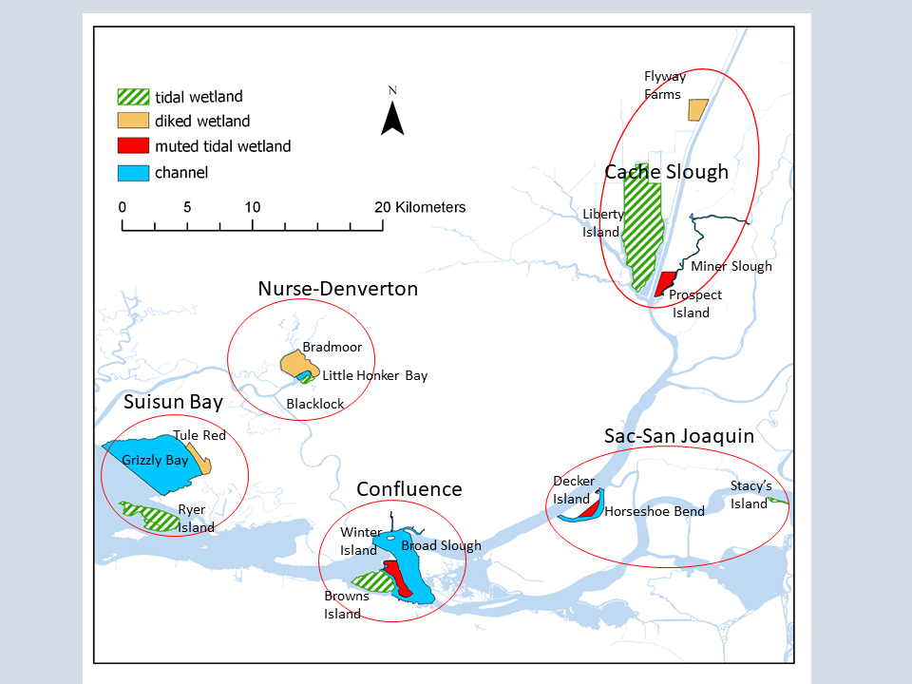

Figure 1 Sites that were sampled during the spring of 2018. Within each region (outlined in red), we compared pre-project data from currently diked or muted tidal wetlands (planned restoration sites), with data from associated channel habitat, and existing tidal wetlands.

Table 1. Sample sizes for spring sampling in 2018. Sample numbers differ based on site size, habitat availability, and logistical constraints.

|  |  |  |  |  |  |  |  |  |
| --- | --- | --- | --- | --- | --- | --- | --- | --- |
| Site | Region | benthic grab | mysids | neuston | phytoplankton | Sweep net | Zooplankton | Total |
| Flyway Farms | Cache Slough Complex | 4 | 0 | 0 | 7 | 6 | 0 | 17 |
| Liberty Island | Cache Slough Complex | 6 | 9 | 6 | 17 | 8 | 9 | 55 |
| Miner Slough | Cache Slough Complex | 4 | 5 | 4 | 4 | 4 | 5 | 26 |
| Prospect Island | Cache Slough Complex | 2 | 3 | 1 | 5 | 9 | 8 | 28 |
| Broad Slough | Confluence | 4 | 5 | 6 | 5 | 5 | 6 | 31 |
| Browns Island | Confluence | 3 | 6 | 6 | 6 | 10 | 6 | 37 |
| Winter Island | Confluence | 9 | 7 | 9 | 6 | 1 | 4 | 38 |
| Grizzly Bay | Suisun Bay | 6 | 8 | 6 | 6 | 0 | 8 | 40 |
| Ryer Island | Suisun Bay | 6 | 6 | 6 | 6 | 12 | 6 | 42 |
| Tule Red | Suisun Bay | 5 | 0 | 4 | 6 | 6 | 6 | 27 |
| Blacklock | Nurse-Denverton | 4 | 4 | 4 | 6 | 4 | 4 | 26 |
| Bradmoor | Nurse-Denverton | 6 | 1 | 1 | 6 | 10 | 6 | 30 |
| Little Honker Bay | Nurse-Denverton | 6 | 8 | 6 | 6 | 8 | 8 | 42 |
| Decker | Sacramento-San Joaquin | 2 | 6 | 5 | 6 | 7 | 9 | 35 |
| Horseshoe Bend | Sacramento-San Joaquin | 6 | 3 | 3 | 3 | 8 | 3 | 26 |
| Stacys Island | Sacramento-San Joaquin | 4 | 5 | 2 | 4 | 4 | 5 | 24 |
| Grand Total |  | 77 | 76 | 69 | 107 | 102 | 92 | 523 |

Table 2 Sample sizes for fall sampling in 2018.

|  |  |  |  |  |  |  |
| --- | --- | --- | --- | --- | --- | --- |
| Samples near | region | site type | Sweep net | Mysid trawl | Zoop trawl | **Total** |
| Winter Island | Confluence | diked wetland | 6 | 3 | 3 | **12** |
| Browns Island | Confluence | tidal wetland | 6 | 3 | 3 | **12** |
| Ryer Island | Grizzly Bay | tidal wetland | 5 | 3 | 3 | **11** |
| Prospect Island | Cache Slough | diked wetland | 6 | 3 | 3 | **12** |
|  |  | **Total** | **23** | **12** | **12** | **47** |

### Habitat Types and Sampling gears

#### Vegetation

Previous studies showed very high replication was necessary to differentiate between vegetation types (2017; 2018; Contreras et al. 2016). Therefore, we randomly distributed our sweep net samples through all vegetation types present on the site in proportion to their abundance, rather than specifically targeting samples from each vegetation type. We haphazardly choose 6-12 sampling locations per site and used sweep nets to sample vegetation.

**Sweep nets:** Sweep nets are a simple but effective way to sample the invertebrate community. Sweep nets may capture higher species diversity than many passive methods, though with higher variability in biomass (Turner and Trexler 1997).We will use a 25cm x 30cm D-frame net with 500 micron mesh for all sweep net samples (Figure 2A). The sweep net technique was adapted slightly in different vegetation types.

**EAV:** Emergent vegetation (EAV) samples occurred in the dominant emergent vegetation species, usually either *Schoenoplectus* spp., *Typha* spp., or *Phragmites australis*. We took five, one-meter sweeps through the edge of the vegetation, scraping the vegetation as much as possible to knock invertebrates off the stems (Figure 2B). We then rinse down the net and preserved all invertebrates in ethanol for later identification.

**SAV:** To sample in SAV, we took the same five, 1-meter sweeps as for EAV and collected any vegetation within the border of the net after the sweep is completed (Figure 2D). The sample will be placed on ice for processing in the lab. In the lab, we will rinse the vegetation, remove all invertebrates, and preserve the invertebrates for later identification. Any vegetation captured in the sweep net will be dried to a constant weight to standardize the sample.

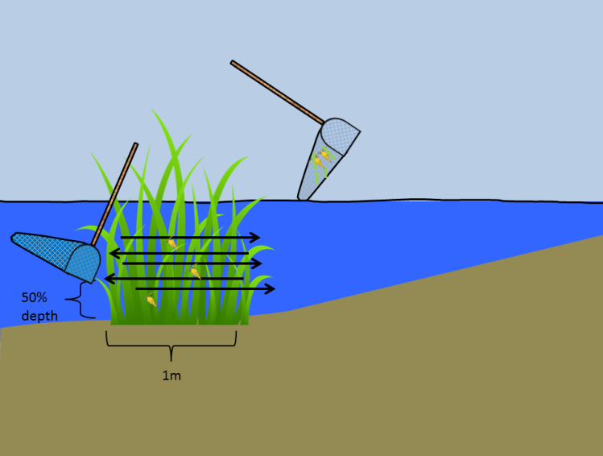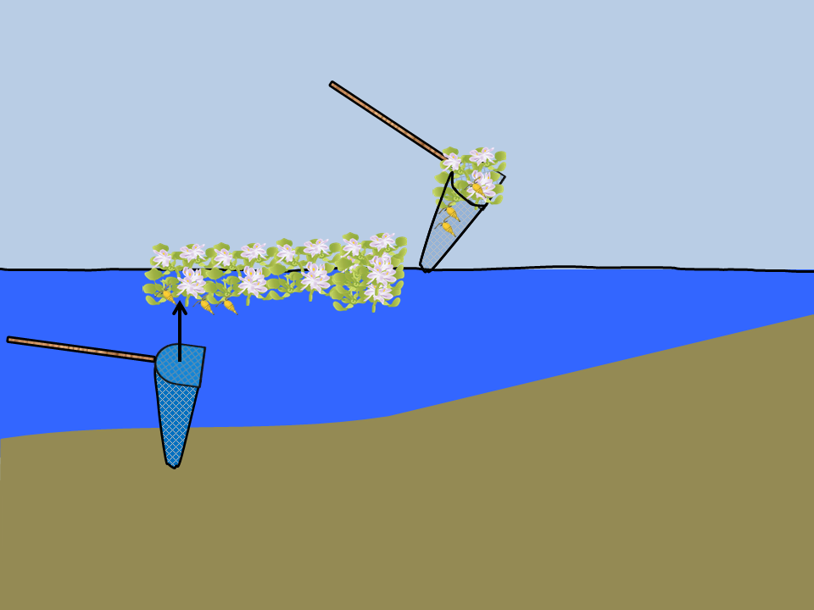

B

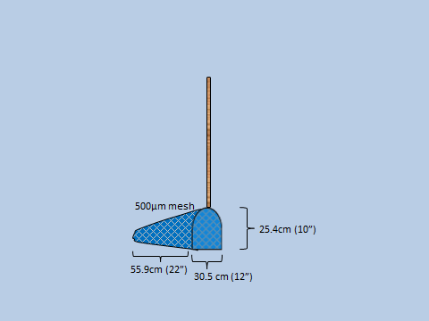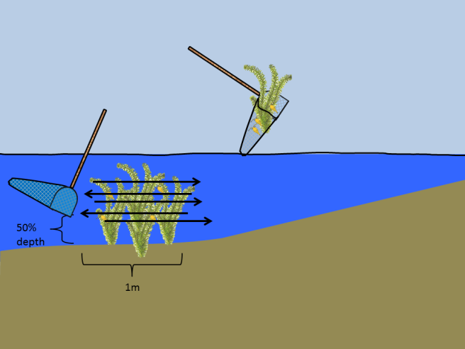

C

D

A

Figure 2 A) Specifications of the sweep net. B) Use of sweep net in emergent vegetation. C) Use of sweep net in submerged vegetation. D) Use of sweep net in floating vegetation.

To allow us to make inferences for broad-scale invertebrate-vegetation relationships, we collected an SAV rake sample immediately after collecting a sweep net sample at each SAV site (see SAV survey techniques, below).

**FAV:**  Sampling techniques in FAV were dependent on FAV species. For *Eichhornia crassipes*, *Hydrocotyle,* and *Azolla*, we harvested a 25cm x 30cm sample from below using the same d-frame net and severing the connection to surrounding plant material with shears (Figure 2C; (Marineau et al. 2019)). We placed the roots of the plant material and associated invertebrates on ice. Upon return from the field, we will separate the invertebrates from the vegetation and dry the plants to a constant weight. *Ludwigia* spp. is a creeping emergent, and does not form discrete, easy-to-harvest clumps. Therefore, it will be sampled with five, 1-meter sweeps, as for EAV.

#### Open water and channel

Our open water sampling patches were haphazardly distributed across all unvegetated open water and channels > 1.5 m across. Methods used in open-water have a long history of use in monitoring in the Delta, and using these same methods will allow us to compare our measurements in vegetated wetlands to conditions in channels and make comparisons to long-term data sets. Methods included: zooplankton and mysid trawls, PVC cores and ponar grabs.

**Benthic core:** Benthic cores have been used extensively to quantify bivalves and other infauna in tidal wetlands (Howe et al. 2014; Wells 2015). In shallow water (<1.5 m), we took a 4 in (10 cm) diameter benthic core (Figure 3A), hand-deployed to a depth of 20 cm. In deep water >1.5 m, we used a 15.2 cm x 15.2 cm ponar grab modified for use in hard substrates (as per USFWS Liberty Island Monitoring, L. Smith pers. comm, Figure 3B), with three samples at each site. The core was washed and sieved on board the boat to remove the sand/mud and preserve any organic detritus and invertebrates. We calculated effort as catch per surface area of substrate sampled.

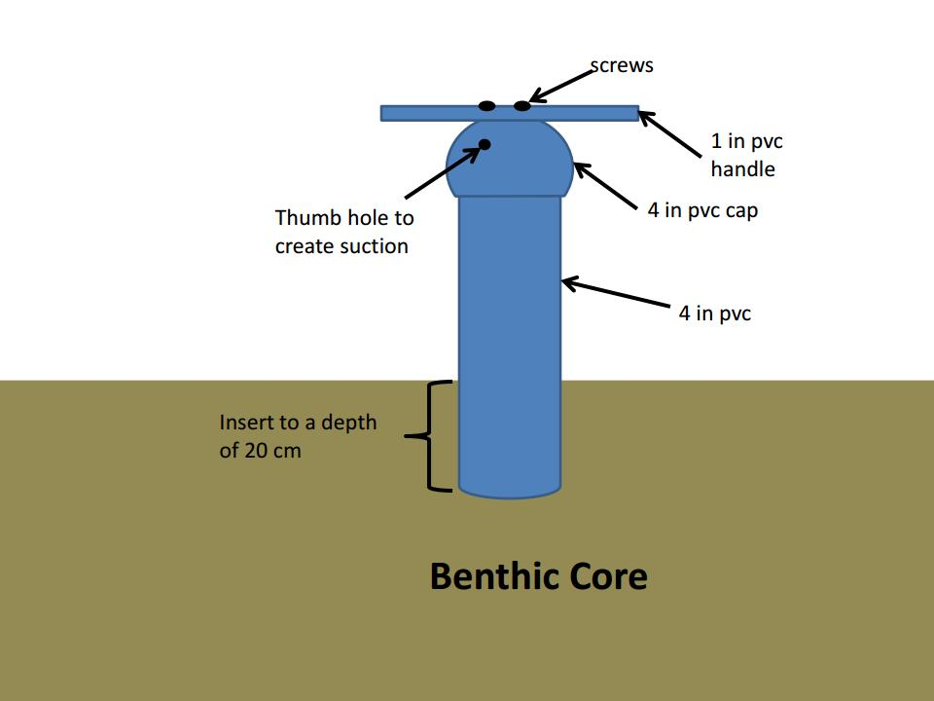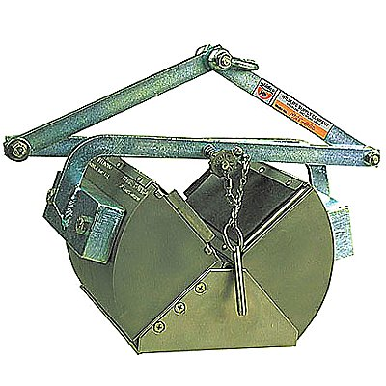

Figure 3. A) Benthic core made of 4” PVC pipe for use in shallow water (<1.5 meters). B) Ponar grab for use in water greater than 1.5 meters.

**Mysid and zooplankton nets:** Macrozooplankton (Mysid) nets have been used extensively to characterize macrozooplankton in the water column. Macrozooplankton includes amphipods and mysids that are large components of fish diets (Feyrer et al. 2003, Slater and Baxter 2014). We sampled macrozooplankton in the water column using a 50 cm mouth diameter (0.500 mm mesh size) mysid net and sampled mesozooplankton with a 14.6 cm diameter (0.150 mm mesh size) zooplankton net attached or held alongside (Figure 4, similar to EMP methods, (Hennessy 2009)). These nets were held approximately 1 m to the site of the bout, 10 cm below the surface of the water and trawled at 1-2 mph for five minutes. A flowmeter mounted in the net measured sample volume, and effort was standardized by catch per liter of water sampled.

Where channels are less than 1.5 m in width, and no open water is present, we placed the net in the channel on an ebb tide and allowed the tidal current to flow through the net for five. After retrieval, the nets were rinsed from the outside to wash down the sample into the cod end. All content collected in a cod end was preserved in 70% ethanol for identification in the lab.

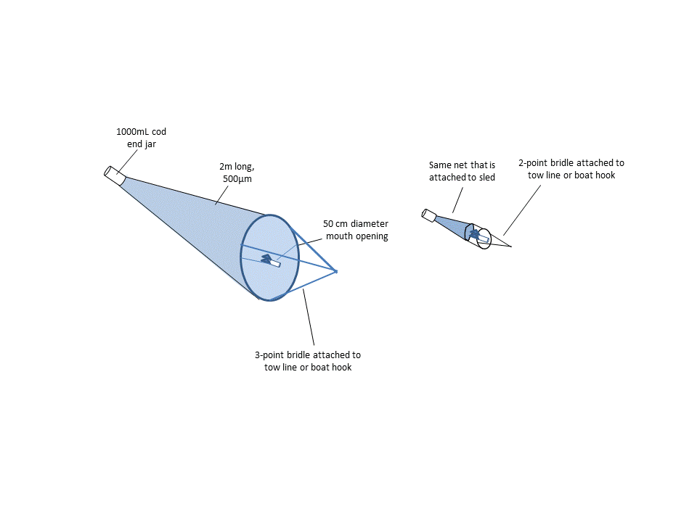

Figure 4. Set up of mysid and zooplankton nets.

**Neuston tow:** The neuston net is a 45 cm x 30 cm rectangular net, 1 m long with 0.500 mm mesh towed half-way out of the water to sample invertebrates on the surface of the water (Figure 5A, B). We towed the neuston net at the surface of the water from the side of the boat via a boat-hook. In very shallow or narrow channels, we pulled the net along the edge of emergent vegetation by hand (Figure 5C; as in (Howe et al. 2014)). We standardized effort by the distance of the tow calculated by GPS track multiplied by half the mouth area of the net to calculate volume of water sampled. After retrieval, all content collected in a cod end was preserved in 70% ethanol for later ID.

**Phytoplankton:** At each zooplankton trawl site, a single, 150 mL sample of water was from the surface and preserved with Lugol’s iodine solution for identification of phytoplankton community composition.

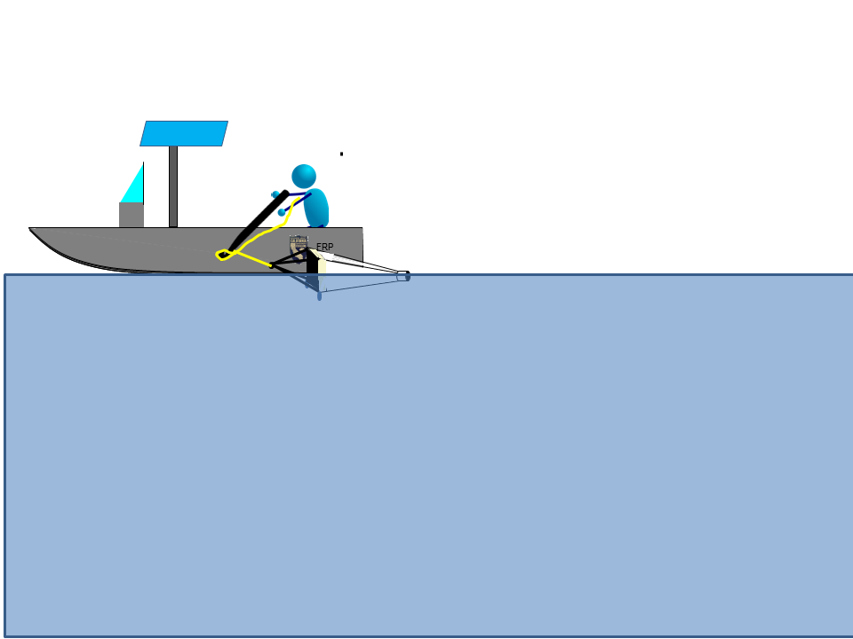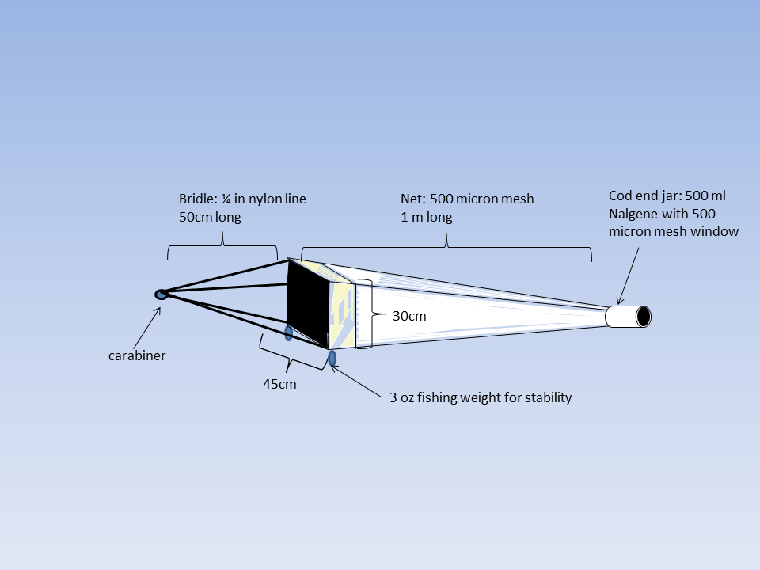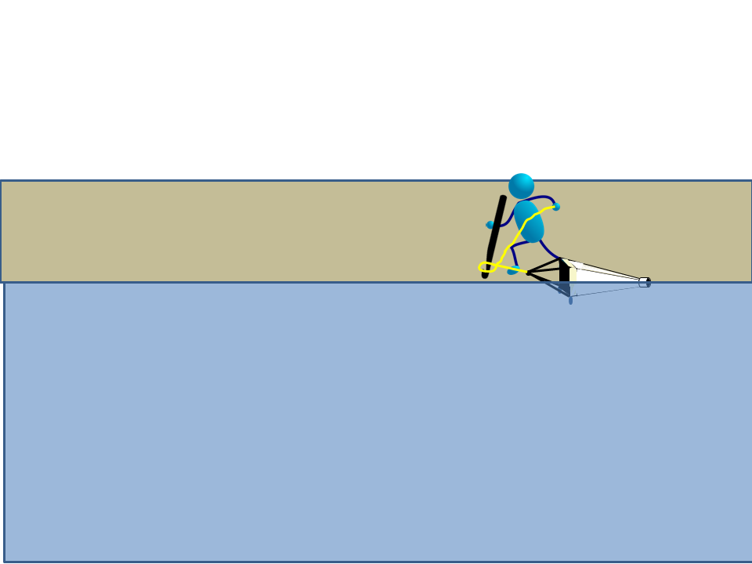

Figure 5. A) Specifications for the neuston net. B) Deploying the neuston net alongside a boat. C) Deploying the neuston net from shore.

### Laboratory Methods

**Taxonomic effort**: Invertebrates were sorted and identified to taxonomic level according to their importance in fish diets (see Table 3). Mysids, isopods and amphipods were identified to Genus or Species; insects were identified to Family. The first twelve individuals of each taxonomic group per sample will be measured to the nearest 0.1mm using an ocular micrometer. Therefore, all bivalves were identified to genus and measured along the longest axis to the nearest mm.

#### Macroinvertebrates

All trawls and sweepnet samples were sorted to extract macroinvertebrates (> 0.500 mm) from plant material and detritus. Benthic infauna (most importantly invasive bivalve grazers *Corbicula* and *Potamocorbula*), are not commonly found in salmon or smelt diets; however, the influence of invasive bivalves on the food web makes them important to predicting availability of production to the pelagic food web (Kimmerer and Lougee 2015; Lucas and Thompson 2012). Therefore, all bivalves were extracted from benthic samples and enumerated. All other benthic infauna were marked as “Present” but not counted. Zooplankton caught incidentally in macroinvertebrate samples were marked as “present” but not counted.

Invertebrates were identified by a Senior Laboratory Assistant (SLA) or Scientific Aide. A subset of samples had identifications checked by an Environmental Scientist for quality assurance. Another subset of samples were checked by an outside lab (EcoAnalysts, Inc.), for external quality assurance.

**Subsampling:** Approximately 400 invertebrates from each sample were identified. If more than 400 invertebrates were present in a sample, or more than four hours was required for processing, they were quantitatively sub-sampled using a grid tray.

Table 3. Levels of taxonomic resolution for each group of taxa commonly found in invertebrate samples.

|  |  |  |  |  |
| --- | --- | --- | --- | --- |
| Phylum | Subphylum | Class | Order | Level of ID |
| Annelida |  | all | all | Class |
| Arthropoda | Chelicerata | Arachnida | all | Class |
| Arthropoda | Crustacea | Maxillopoda: Copepoda | all | Genus |
| Arthropoda | Crustacea | Malacostraca | Amphipoda | Genus |
| Arthropoda | Crustacea | Malacostraca | Cumacea | Class |
| Arthropoda | Crustacea | Malacostraca | Decapoda | Species |
| Arthropoda | Crustacea | Malacostraca | Isopoda | Genus |
| Arthropoda | Crustacea | Malacostraca | Mysidea | Species |
| Arthropoda | Crustacea | Branchiopoda | Cladocera | Genus |
| Arthropoda | Crustacea | Ostracoda | Podocopida | Order |
| Anthropoda | Hexapoda | Collembola | All | Class |
| Anthropoda | Hexapoda | Insecta | All | Family |
| Mollusca |  | Bivalvia | All | Genus |
| Mollusca |  | Gastropoda | All | Family |
| Nematoda |  | All | All | Phylum |
| Platyhelminthes |  | All | All | Phylum |

#### Zooplankton

Most zooplankton samples were processed by CDFW staff at the Stockton laboratory, but 50 samples were processed by EcoAnalysts, Inc. (Moscow, ID). Samples were processed in the same manner by both laboratories. First, samples were filtered and washed in a 0.150 mm mesh sieve. Filtered zooplankton were diluted to a set volume depending on the concentration of zooplankton and/or detritus. One-mL subsamples were then placed on a Sedgewick-Rafter cell glass slide. All organisms were identified to the taxonomic resolution identified in Table 3. At least 5 slides, but no more than 20 slides were processed for each sample, targeting at least 400 organisms. This subsample was then extrapolated to calculate the total number of organisms in the sample. A subset of samples was checked by a second taxonomist for quality assurance.

#### Phytoplankton

All laboratory analysis of algal samples was conducted by EcoAnalysts, Inc. (Moscow, ID), using the Utermöhl microscopic method (Utermöhl 1958) and APHA Standard Methods (APHA 2017). In brief: At least 400 total algal units and 100 units of the dominant taxon or taxa (genus or species level) were counted at appropriate levels of magnification for the cell size. Final counts were expanded to account for subsampling.

### Analysis

To answer Questions 1 and 2 on the variation in phytoplankton, zooplankton, and macroinvertebrate abundance, we compared samples from across sites in 2017 and 2018. We used mean log-transformed CPUE to compare invertebrate abundance across sites and between years using generalized linear mixed models (GLMMs) with site as an error term and the predictor variables listed in Table 4. These different wetland sites will provide the “Control-Impact” blocks for our BACI design in future analyses. We tested the fit of all possible models using Akaike’s Information Criterion corrected for small sample sizes (AICc) (Anderson 2008, Gotelli and Ellison 2012). Since we only have two years of data per site, we were not able to differentiate between variance due to water year type and variance due to other inter-annual factors, however the same analyses can be conducted in future years when we have more data per water year type. This data will also provide the “Before” of our Before-After Control-Impact design. All GLMMs used the “lme4” package in R (Bates et al. 2016).

To detect differences in community composition, we used permutational multivariate analysis of variance (PERMANOVA) and non-metric multidimensional scaling (NMDS) on the Bray-Curtis dissimilarities to assess overall differences in communities. These analyses used the R package “vegan”(Oksanen et al. 2016). To see whether some organisms at as “indicators” for a particular wetland type, were performed a multi-level pattern analysis using the multipat function from the “indicspecies” R package (Cáceres and Jansen 2016).

Table 4 Predictor variables for GLMMs of log-transformed invertebrate CPUE.

|  |  |  |
| --- | --- | --- |
| **Variable** | **Variable type** | **Description** |
| Region | Categorical | Region of the estuary as shown on Figure 1 |
| Site type | Categorical | Depth and water management regime (diked wetland, tidal wetland, shallow open water, or channel) |
| Habitat type | Categorical | Depth of water and presence of vegetation (Emergent wetland, SAV, FAV, open-water, or benthic) |
| Site (error term) | Categorical | Identity of wetland site, sued as an error term to prevent pseudoreplication. |

To answer Question 3, we will analyze the four sampling events from Decker Island to see when CPUE and BPUE of fish food invertebrates are maximal. We will test the fit of linear and quadratic equations of catch versus date to see when abundance peaks. We also tested the fit of a linear model of catch versus Sacramento river flow to see whether flow was a better predictor of abundance than date (using DAYFLOW calculations: <https://water.ca.gov/Programs/Environmental-Services/Compliance-Monitoring-And-Assessment/Dayflow-Data>). We graphically compared the trend in macroinvertebrate catch to the catch of Chinook Salmon smolts caught by the USFWS Chipps Island survey (USFWS data available <https://www.fws.gov/lodi/juvenile_fish_monitoring_program/jfmp_index.htm>) and the catch of Delta Smelt caught by the Spring Kodiak Trawl (CDFW data available <https://www.wildlife.ca.gov/Conservation/Delta/Spring-Kodiak-Trawl>).

We analyzed the data from the subset of stations with both Spring and Fall sampling by analyzing log-transformed CPUE of macroinvertebrate abundance using GLMMs similar to those used for the spring dataset. To detect differences in community composition, we used PERMANOVA and NMDS to assess overall differences in communities. We then qualitatively compared the differences in communities to organisms found in Delta Smelt diets for the life stage at observed in proximity to the sites using published diet studies (Slater and Baxter 2014).

## Results

FMWT caught no Delta Smelt during 2018. EDSM caught 89 Delta Smelt in September and October, most of which were either in the Sacramento Deep Water Ship Channel, or the Lower Sacramento River (Table 5). This was similar to the distribution predicted in our workplan, so our fall sampling proceeded as planned, targeting the Confluence and Cache Slough Complex.

Table 5. EDSM Delta Smelt catch from September and October, 2018 (USFWS, data available <https://www.fws.gov/lodi/juvenile_fish_monitoring_program/jfmp_index.htm>) .

|  |  |  |
| --- | --- | --- |
| **EDSM Stratum** | **September** | **October** |
| Lower Sacramento | 17 | 6 |
| Sac DW Ship Channel | 38 | 26 |
| Suisun Marsh | 2 | 0 |
| **Grand Total** | **57** | **32** |

Macroinvertebrate abundance, zooplankton abundance, and chlorophyll during the spring sampling period were all highly variable, both within sites and between sites (Figure 6, Table 10). There was significantly higher catch in the mysid net, zooplankton net, and sweep nets in diked wetlands than any other habitat type. There was also significantly higher chlorophyll in diked wetlands (Figure 9, Table 6). However, there was significantly lower clam abundance in diked wetlands than other site types (Table 6, Figure 7). There was significantly higher catch of clams and mysids in 2018 than 2017, but no other significant differences in abundance between years. Region of the estuary was included in the models for zooplankton and clam abundance, however there were no significant differences between regions for either parameter (Table 6). Within the sweep net samples, EAV had the lowest average CPUE, FAV had significantly higher CPUE, and SAV had the highest CPUE (Table 6). Model selection for Neuston tows did not select any of the potential explanatory variables, choosing the intercept-only model instead.

There were more clear patterns in community composition than CPUE. There were significant differences in Region, Year, and Site Type for all the parameters tested (Figure 11, Figure 10, Figure 12, Table 9). NMDS plots indicate some differences between communities by site type, however the separation between the hulls varies by gear type, and most of the hulls overlap (Figure 13, Figure 14, Figure 15, Figure 16). This indicates that the communities share some components but also have some unique taxa or unique combinations of taxa. The indicator species analysis found 13 indicator taxa for diked wetlands, 10 indicator taxa for muted tidal wetlands, three taxa for tidal wetlands, and no indicator taxa for channel habitat (Table 8).

The GLM of macroinvertebrate CPUE at Decker island over the course of the spring found a significant interaction between Day of the Year and Year, such that invertebrate CPUE increased over the spring in 2017 but decreased slightly in 2018 (Table 12). Without the interaction term, there was a slight, non-significant, positive effect of Day of the Year. Data from EMP’s Zooplankton Study Mysid data show a similar pattern (Figure 18). When flow in the Sacramento River was added to the model, there was a clear negative relationship between flow and CPUE, and flow was a better predictor than Day of the Year when all possible models were ranked with AICc (Table 13, Figure 19). Catch of adult Delta Smelt in the Spring Kodiak Trawl peaks in January, whereas catch of Chinook Salmon smolts peaks in May (Figure 18).

Four sites had fall macroinvertebrate sampling events in addition to the spring sampling event. The GLM found no significant difference between total invertebrate CPUE between the spring and fall sampling events, however Prospect Island had significantly higher catch than the other sites, and the sweep net had significantly higher catch than the mysid net (Table 13). There were larger differences in community composition. The PERMANOVA found a highly significant effect of season, with more cumaceans, collembola, and larval fish in the spring, and more amphipods and isopods in the fall (Table 14, Figure 21). The NMDS plot shows that hulls for season overlap somewhat, but have some unique NMDS space by season (Figure 22). There were also significant differences in community composition between sites, with Prospect Island having particularly low overlap in the NMDS plot (Figure 22, Table 14).

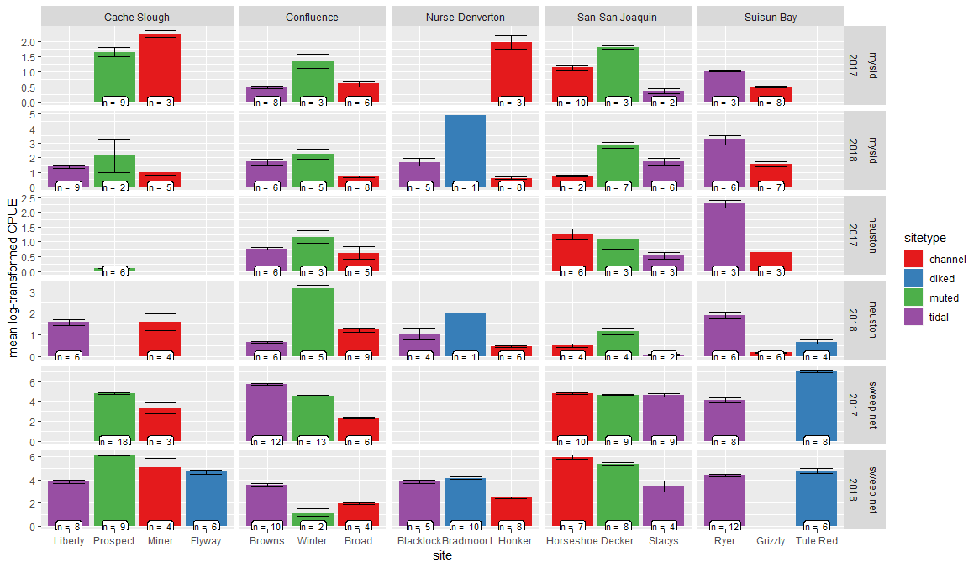

Figure 6 – Log-transformed CPUE of macroinvertebrates collected during the spatially intensive spring sampling events of 2017 and 2018, +/- one standard error. Data are separated by site, year, and gear type.

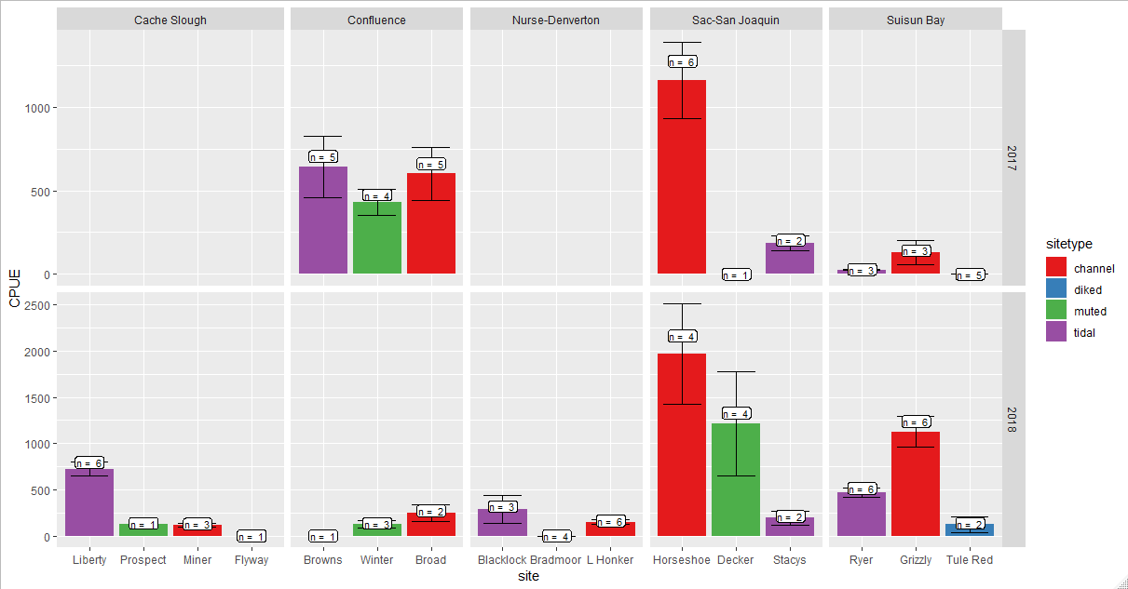

Figure 7 - Catch of clams per square meter of substrate in 2017 and 2018.

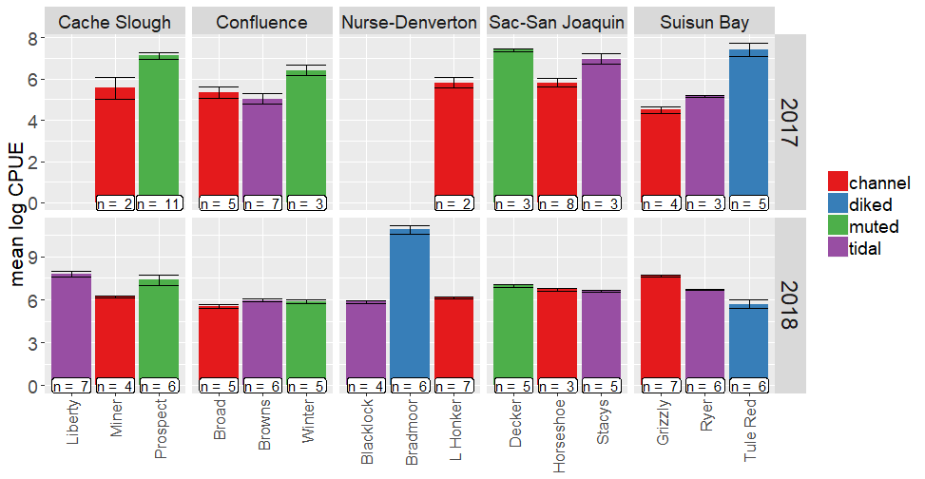

Figure 8 - Mean log-transformed CPUE of zooplankton catch collected during the intensive spring sampling period of 2017 and 2018.



Figure 9 - mean log-transformed concentration of Chlorophyll (ug/L) measured by florescence during spring of 2018.

Table 6 - GLMM for each ecosystem component. Predictor variables were chosen via AICc selection and site was included as an error term in each model. Response variables were log-transformed to conform with model assumptions, where necessary.

|  |  |  |  |  |  |  |
| --- | --- | --- | --- | --- | --- | --- |
| Mysid catch per m3 |  |  |  |  |  |  |
|  | Estimate | Std. Error | DF | t value | P value |  |
| (Intercept: channel, 2017) | 0.737 | 0.207 | 12.371 | 3.561 | 0.004 | ** |
| site type: muted | 1.079 | 0.307 | 9.365 | 3.519 | 0.006 | ** |
| site type: tidal | 0.427 | 0.272 | 9.640 | 1.570 | 0.149 |  |
| Year: 2018 | 0.517 | 0.204 | 122.198 | 2.532 | 0.013 | * |
|  |  |  |  |  |  |  |
| Sweep net catch per m3 |  |  |  |  |  |  |
|  | Estimate | Std. Error | DF | t value | P value |  |
| (Intercept: EAV, channel) | 3.123 | 0.327 | 11.886 | 9.551 | <0.0001 | *** |
| Veg type: FAV | 1.423 | 0.257 | 192.226 | 5.536 | <0.0001 | *** |
| Veg type: SAV | 2.197 | 0.252 | 191.961 | 8.729 | <0.0001 | *** |
| site type: diked | 1.548 | 0.495 | 11.386 | 3.128 | 0.009 | ** |
| site type: muted | 0.890 | 0.471 | 9.432 | 1.891 | 0.090 | . |
| site type: tidal | 0.693 | 0.428 | 10.515 | 1.621 | 0.135 |  |
|  |  |  |  |  |  |  |
| Neuston net catch per m3 |  |  |  |  |  |  |
|  | Estimate | Std. Error | DF | t value | P value |  |
| (Intercept) | 1.056 | 0.193 | 12.040 | 5.482 | <0.0001 | *** |
|  |  |  |  |  |  |  |
| Zooplankton catch per m3 |  |  |  |  |  |  |
|  | Estimate | Std. Error | DF | t value | P value |  |
| (Intercept: Cache, Channel, 2017) | 6.345 | 0.788 | 7.414 | 8.057 | 0.000 | *** |
| Region: Confluence | -1.281 | 0.888 | 6.462 | -1.444 | 0.196 |  |
| Region: Nurse-Denverton | -0.102 | 1.005 | 7.256 | -0.101 | 0.922 |  |
| Region: Sac-San Joaquin | -0.283 | 0.892 | 6.584 | -0.317 | 0.761 |  |
| Region: Suisun Bay | -1.200 | 0.983 | 6.651 | -1.221 | 0.264 |  |
| Site type: diked | 2.560 | 1.009 | 6.623 | 2.537 | 0.041 | * |
| Site type: muted | 0.737 | 0.841 | 6.456 | 0.876 | 0.412 |  |
| Site type: tidal | 0.330 | 0.695 | 6.739 | 0.475 | 0.6501 |  |
| year: 2018 | 0.451 | 0.245 | 124.870 | 1.839 | 0.0682 | . |
|  |  |  |  |  |  |  |
| Clam catch per m2 |  |  |  |  |  |  |
|  | Estimate | Std. Error | DF | t value | P value |  |
| (Intercept: Cache, Channel, 2017) | 4.791 | 1.028 | 23.387 | 4.662 | 0.000 | *** |
| Region: Confluence | -0.225 | 1.071 | 14.446 | -0.210 | 0.837 |  |
| Region: Nurse-Denverton | -1.499 | 1.039 | 12.275 | -1.444 | 0.174 |  |
| Region: Sac-San Joaquin | 0.464 | 1.028 | 11.876 | 0.451 | 0.660 |  |
| Region: Suisun Bay | -0.018 | 0.963 | 9.218 | -0.019 | 0.985 |  |
| Site type: diked | -4.609 | 0.925 | 7.982 | -4.980 | 0.001 | ** |
| Site type: muted | -1.642 | 0.905 | 7.409 | -1.815 | 0.110 |  |
| Site type: tidal | -0.891 | 0.673 | 6.502 | -1.323 | 0.230 |  |
| Year: 2018 | 1.276 | 0.582 | 75.740 | 2.193 | 0.031 | * |
|  |  |  |  |  |  |  |
| Chlorophyll fluorescence in ug/L |  |  |  |  |  |  |
|  | Estimate | Std. Error | DF | t value | P value |  |
| (Intercept: channel) | 1.577 | 0.260 | 12.062 | 6.073 | 0.000 | *** |
| Site type: diked | 1.475 | 0.426 | 12.292 | 3.462 | 0.005 | ** |
| Site type: muted | -0.381 | 0.426 | 12.232 | -0.894 | 0.388 |  |
| Site type: tidal | -0.207 | 0.370 | 12.341 | -0.559 | 0.586 |  |

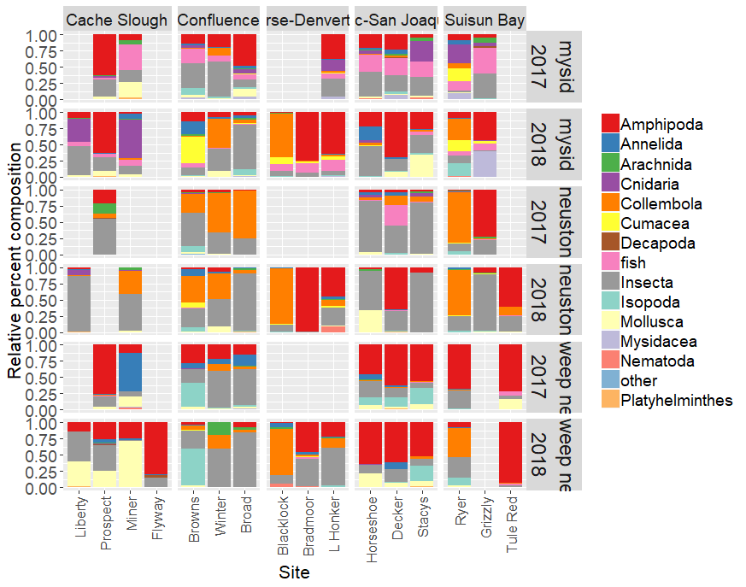

Figure 10. Relative composition of macroinvertebrate samples separated by gear type, site, and year for sampling during the intensive spring sampling period in 2017 and 2018.

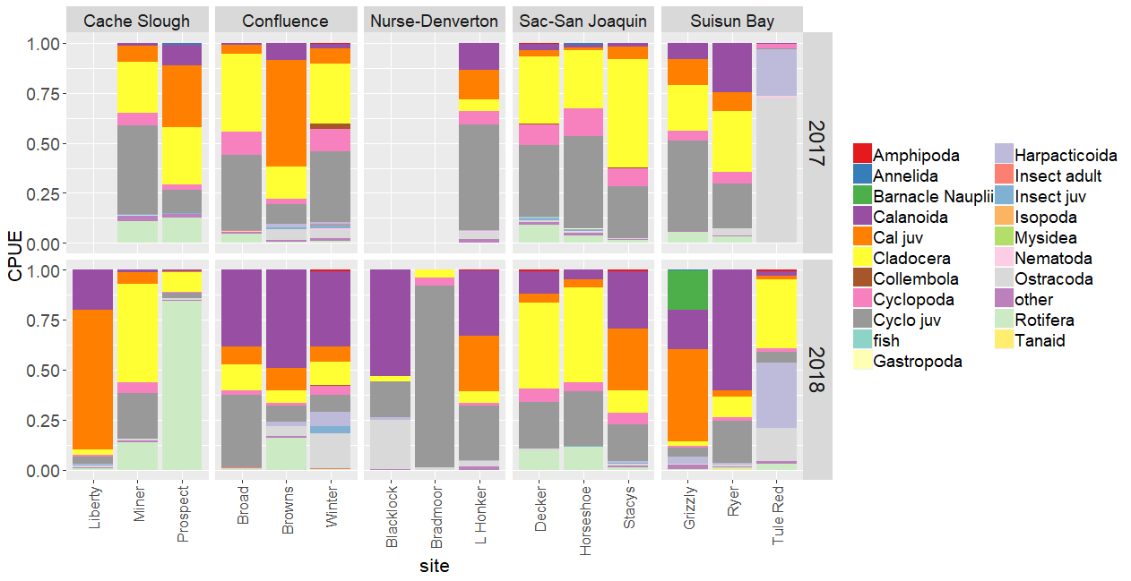

Figure 11 - Relative composition of zooplankton samples separated by site, and year for sampling during the intensive spring sampling period in 2017 and 2018.



Figure - Relative composition of phytoplankton samples separated by site and year for sampling during the intensive spring sampling period in 2017 and 2018.

Table 8 - Multilevel pattern analysis of invertebrate associations with wetlands of differing types.

|  |  |  |  |
| --- | --- | --- | --- |
| **Diked Wetlands** |  |  |  |
|  | **Stat** | **P value** |  |
| *Eogammarus* spp. | 0.361 | 0.001 | *** |
| Dytiscidae | 0.306 | 0.001 | *** |
| Mosquitofish | 0.272 | 0.001 | *** |
| Hydrophilidae | 0.272 | 0.001 | *** |
| Corixidae | 0.259 | 0.001 | *** |
| Threespine Stickleback | 0.244 | 0.001 | *** |
| *Procambarus clarkii* | 0.233 | 0.001 | *** |
| Prickly Sculpin | 0.226 | 0.001 | *** |
| *Americorophium spinicorne* | 0.218 | 0.001 | *** |
| Notonectidae | 0.195 | 0.004 | ** |
| Hydrobiidae | 0.159 | 0.003 | ** |
| Hydroscaphidae | 0.152 | 0.007 | ** |
| Hemiptera Other | 0.137 | 0.041 | * |
|  |  |  |  |
| **Muted Tidal Wetlands** |  |  |  |
|  | **Stat** | **P value** |  |
| Mesoveliidae | 0.259 | 0.001 | *** |
| *Palaemonetes* spp. | 0.203 | 0.002 | ** |
| Hymenoptera adult | 0.168 | 0.015 | * |
| Libellulidae larvae | 0.162 | 0.02 | * |
| Coenagrionidae larvae | 0.157 | 0.016 | * |
| Diptera adult | 0.153 | 0.029 | * |
| *Ferrissia* spp. | 0.146 | 0.034 | * |
| Ceratopogonidae larvae | 0.146 | 0.021 | * |
| Tipulidae larvae | 0.146 | 0.026 | * |
| Vellidae adult | 0.127 | 0.028 | * |
|  |  |  |  |
| **Tidal Wetlands** |  |  |  |
|  | **Stat** | **P value** |  |
| *Gnorimosphaeroma* | 0.22 | 0.001 | *** |
| Collembola | 0.151 | 0.026 | * |
| Tanaidacea | 0.131 | 0.041 | * |



Figure 13 - Mysid NDMS of bray-curtis dissimilarities, stress = 0.2276. Two convergent solutions found after 100 tries.



Figure 14 – NMDS of bray-curtis dissimilarities for neuston tow samples. Stress = 0.122. Two convergent solutions found after 63 tries.



Figure 15 - NMDS of Bray-Curtis dissimilarities for sweep net data (2018 only). Stress = 0.153. Two convergent solutions found fter 624 tries.



Figure 16 - NMDS of of Bray-Curtis dissimilarities for phytoplankton taxa scaling using Bray-Curtis Dissimilarity index. Stress = 0.227. Two convergent solutions after 99 tries.

Table 9 – PerMANOVA of relative percent composition of taxa for each ecosystem component.

|  |  |  |  |  |  |  |  |
| --- | --- | --- | --- | --- | --- | --- | --- |
| **Mysids** |  |  |  |  |  |  |  |
|  | **DF** | **SumsOfSqs** | **MeanSqs** | **F value** | **R2** | **P value** |  |
| Site type | 2 | 2.210 | 1.105 | 5.753 | 0.068 | 0.001 | *** |
| Year | 1 | 0.767 | 0.767 | 3.995 | 0.024 | 0.004 | ** |
| Region | 4 | 3.085 | 0.771 | 4.016 | 0.096 | 0.004 | ** |
| Site | 6 | 3.160 | 0.527 | 2.742 | 0.098 | 0.001 | *** |
| Residuals | 120 | 23.046 | 0.192 |  | 0.714 |  |  |
| Total | 133 | 32.268 |  |  | 1.000 |  |  |
|  |  |  |  |  |  |  |  |
| **Sweepnets** |  |  |  |  |  |  |  |
|  | **DF** | **SumsOfSqs** | **MeanSqs** | **F value** | **R2** | **P value** |  |
| Site type | 3 | 5.022 | 1.674 | 13.546 | 0.121 | 0.001 | *** |
| Year | 1 | 1.210 | 1.210 | 9.789 | 0.029 | 0.001 | *** |
| Vegetation type | 2 | 3.627 | 1.813 | 14.672 | 0.088 | 0.001 | *** |
| Region | 4 | 4.867 | 1.217 | 9.845 | 0.117 | 0.001 | *** |
| Site | 7 | 4.587 | 0.655 | 5.303 | 0.111 | 0.001 | *** |
| Residuals | 179 | 22.122 | 0.124 |  | 0.534 |  |  |
| Total | 196 | 41.436 |  |  | 1.000 |  |  |
|  |  |  |  |  |  |  |  |
| **Neuston** |  |  |  |  |  |  |  |
|  | **DF** | **SumsOfSqs** | **MeanSqs** | **F value** | **R2** | **P value** |  |
| site type | 3 | 2.517 | 0.839 | 6.923 | 0.139 | 0.001 | *** |
| Year | 1 | 0.172 | 0.172 | 1.420 | 0.010 | 0.263 |  |
| Region | 4 | 2.380 | 0.595 | 4.910 | 0.132 | 0.001 | *** |
| Site | 7 | 2.589 | 0.370 | 3.052 | 0.143 | 0.001 | *** |
| Residuals | 86 | 10.422 | 0.121 |  | 0.576 |  |  |
| Total | 101 | 18.079 |  |  | 1.000 |  |  |
|  |  |  |  |  |  |  |  |
| **Zooplankton** |  |  |  |  |  |  |  |
|  | **DF** | **SumsOfSqs** | **MeanSqs** | **F value** | **R2** | **P value** |  |
| Region | 4 | 4.687 | 1.172 | 9.303 | 0.157 | 0.001 | *** |
| Site type | 3 | 4.355 | 1.452 | 11.526 | 0.146 | 0.001 | *** |
| year | 1 | 1.571 | 1.571 | 12.469 | 0.052 | 0.001 | *** |
| site | 7 | 3.951 | 0.564 | 4.481 | 0.132 | 0.001 | *** |
| Residuals | 122 | 15.367 | 0.126 |  | 0.513 |  |  |
| Total | 137 | 29.930 |  |  | 1.000 |  |  |
|  |  |  |  |  |  |  |  |
| **Phytoplankton** |  |  |  |  |  |  |  |
|  | **DF** | **SumsOfSqs** | **MeanSqs** | **F value** | **R2** | **P value** |  |
| Site type | 3 | 5.127 | 1.709 | 7.830 | 0.109 | 0.001 | *** |
| year | 1 | 3.050 | 3.050 | 13.976 | 0.065 | 0.001 | *** |
| Region | 4 | 5.920 | 1.480 | 6.782 | 0.126 | 0.001 | *** |
| site | 7 | 6.510 | 0.930 | 4.262 | 0.138 | 0.001 | *** |
| Residuals | 121 | 26.408 | 0.218 |  | 0.562 |  |  |
| Total | 136 | 47.015 |  |  | 1.000 |  |  |

Table 10 - coefficients of variation for each sample type in each year.

|  |  |  |  |
| --- | --- | --- | --- |
| **Sample Type** | **Year** | **Mean within-site CV** | **Mean between-site CV** |
| benthic | 2017 | 0.826577536 | 1.894361 |
| benthic | 2018 | 1.015171266 | 1.212494 |
| mysid | 2017 | 0.740843281 | 0.922856 |
| mysid | 2018 | 1.367034748 | 1.550785 |
| neuston | 2017 | 0.970689418 | 0.995882 |
| neuston | 2018 | 0.933620472 | 1.445109 |
| sweep net | 2017 | 1.125644042 | 1.47165 |
| sweep net | 2018 | 1.039019521 | 1.416646 |
| zooplankton | 2017 | 0.9318 | 1.4391 |
| zooplankton | 2018 | 0.7345 | 3.2851 |



Figure 17 – CPUE of macroinvertebrates at Decker Island over the course of the spring.

Table 11 - GLMM of log total CPUE of macroinvertebrate samples collected at Decker over the course of the spring of 2017 and 2018. Preliminary analyses found no significant effect of Julian Day unless the interaction term was included.

|  |  |  |  |  |  |
| --- | --- | --- | --- | --- | --- |
| **Factor** | **Estimate** | **Std. Error** | **t value** | **P value** |  |
| (Intercept – mysids, 2017) | 0.284 | 0.481 | 0.591 | 0.557 |  |
| Gear - neuston | -1.174 | 0.351 | -3.343 | 0.002 | ** |
| Gear – EAV sweep net | 2.042 | 0.341 | 5.985 | 0.000 | *** |
| Julian Day | 0.018 | 0.006 | 3.114 | 0.003 | ** |
| Year - 2018 | 2.458 | 0.619 | 3.968 | 0.000 | *** |
| Julian Day *Year | -0.022 | 0.007 | -3.186 | 0.003 | ** |

Table 12 - GLM of log total CPUE of macroinvertebrate samples at Decker. AICc model selection found Sacramento river flow to be a better predictor than Julian Day.

|  |  |  |  |  |  |
| --- | --- | --- | --- | --- | --- |
| **Factor** | **Estimate** | **Std. Error** | **t value** | **P value** |  |
| (Intercept: mysid) | 2.742 | 0.336 | 8.163 | 0.000 | *** |
| Gear: neuston | -1.030 | 0.363 | -2.836 | 0.007 | ** |
| Gear: sweep net | 1.960 | 0.358 | 5.484 | 0.000 | *** |
| Saramento River Flow (CFS) | -1.816E-05 | 5.501E-06 | -3.302 | 0.002 | ** |

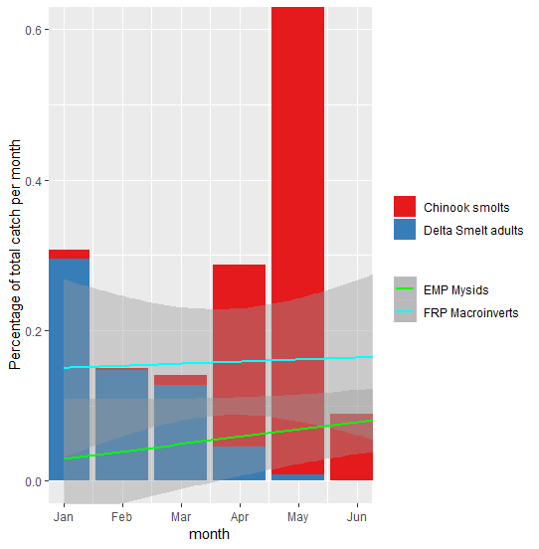

Figure 18 - Distribution of catch per month for adult Delta Smelt (SKT survey, 2002-2018), Chinook Salmon smolts (chipps island survey, 2002-2018) and macroinvertebrates at Decker Island (FRP data, 2017-2018)

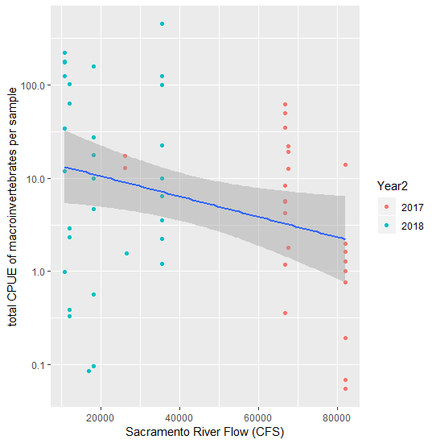

Figure 19 - Macroinvertebrate catch versus Sacramento River flow (CFS) for samples collected at Decker Island in spring of 2017 and 2018. Flow from CDWR’s Dayflow calculations.



Figure 20 - Mean log-transformed CPUE of mysid and sweep net samples in the fall versus spring of 2018. +/- 1 SEM.

Table 13 - GLMM of log-transformed CPUE of invertebrates collected during the spring sampling period versus the fall sampling period.

|  |  |  |  |  |  |
| --- | --- | --- | --- | --- | --- |
| **Factor** | **Estimate** | **Std. Error** | **t value** | **P value** |  |
| (Intercept – mysid, Ryer, spring) | 1.563 | 0.528 | 2.959 | 0.004 | ** |
| Site: Browns | -0.999 | 0.589 | -1.698 | 0.093 | . |
| Site: Winter | -1.157 | 0.674 | -1.718 | 0.090 | . |
| Site: Prospect | 1.748 | 0.630 | 2.775 | 0.007 | ** |
| Gear: sweep net | 4.250 | 0.470 | 9.037 | <0.0001 | *** |
| Season: fall | 0.471 | 0.466 | 1.011 | 0.315 |  |

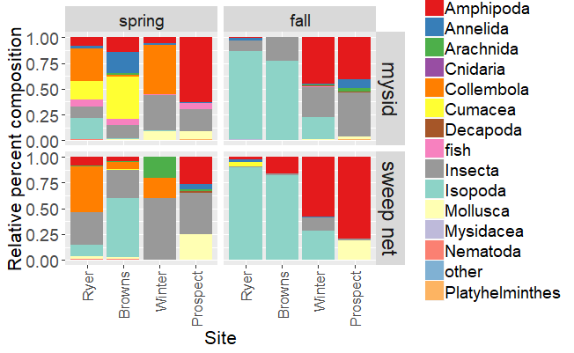

Figure 21 - relative percent composition of spring verses fall macroinvertebrates.

Table 14 - PerMANOVA comparing site, geartype, and season for macroinvertebrate samplig in 2018

|  |  |  |  |  |  |  |  |
| --- | --- | --- | --- | --- | --- | --- | --- |
| **Factor** | **DF** | **SumsOfSqs** | **MeanSqs** | **F value** | **R2** | **P value** |  |
| Site | 3 | 5.6911 | 1.897 | 11.1194 | 0.24275 | 0.001 | *** |
| Gear | 1 | 0.7332 | 0.7332 | 4.2978 | 0.03128 | 0.002 | ** |
| season | 1 | 3.2007 | 3.2007 | 18.7607 | 0.13652 | 0.001 | *** |
| Residuals | 81 | 13.8191 | 0.1706 |  | 0.58945 |  |  |
| Total | 86 | 23.4442 |  |  | 1 |  |  |

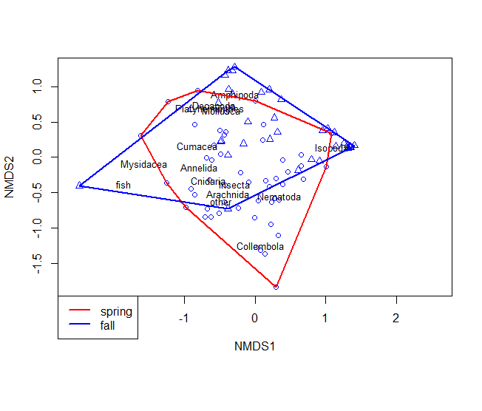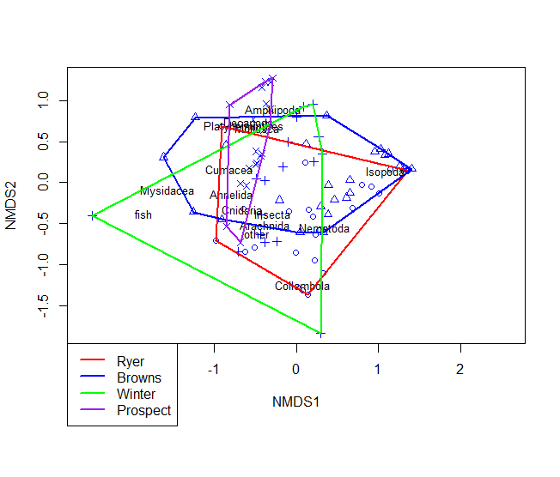

Figure 22. NMDS plot of Bray-Curtis dissimilarity indices of community composition of invertebrate data. Stress = 0.182, two convergent solutions found after 50 tries. With A) Hulls are drawn around samples from spring versus fall. and B) Hulls drawn around samples from different sites.

## Discussion

### Inter-annual differences

There were some differences in invertebrate and phytoplankton communities in 2018 versus 2017, most likely driven by the difference in water flow. There was significantly higher catch overall in mysid nets and benthic cores during the intensive spring sampling event (Table 6), and most ecosystem components also had significantly different community compositions (Table 8). The data from Decker Island provides a potential explanation for this difference. While there was a pattern of increased catch over the course of the spring in 2017, there was no similar increase in 2018, and the total catch was highly correlated with flow in the Sacramento River (Figure 18). Flow during 2017 was much higher than 2018 throughout the spring, and high river flows may serve to dilute existing productivity, while short residence times and cooler temperatures may slow growth of phytoplankton and zooplankton (Downing et al. 2016; Glibert et al. 2014). This pattern has been described many times throughout the estuary, though it is dependent on the study species and region (Cloern et al. 2010; Kimmerer 2002; Kimmerer et al. 2018b; Sommer et al. 2004).

Overall, a greater proportion of the macroinvertebrate catch was larval fish and amphipods in 2017, whereas more cumaceans and isopods were caught in 2018 (Figure 9), but the differences in community composition tended to describe a small proportion of the variance (less than 10%, Table 8). This is similar to research by Howe et al (Howe et al. 2014), who also found sampling year to describe around 5% of variation in invertebrate communities. Broad-scale classification of benthic invertebrates also show communities tend to be fairly similar year-to-year, with greater differences between geographic regions or substrate types (Thompson et al. 2013). We will be able to make a more substantial analysis of the sources of year-to-year variation once more years of data have been collected.

### Differences between site types

Total catch of macroinvertebrates and chlorophyll was higher in diked wetlands than any other site type (Figure 6, Table 6), though diked wetlands also had significantly lower clam abundance than channel habitat (Table 6). Similar to inter-annual differences in catch, the difference in total catch of between site types may also be explained by water residence times. Diked wetlands, with long residence times, have ample opportunity to grow large standing stocks of organic material, phytoplankton, and zooplankton, though extremely long residence times may deplete nutrients (Brown et al. 2016; Herbold et al. 2014), and low dissolved oxygen conditions may dominate during the summer and fall (Moyle et al. 2014). Similar patterns of increased chlorophyll in disconnected wetlands have also been found in floodplains in the region (Ahearn et al. 2006). Despite the high concentrations of phytoplankton and zooplankton, production in diked wetlands may not benefit pelagic fish species if fish are excluded from the site. Export of production from the site only occurs when the site is being drained, usually over the span of a week or two during the spring (Moyle et al. 2014). Also, even though chlorophyll concentrations in diked wetlands were high relative to other site types, they were still less than the 10 ug/L considered necessary for high zooplankton production (Brown et al. 2016).

Tidal and muted-tidal wetlands have also demonstrated greater concentrations of organic material and chlorophyll than open-water sites in other studies (Lehman et al. 2015; Muller-Solger et al. 2002; Strong 2015), however, in many tidal systems benthic grazing may deplete phytoplankton biomass (Lucas and Thompson 2012). In our study, diked wetlands had high abundance of invertebrates and high concentrations of chlorophyll, but also the lowest abundance of invasive clams in benthic samples (Figure 7). Therefore, the high chlorophyll content is likely a combination of high productivity and low benthic grazing rates. We did not see higher invertebrate abundance in tidal wetlands than diked wetlands or channel habitat, in contrast to results from 2017 (Contreras et al. 2018). This may be because the data were more variable in 2018 than 2017 (Table 11), making it more difficult to see trends, or it may be due to inter-annual differences in weather and hydrology (as seen in Cloern et al. 2010). More years of data may better elucidate these trends.

Wetlands also had significantly different community composition from the channel habitat. Zooplankton communities were very unusual at the diked wetland of Tule Red in particular, where large numbers of ostracods and harpacticoid copepods dominated the samples. Harpacticoid copepods occur occasionally in Delta Smelt diets (Slater and Baxter 2014), and may more common in the diets of other fishes (Howe et al. 2014), but are not consumed as frequently as calanoid copepods. Ostracods are also rare in smelt diets, but may occur in salmon diets in greater frequency than in the surrounding habitat (Katz et al. 2017). Diked wetlands, also had a greater relative abundance of amphipods than other sites, while tidal wetlands had a greater relative abundance of collembola and isopods. Amphipods and isopods are generally epibenthic or epiphytic, and while they occur less frequently in smelt diets than copepods, they are increasing in dietary importance (Brown et al. 2016; Slater and Baxter 2014). Collembola and isopods are found frequently in salmon diets, and Collembola, along with other terrestrial fall-out invertebrates, may be a significant portion of salmon diets (David et al. 2016a; David et al. 2016b).

The phytoplankton communities were also unique in diked wetlands. While most tidal and channel habitats had large proportions of pennate and centric diatoms, diked wetlands had more variable communities, including some samples with large numbers of dinoflagellates (see Bradmoor in 2018), or chrysophytes (see Tule Red in 2017). The large proportion of diatoms in all the samples was somewhat unexpected, since the relative concentration and absolute abundance of diatoms has been in decline since the introduction of the invasive clam, *Potamocorbula*, in the 1980s (Lehman 2000; Winder and Jassby 2011). Dinoflagellates, chrysophytes, and cyanobacteria that dominated diked wetlands are not thought to be preferred zooplankton food (Kimmerer et al. 2018a), though there is insufficient research on zooplankton feeding.

The large number of indicator macroinvertebrate species identified for diked wetlands most likely resulted from the lack of connection to the surrounding area and difference in water quality components. Diked wetlands may experience low dissolved oxygen conditions, larger swings in temperatures, and lower pH than surrounding tidal waters (Brown et al. 2016; Moyle et al. 2013). Therefore, taxa that thrive in tidal may not be able to thrive in impounded water and vise versa. Tidal wetlands share a direct connection with the surrounding sloughs, so only two taxa were identified as indicators.

### Intra-annual differences

#### Timing of spring sampling

During 2017, total macroinvertebrate biomass increased monotonically over the course of the spring. This trend led us to select April as the month with the greatest overlap between adult Delta Smelt, juvenile Chinook Salmon, and macroinvertebrates (Contreras et al. 2018). However, in 2018 we found the opposite trend between day of year and invertebrate abundance, with a slight decrease over the course of the spring (Table 10). AICc model selection indicated that flow in the Sacramento River was a better predictor than Julian Day when data from both years were analyzed together (Table 11). There was a clear trend towards lower invertebrate biomass during high flows (Figure 16). As noted above, many studies have seen a similar inverse relationship between invertebrate abundance and flow (Kimmerer 2002; Kimmerer et al. 2018b; Sommer et al. 2004). While flow did decrease over the course of the spring in 2018, the maximum flows were never as high as in 2017 (Figure 19), so the slight decreasing trend in invertebrate abundance is most likely an artifact of the high variability of invertebrate biomass.

Besides the differences in flow, some of the difference in invertebrate catch may have been due to the presence or absence of aquatic vegetation in the samples. We specifically excluded SAV sweep nets from the analysis because they were not collected in all months, and SAV sweep nets tended to have an order of magnitude higher catch than some of the other gear types (Figure 6), and many researchers have found similar high invertebrate productivity in SAV (Boyer et al. 2013; Young et al. 2018). However, the mysid net and neuston net would also occasionally hit patches of aquatic vegetation, resulting in much higher total invertebrate CPUE. We did not collect quantitative data on abundance of vegetation in 2017 or 2018, but it has been added to our sampling plan in 2019 and 2020 to attempt to refine this problem.

Other researchers with larger data sets support an increase in overall abundance over the course of the spring, similar to our results in 2017. The IEP Zooplankton Study shows an overall increase in zooplankton and macroinvertebrate abundance during the spring, peaking in July (Figure 17) (Hennessy and Enderlein 2013). Studies of floodplains and wetland habitat also show increases in abundance of zooplankton during the spring, and associated with lower flows (Sommer et al. 2004). Even benthic and drift invertebrates often have summer peaks in abundance (Howe et al. 2014). Therefore, negative trend for macroinvertebrate abundance in 2018 is most likely anomalous.

Fish trends are complicated. Salmon smolt abundance in the Delta usually peaks in May (Brandes and McLain 2000), but number of fry versus smolts depends on water year type. Total production of juvenile salmonids is higher in wet years, but more of them enter the estuary as fry rather than smolts, and may move through the Delta faster (Brandes and McLain 2000). Juvenile survival is also higher in wet years versus dry years, especially along the Sacramento River(Michel et al. 2015). However, higher survival may be because smolts move quickly down the channelized river, exposing themselves to less predation but also spending less time in wetlands. Invertebrate production in 2017 was low during the high flows in January and February, but by the time salmon outmigration peaked in May, invertebrate production had increased and was similar to 2018 (Figure 19).

The complicated relationship between invertebrate biomass, time of year, and flow, warrants more investigation. We only planned a single spring sampling event in 2019 because we had not analyzed the 2018 data before developing our workplan. We expected 2018 data to be similar to 2017, with increasing biomass over the course of the spring. Given the difference in temporal trends between 2017 and 2018, we are planning to repeat the series of four sampling events in 2020.

#### Spring versus fall

Overall invertebrate abundance was similar in spring and fall, but the species composition was significantly different. High abundances of collembola and cumaceans in spring were replaced by isopods in the fall, though insects and amphipods remained abundant throughout. These differences in invertebrate composition may result in different use of wetland invertebrates by different life stages of at-risk fishes.

Fall invertebrate abundance is particularly important for rearing Delta Smelt, since fall food resources have been identified as a limiting factor in population growth (Brown et al. 2014). We found amphipods and isopods to be especially abundant in the fall (Figure 21), and Delta Smelt diet studies found higher rates of consumption of amphipods in late summer and fall versus spring (Slater and Baxter 2014). Rearing Delta Smelt are most common in the Low Salinity Zone (1-6 PSU), which is geographically located in Suisun or the Confluence region in the fall, depending on water flow (Brown et al. 2014). However, the high abundance of the invasive clam *Potamocorbula amurensis* in Suisun means zooplankton abundance is generally low (Kimmerer and Lougee 2015). Therefore, wetlands, and wetland-derived invertebrates (such as amphipods) may be particularly important to Delta Smelt when in this region (as suggested by Hammock et al. 2019).

Total juvenile salmon abundance and biomass peaks in the spring, generally Mar-June, however spring out-migrants are mostly fall-run Chinook. Late-fall run, winter-run, and some spring-run Chinook smolts out-migrate November-April, so may be accessing the isopods, insects, and amphipods common in wetlands during the fall. (Yoshiyama et al. 1998). Chinook diets will shift rapidly based on the prey available in the surrounding environment, and they can consume large numbers of insects, amphipods, collembola, and isopods (Busby and Barnhart 1995; Duffy et al. 2010; Goertler et al. 2018). Insects and amphipods, in particular, are more energy-dense than zooplankton (Duffy et al. 2010; Tiffan et al. 2014), so provide valuable food resources for fish large enough to eat them.

### A note on neuston:

In 2017, we combined data from neuston tows with data from mysids tows and sweep nets to test for differences between site types. Power analysis showed poor ability for CPUE of neuston tows to differentiate between site types or regions even at increased sample size (Contreras et al. 2018). This year, we decided to conduct separate analyses on each sampling type, and the GLMM of neuston tow data failed to find any differences between years, regions, or site types (Table 6). However, neuston tows were able to show differences in community composition between site types in both 2017 and 2018. Fall-out invertebrates and terrestrial drift invertebrates have been identified as important components of salmon diets (David et al. 2014; Duffy et al. 2010), so while neuston tows may not be the most effective means of differentiating between restoration sites and surrounding channels, they may still be important in assessing availability of surface invertebrates for fish diets.

# Part 2: Channel-Shoal Gear Comparison

## Introduction

### Nutrients

### Zooplankton

Mesozooplankton are recognized as the largest component of Delta Smelt diets (Slater and Baxter 2014) and a significant component of salmon diets (Sommer et al. 2001). Our conceptual models postulate that tidal wetland restoration sites will have higher production and availability of zooplankton when compared with existing channel habitat and pre-project conditions (Hartman et al. 2017a). In order to support this hypothesis, we must compare zooplankton we collect within the wetland to zooplankton collected from the channels. We will leverage existing datasets from long-term monitoring programs currently sampling pelagic and channel habitat whenever possible, but we need a better understanding of how these samples compare to samples taken concurrently from adjacent wetlands. Water depth, substrate, presence of vegetation, presence of benthic grazers (clams), and differences in fish community may alter the zooplankton community (Bollens et al. 2014; Kimmerer and Thompson 2014). Furthermore, changes to the physical environment will affect the efficiency of our sampling gear.

By sampling wetlands concurrently with existing channel sampling, we can characterize some of these sources of variation. During Phase III sampling we conducted sampling of wetland habitat adjacent to eight of the long-term stations sampled by 20mm, however the extremely high water year of 2017 meant that results from that study may not be applicable to all years. Therefore, we repeated our channel-shallow comparisons using stations sampled by either 20mm, FMWT, or the Environmental Monitoring Program (EMP) (see Table 14). We tested for differences in mesozooplankton, macrozooplankton (mysids), and nutrients between channel habitats in which IEP samples and the shallow littoral habitats in which we sample. This will also give us a better understanding of the spatial variability in zooplankton in wetlands across the estuary.

Mesozooplankton questions:

1. How do mesozooplankton and macrozooplankton communities in the littoral and wetland habitat compare to open water habitat?
2. How do these communities change over the course of the year?
3. How do these communities change along the salinity gradient?

Nutrient questions:

1. Are there differences in nutrients, chlorophyll, and organic carbon concentrations between the wetland and the exterior channel?
2. Are nutrients limiting phytoplankton production?
3. Are excess nutrients a causal factor for harmful algal blooms on our sites?

### Fish

The extent to which at-risk fish species will benefit from tidal wetland restoration in the San Francisco Estuary is unknown (Brown 2003; Herbold et al. 2014). However, restored wetlands in other areas have shown to be productive food sources and provide refuge from predation (Gray et al. 2002; Shreffler et al. 1992; Simenstad and Cordell 2000). The FRP Monitoring Team was established to monitor the benefits of tidal wetland restoration to at-risk fish species in the San Francisco Estuary. Comparing fish communities and their condition pre- and post-construction can inform how at-risk fish benefit from tidal wetland restoration.

Littoral habitat provides benefits to at-risk fish species, such as salmon, which rear in littoral areas, and Delta Smelt, which inhabit the littoral zone to maintain their position during ebb tides when migrating (Bennett and Burau 2015; McLain and Castillo 2009). However, many of CDFW’s long term monitoring studies sample open water habitat due to gear size, boat size, and absence of vegetation. Sampling littoral and open water habitat simultaneously can provide insights into how fish species utilize different habitats. FRP sampled littoral habitat near planned tidal wetlands concurrently with mid-channel sampling by the IEP Summer Townet and Fall Midwater Trawl surveys.

## Methods

### IEP Surveys

The EMP survey monitors water quality, phytoplankton, meso-/marco-zooplankton, and benthic invertebrates in the upper estuary throughout the year. Zooplankton is collected using a steel sled with paired mesozooplankton (0.160 mm mesh) and macrozooplankton (0.500 mm mesh) nets. Phytoplankton is sampled using water collected from submersible pump.

The 20mm Survey monitors Delta Smelt distribution throughout their historical spring range in the Sacramento-San Joaquin Delta and San Francisco Estuary during the spring. The 20mm survey targets Delta Smelt in the post-larval and juvenile life stage, at lengths >20mm. The net is a cone shaped plankton net 5.1 meters in length with an opening circumference of 4.9 meters (1.5 cubic meters). Zooplankton is collected concurrently with a 0.160 mm mesh modified Clarke-Bumpus net mounted on the frame with its own flowmeter. The survey samples at 40 stations throughout the estuary and completes three 10-minute tows at each station. Zooplankton are only sampled at the first of these tows (Damon, 2015).

The Summer Townet Survey ….

The FMWT survey was designed to study Striped Bass distribution throughout the upper estuary, but has since become an integral part of monitoring Delta Smelt and Longfin Smelt distribution and abundance during the fall. DESCRIBE FMWT HERE!

Beginning in 2010, meso- and macro-zooplankton sampling was added at 32 of the 122 regular FMWT fish sampling sites. Zooplankton is collected after fish trawling is complete, using a same sized EMP steel sled with paired mesozooplankton (0.160 mm mesh) and macrozooplankton (0.500 mm mesh) nets. We will sample near five EMP sites, five 20mm sites, two FMWT sites, in adjacent tidal channels or fringing marsh (Table 5, Figure 8), using a paired mysid and zooplankton net as described in Chapter I (Figure 6). These sampling sites were chosen based on their proximity to future FRP restoration sites or comparison wetlands. Thus, we will be able to use these stations to establish a pre-project baseline for zooplankton production, and determine to what extent the effect of restoration is detectable in nearby long-term survey monitoring. Note that while we will discontinue the 2017 macroinvertebrate sampling in Lindsey Slough, we will continue to survey zooplankton alongside 20mm to increase our power to compare data between years.

### FRP Sampling

#### Zooplankton

FRP gear and methods are easily comparable to IEP’s methods. The most important difference is our gear was trawled at the surface of the water for five minutes instead of ten minutes, to reduce potential for take of listed fishes. Where tidal channels or marsh habitat was too short to take a full five-minute tow, the tow time was reduced. In some cases, the gear was held in the mouth of a tidal channel to sample water flowing out of the channel on an ebb tide instead of being trawled.

We sampled monthly from March-June and September - December, in wetlands nearby the long-term surveys as close to the same time as possible. When it was not possible to sample at the same time as the long-term surveys, we sampled the following day at the same point in the tidal cycle.

#### Nutrients

Nutrient sampling methods followed methods used by EMP as closely as possible. At each FRP sampling site, we collected two to three nutrient samples from three different sampling locations:

1. Deep within the wetland as possible, where the water will have the greatest influence from the wetland and least influence from the channel (when possible);
2. At breach/outlet of the site where water is actively moving in or out of the site, or the location of the future breach at pre=restoration sites; and
3. Approximately 100 m outside the site, where we expect some influence of the wetland on water quality in the surrounding channel.

At Tule Red it was infeasible to sample within the wetland on the same date as exterior samples, so only exterior samples were collected.

For each sample we collected two liters of water from just below the surface and transported them back to the lab on ice. We measured chlorophyll florescence from 10 cm below the water’s surface using a YSI 6600 sonde.

In the laboratory, we processed the water as required by DWR’s Bryte laboratory (Wong 2012). For dissolved nutrient samples, we filtered 200 mL water using a 0.45 micron nitrocellulose membrane filter and saved the filtrate on ice; for total nutrients, we filled the sample bottle with unfiltered water and placed the sample on ice. We collected one chlorophyll sample per day to calibrate chlorophyll florescence readings. For each chlorophyll sample, we collected one liter of surface water and transported the water to the lab. In the lab, we filtered 500 mL of water onto a 0.7 micron GF/F glass fiber filter and froze the sample immediately.

#### Fish

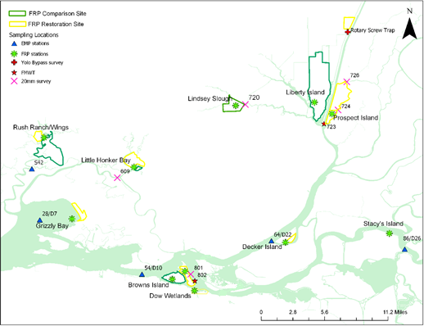

Figure 23. Zooplankton sampling stations. We collected zooplankton, macroinvertebrates, and nutrients samples from shallow wetland habitats (green stars) in proximity to established 20mm sampling sites (pink Xs), established FMWT zooplankton sites (red stars), and EMP sites (blue triangles).

Table 15. Sample numbers for meso- and macro-zooplankton trawls and nutrient samples taken concurrently with other monitoring programs.

|  |  |  |  |  |  |  |  |  |
| --- | --- | --- | --- | --- | --- | --- | --- | --- |
| **Survey** | **Months** | | **FRP Site** | **Long Term Site** | **Mysid Trawl** | **Zoop Trawl** | **Nutrient Water Sample** | **Total** |
| 20mm | March-June | | Little Honker/Blacklock | 609 | 4 | 4 | 24 | 32 |
| 20mm | March-June | | Lindsey Slough | 720 | 4 | 4 | 12 | 20 |
| 20mm | March-June | | Prospect Island | 724 | 4 | 4 | 12 | 20 |
| 20mm | March-June | | Liberty Island | 723 | 4 | 4 | 12 | 20 |
| 20mm | March-June | | Winter, Dow | 801 | 8 | 8 | 24 | 40 |
| FMWT | Sept-Dec | | Prospect, Liberty | 723 | 8 | 8 | 24 | 40 |
| FMWT | Sept-Dec | | Winter, Dow | 802 | 8 | 8 | 24 | 40 |
| EMP | March-Dec | | Grizzly Bay | 28/D7 | 8 | 8 | 16 | 32 |
| EMP | March-Dec | | Rush Ranch/Wings | S42 | 8 | 8 | 24 | 40 |
| EMP | March-Dec | | Decker Island | 64/D22 | 8 | 8 | 24 | 40 |
| EMP | March-Dec | | Stacy’s Island | 86/D26 | 8 | 8 | 24 | 40 |
| EMP | Sept-Dec | | Browns | 54/D10 | 4 | 4 | 12 | 20 |
|  |  | Total | |  | 76 | 76 | 232 | 384 |

### Lab Methods

Zooplankton were processed using similar methods to IEP’s 20mm Survey, FMWT survey and EMP survey. In brief:

All samples were filtered and washed in a 0.150 mm mesh sieve. Filtered zooplankton were diluted to a set volume depending on the concentration of zooplankton and/or detritus. One mL subsamples were placed on a Sedgewick-Rafter cell glass slide. All organisms were identified to the taxonomic resolution identified in Table 3. At least 5 slides, but no more than 20 slides were processed for each sample, targeting 400 organisms. This subsample was then extrapolated to calculate the total number of organisms in the sample in individuals per cubic meter of water sampled.

Most samples were processed by a trained Senior Laboratory Assistant (SLA) at the CDFW office in Stockton, California. A subset of samples had identifications checked by a second SLA or Environmental Scientist for quality assurance. Some samples were processed by EcoAnalysists, Inc (Moscow, ID).

Macrozooplankton will be processed using the same methods as described in Chapter 1. Because the FMWT survey and EMP survey only enumerate mysids and amphipods in their samples, we could only compare catches of these taxa, and use catch of other taxa for separate analyses of spatial variability.

Nutrient samples are processed at DWR’s Bryte laboratory using standard methods (Wong 2012).

### Analysis

As of July, 2019, processing of FRP zooplankton, FMWT mysids and zooplankton, and 20mm survey zooplankton was not complete. Therefore, we will not present analysis of that data at this time. The 2018 data will be presented along with a full analysis of 2017 data when sample processing is complete.

To test differences in nutrients and carbon between the wetland and the channel, we graphed chlorophyll, nutrients, and organic carbon versus sampling location (inside, breach, outside, far outside), over time at each site. A generalized linear model will be attempt compare these values statistically, but it is unlikely any detection will occur with one year of data. To determine whether nutrients are limiting phytoplankton production, we will compare nutrient and chlorophyll concentrations in the wetland to published literature values for nutrient concentrations and ratios in the Delta. A GLM of all the chlorophyll and nitrogen data will be best modeled by a parabolic curve or show a threshold of chlorophyll above which nitrogen decreases. To answer causal factors for algal blooms, we will compare visual reports of *Microcystis* and other cyanobacteria with nitrogen concentrations.

Table 16. Predictor variables for models of spatial and intra-annual variation in zooplankton catch and biomass

|  |  |  |
| --- | --- | --- |
| **Variable** | **Variable type** | **Description** |
| Julian day | Continuous | Day of year sample was collected |
| Collection group | Categorical | EMP, 20mm survey, FMWT survey, or FRP survey |
| Habitat type | Categorical | Deep channel, tidal channel, or shoals. |
| Distance from GG | Continuous | Distance from the Golden Gate, in Km. |

This work will help us determine the future level of replication necessary to support assessment of restoration project goals. Data used to answer our questions on timing and replication of samples will also provide pre-project data for evaluating the food web benefits of restoration sites.

## Results

Dissolved nitrate + nitrite

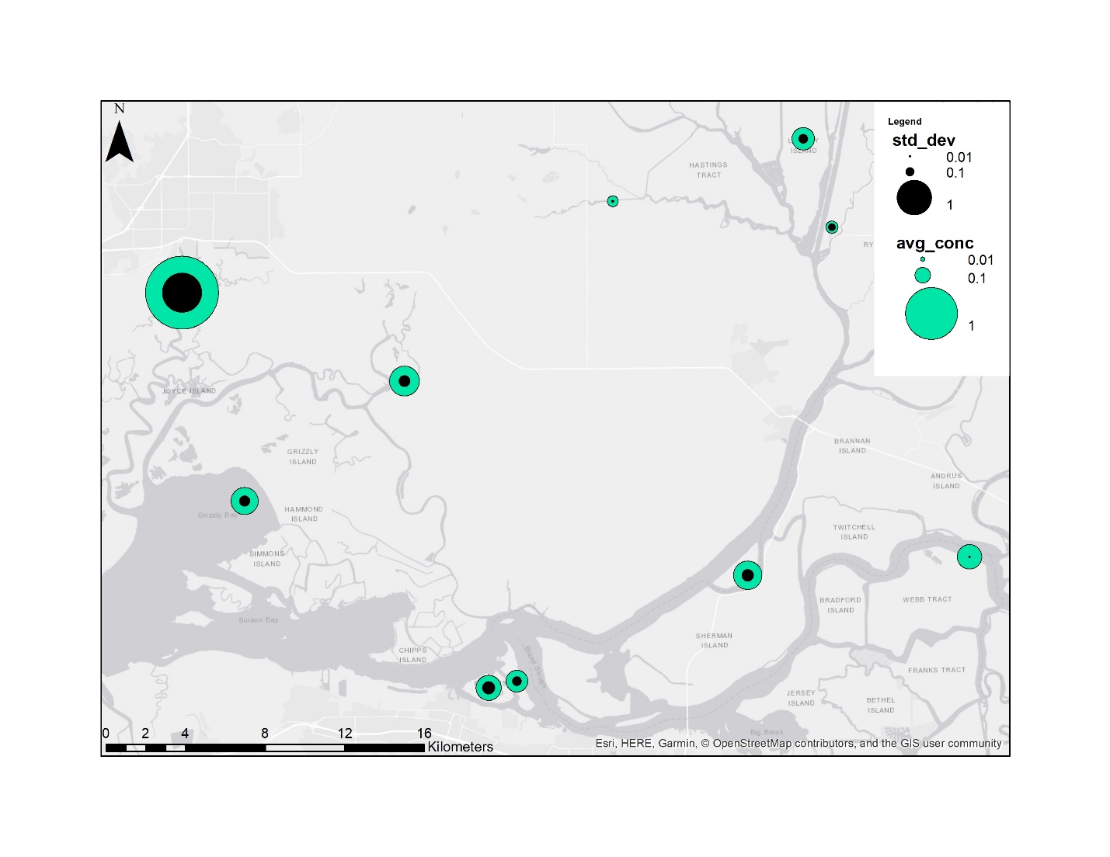

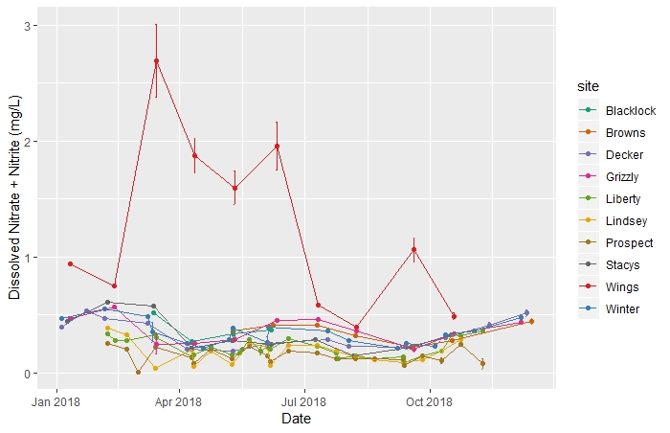

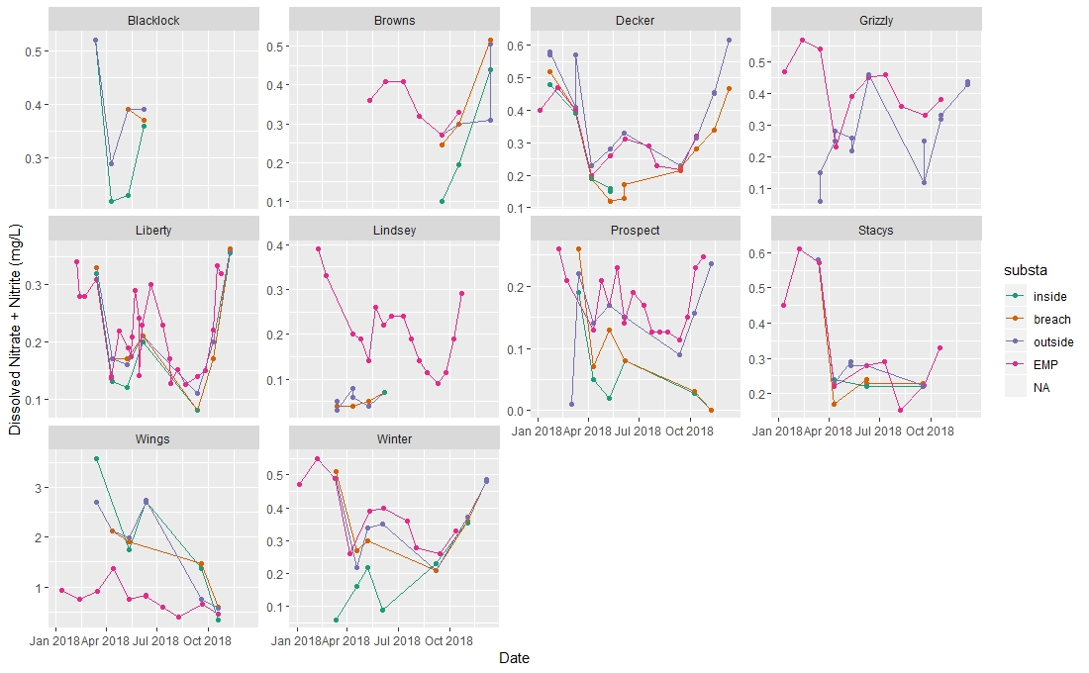

Dissolved ammonia

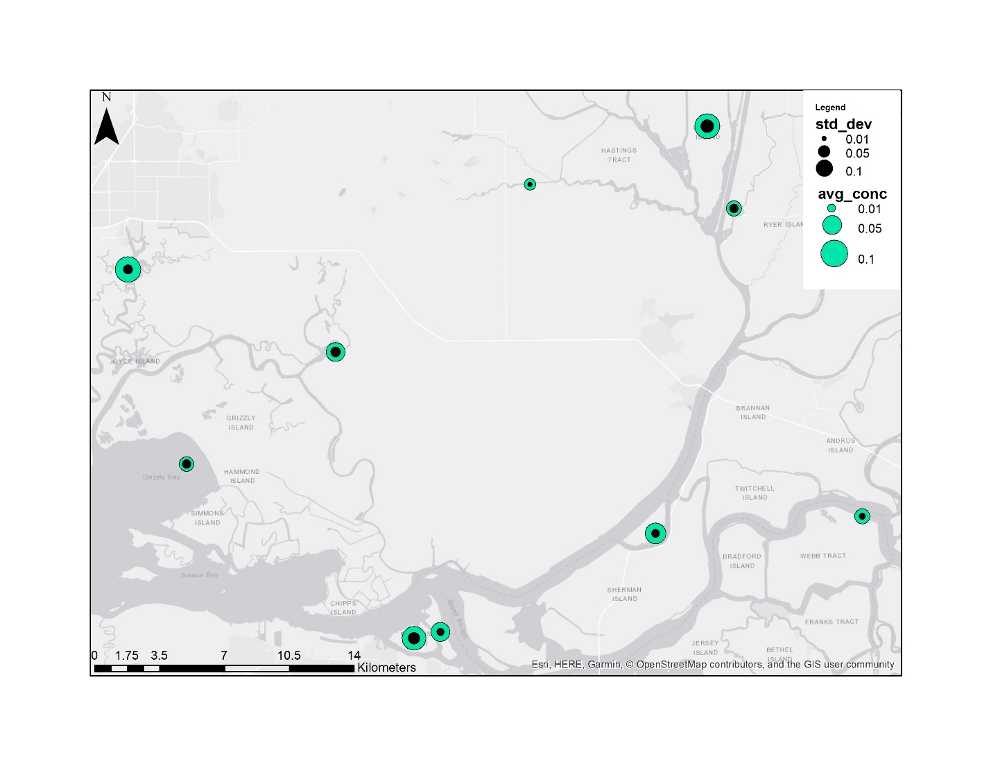

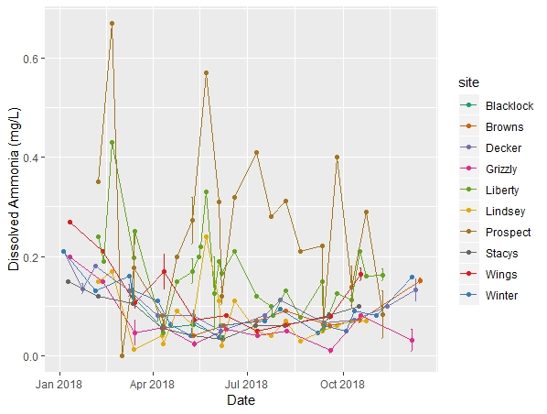

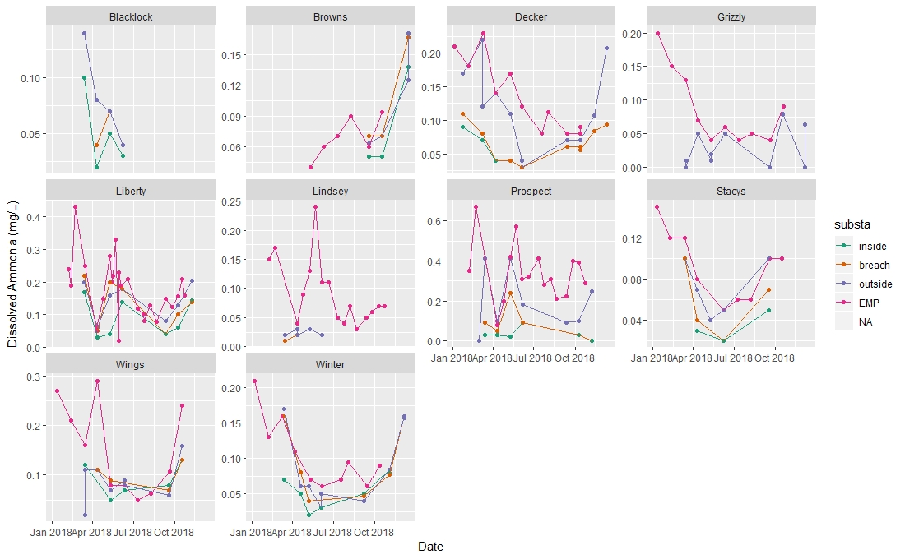

YSI chlorophyll

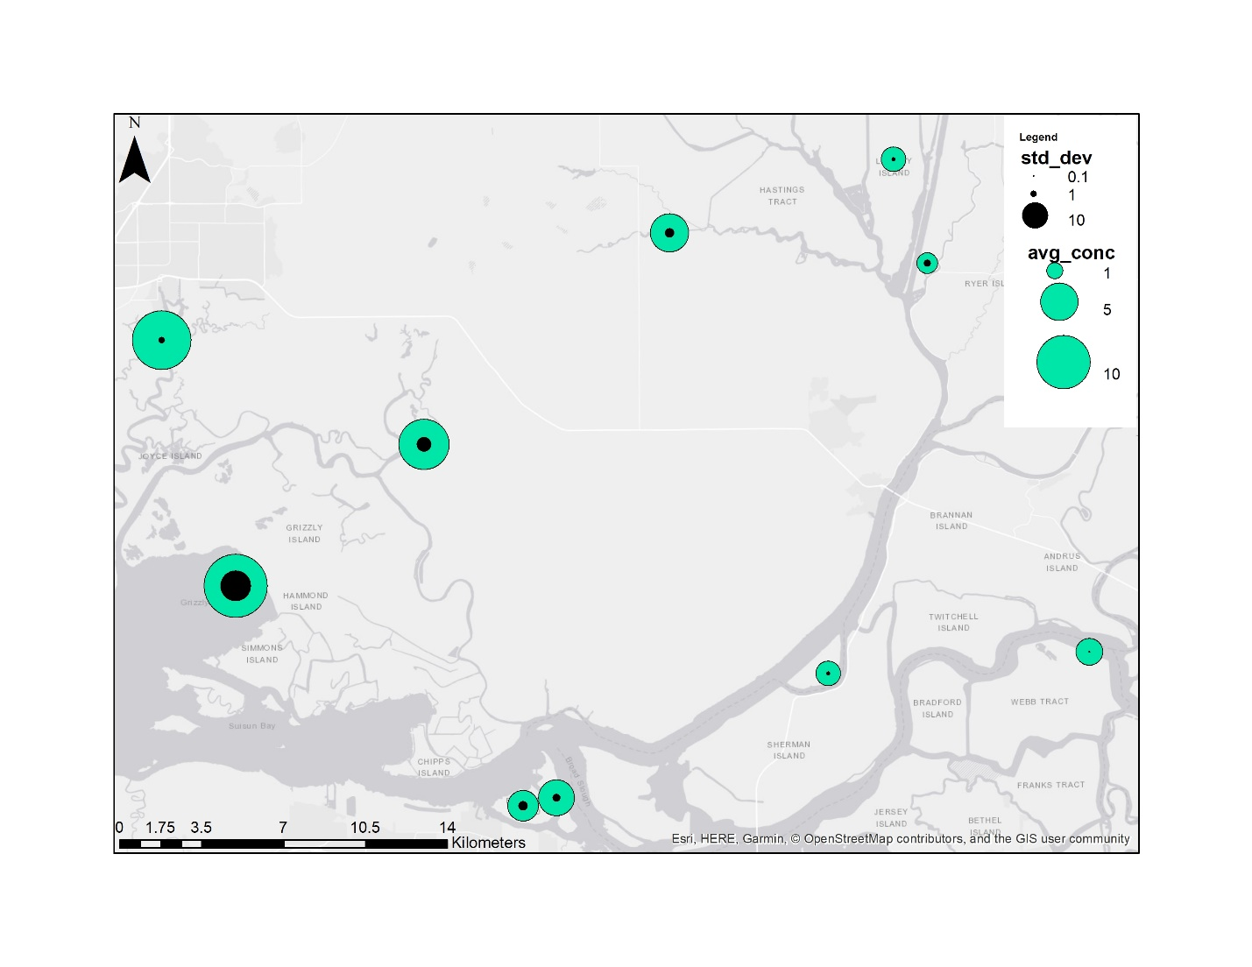

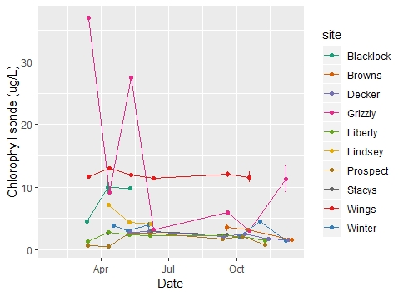

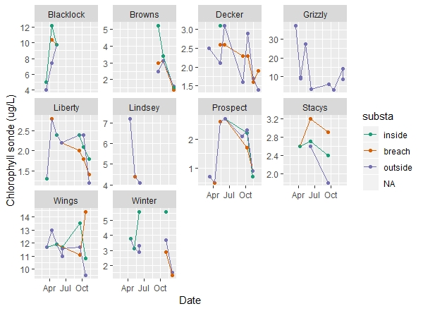

Chlorophyll a

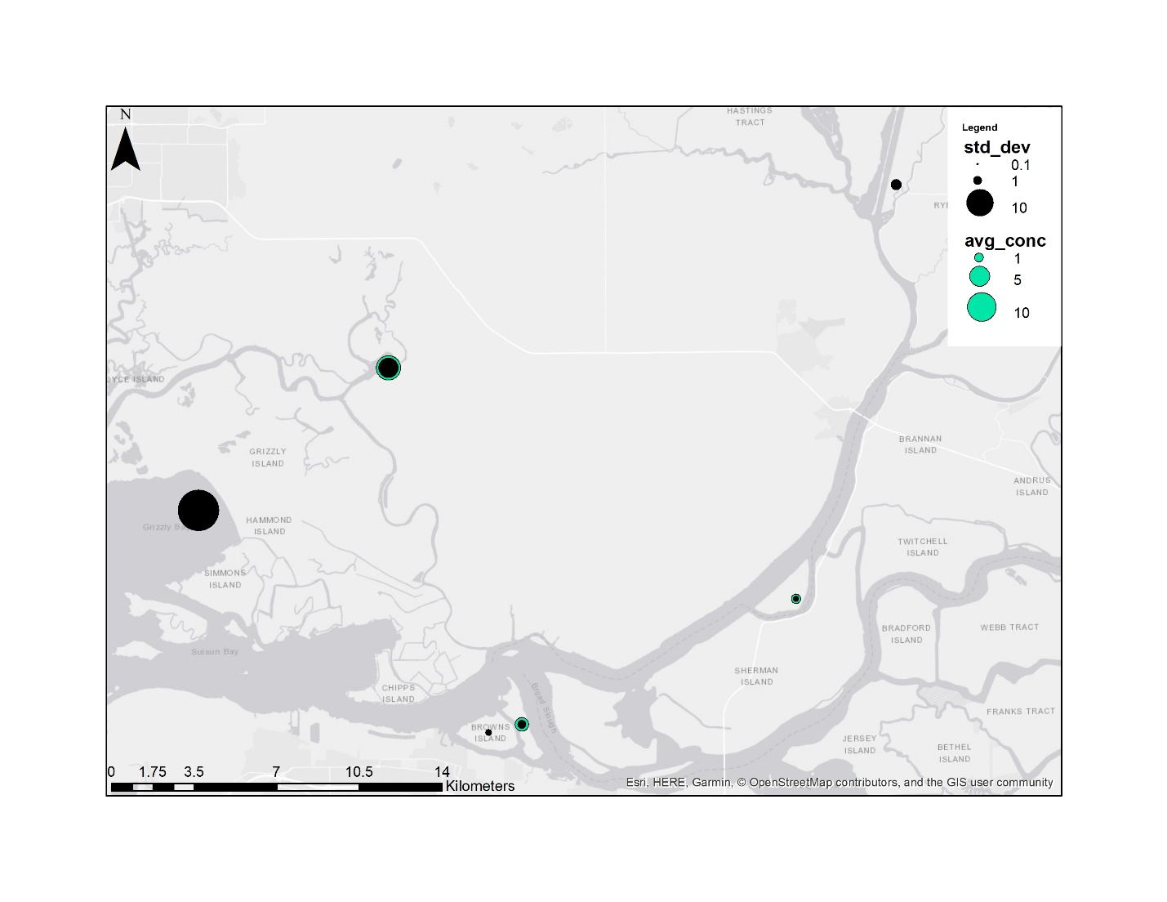

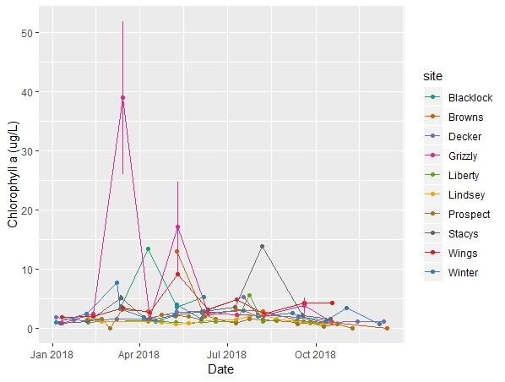

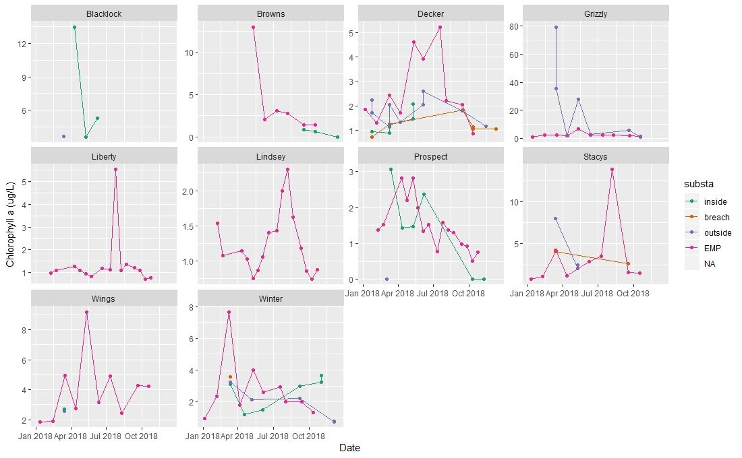

DON

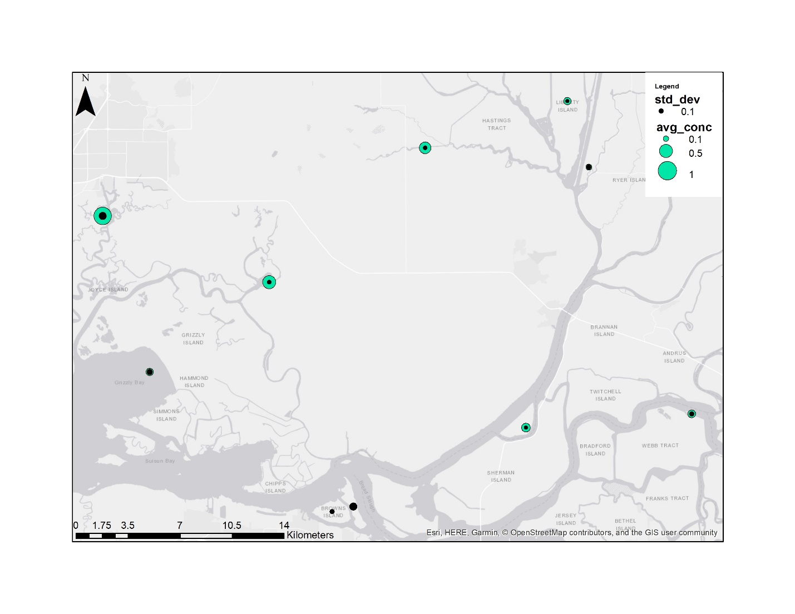

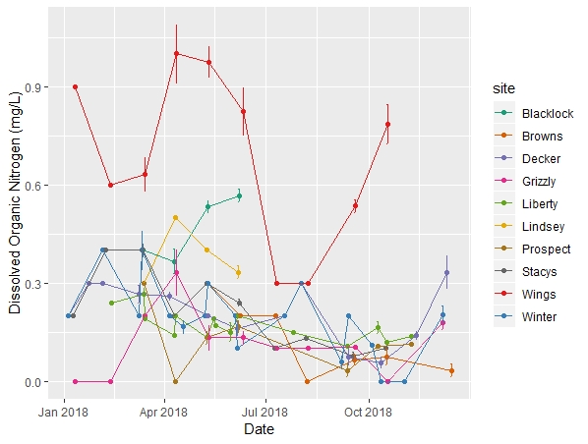

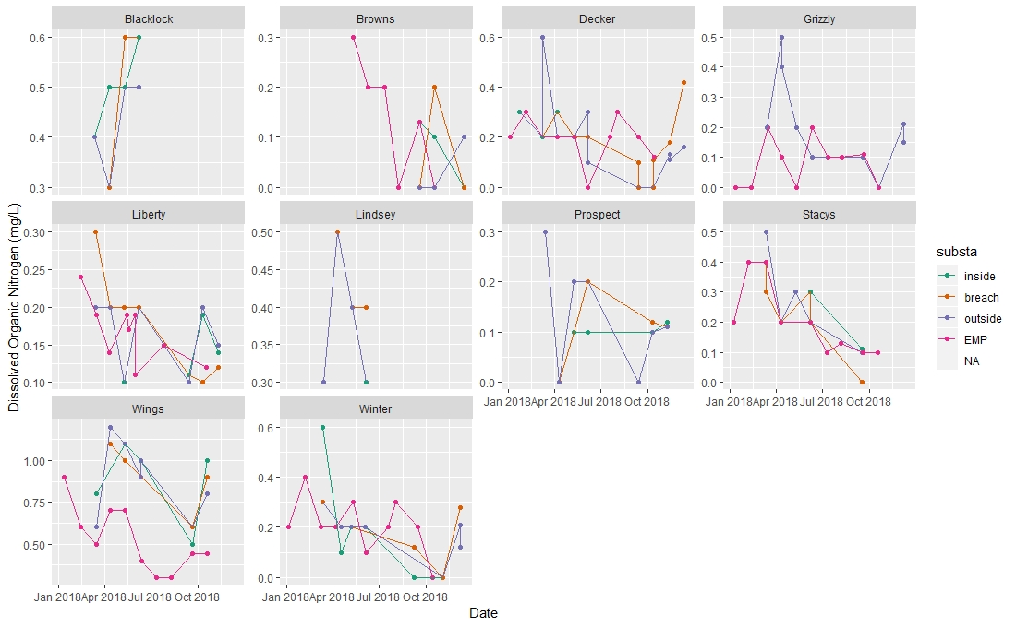

DOP

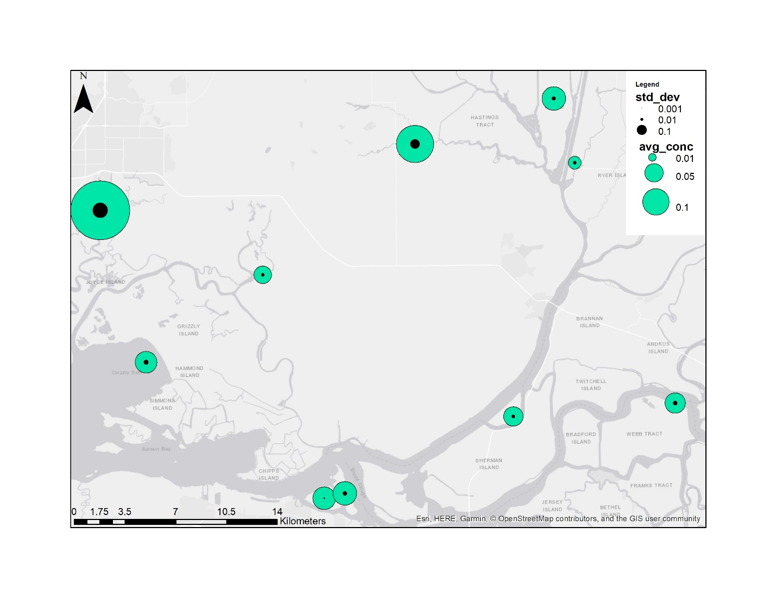

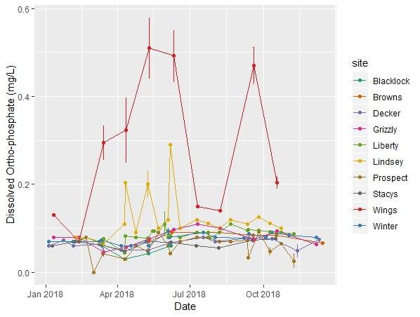

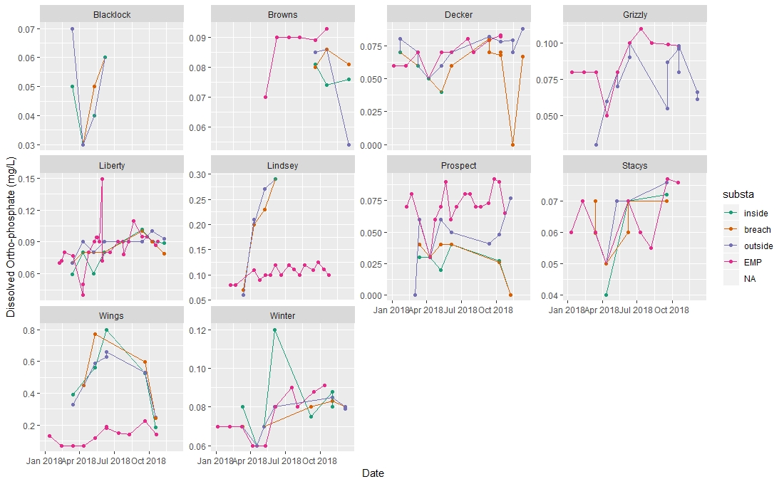

Pheophytin a

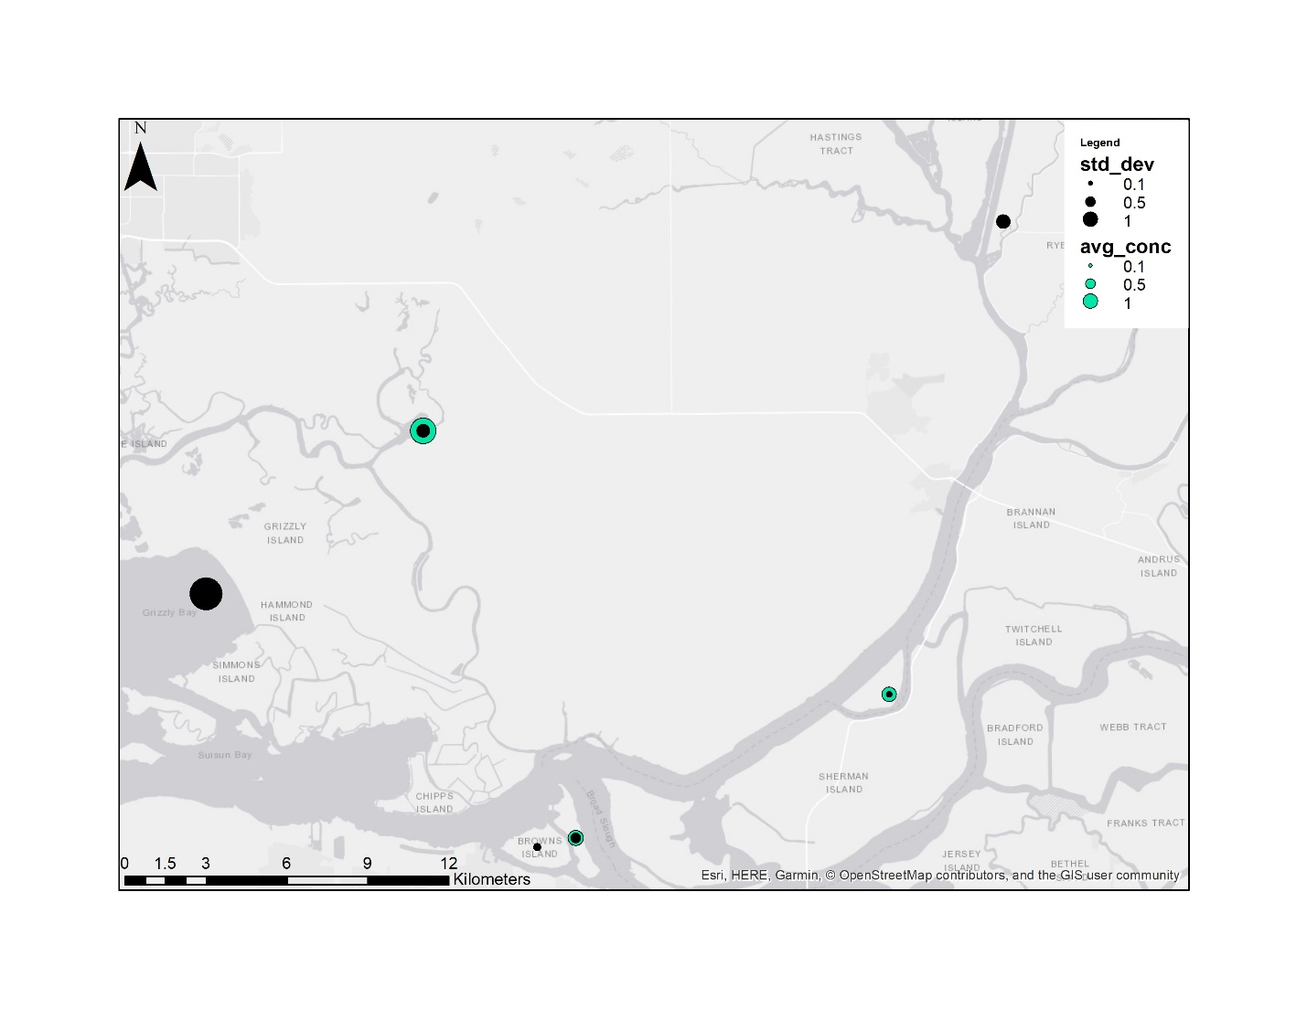

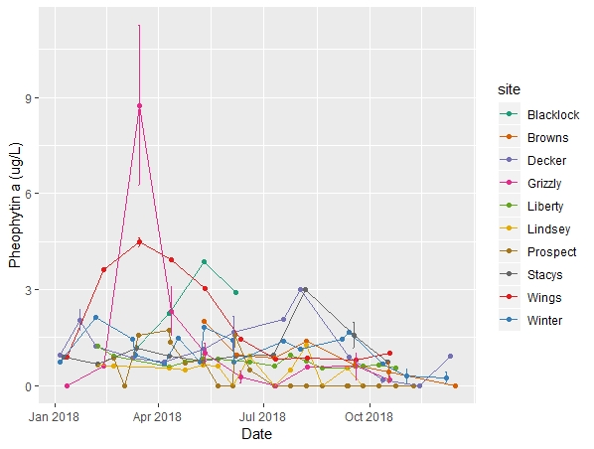

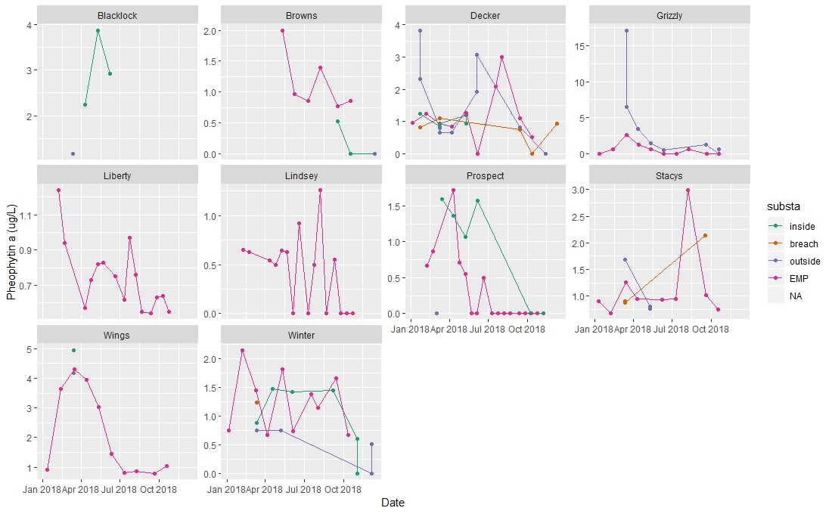

Tot Kj Nitrogen

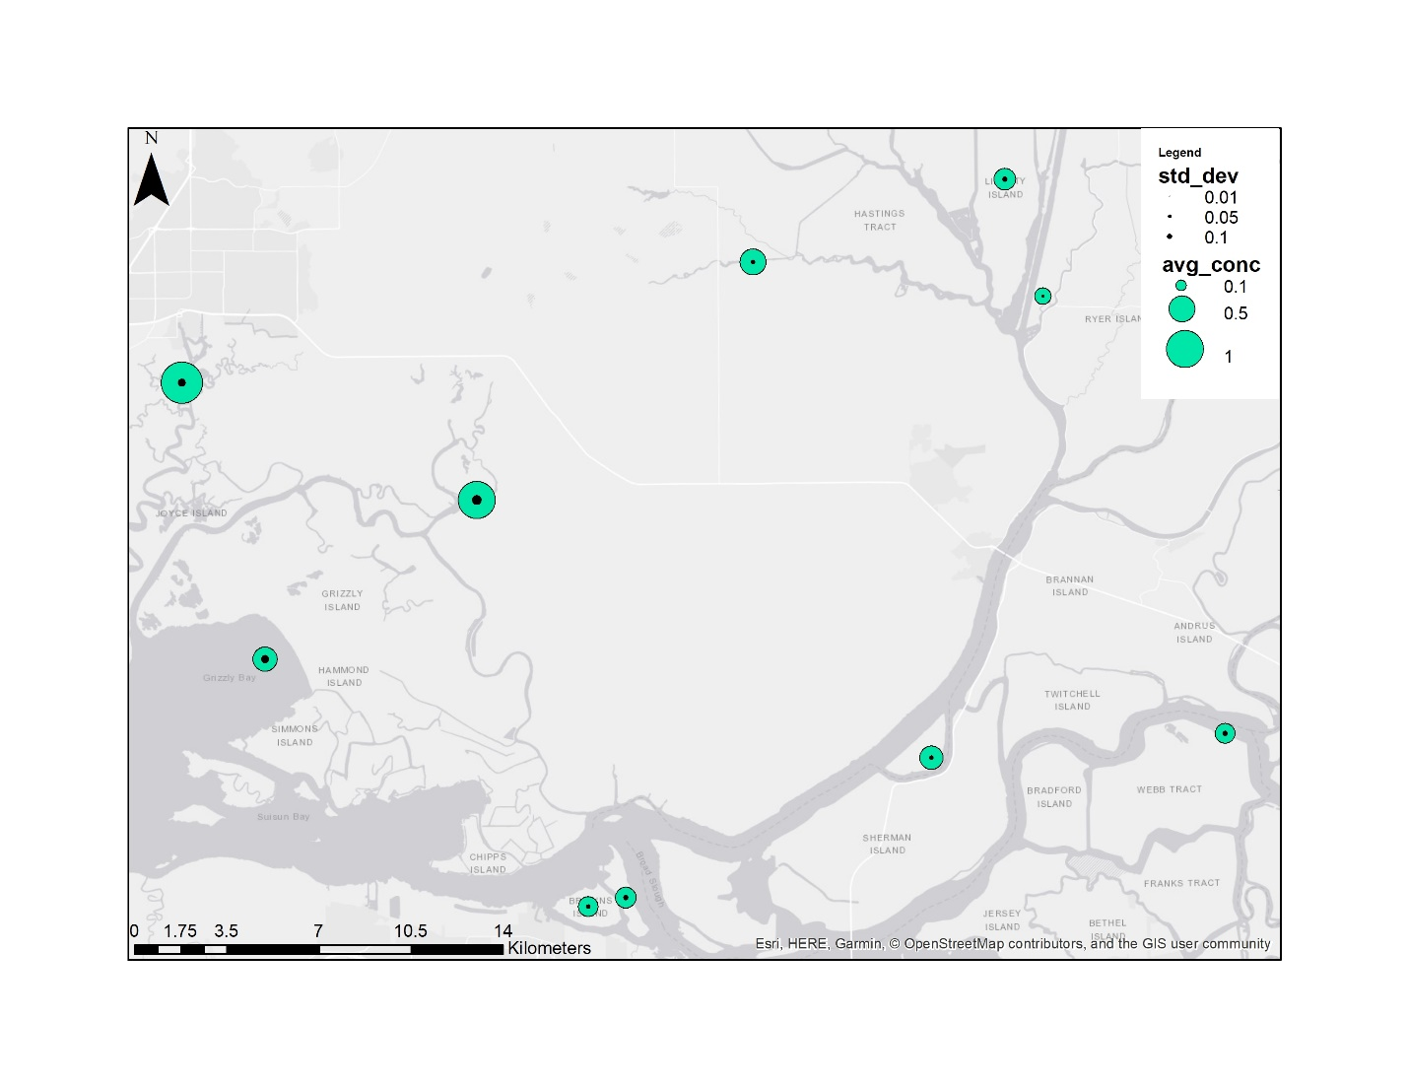

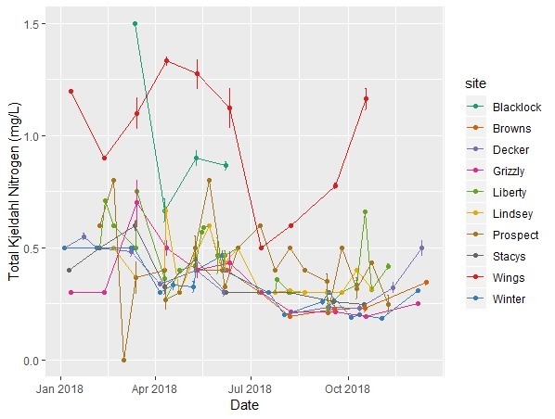

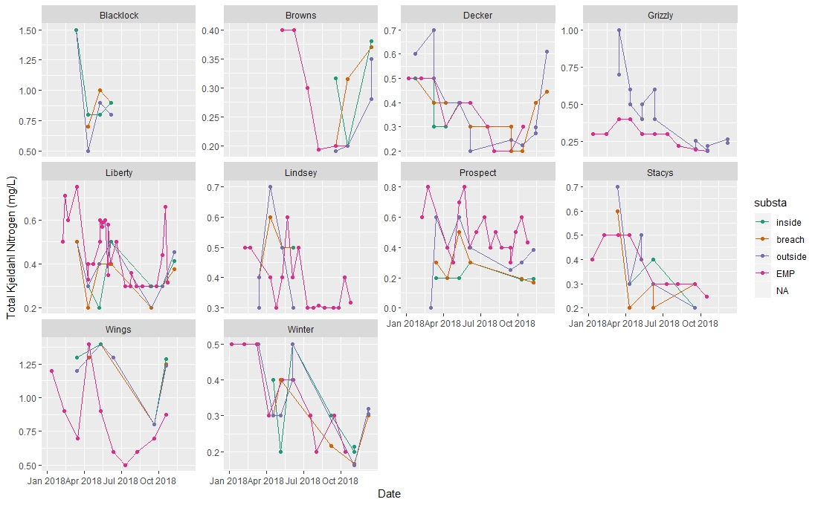

Tot phosphorous

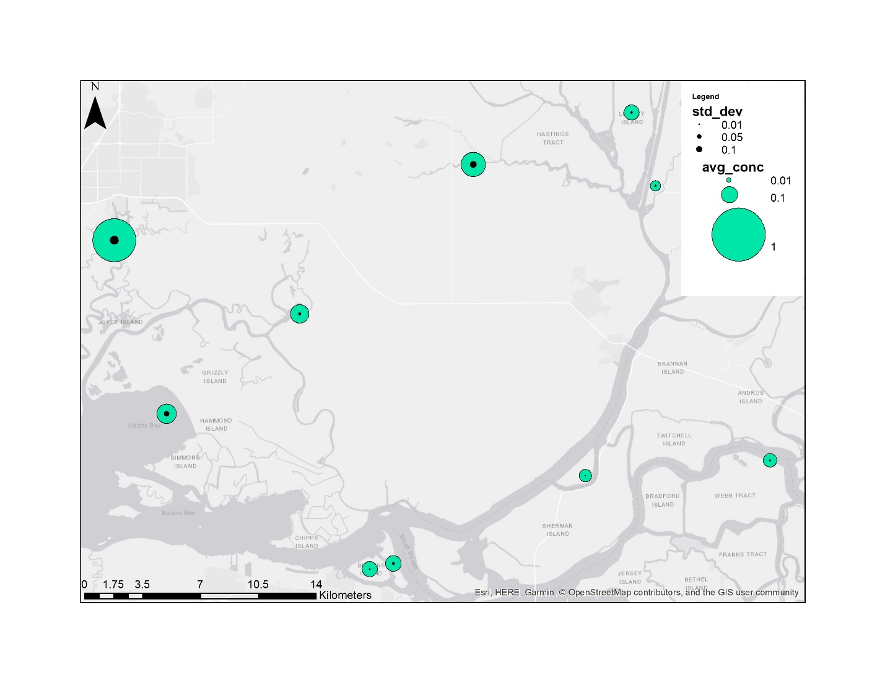

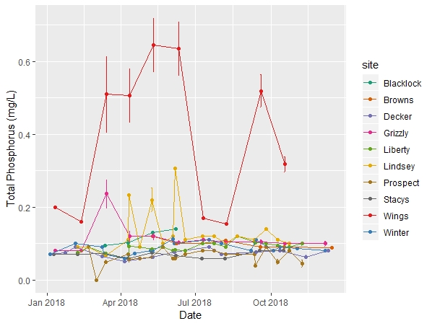

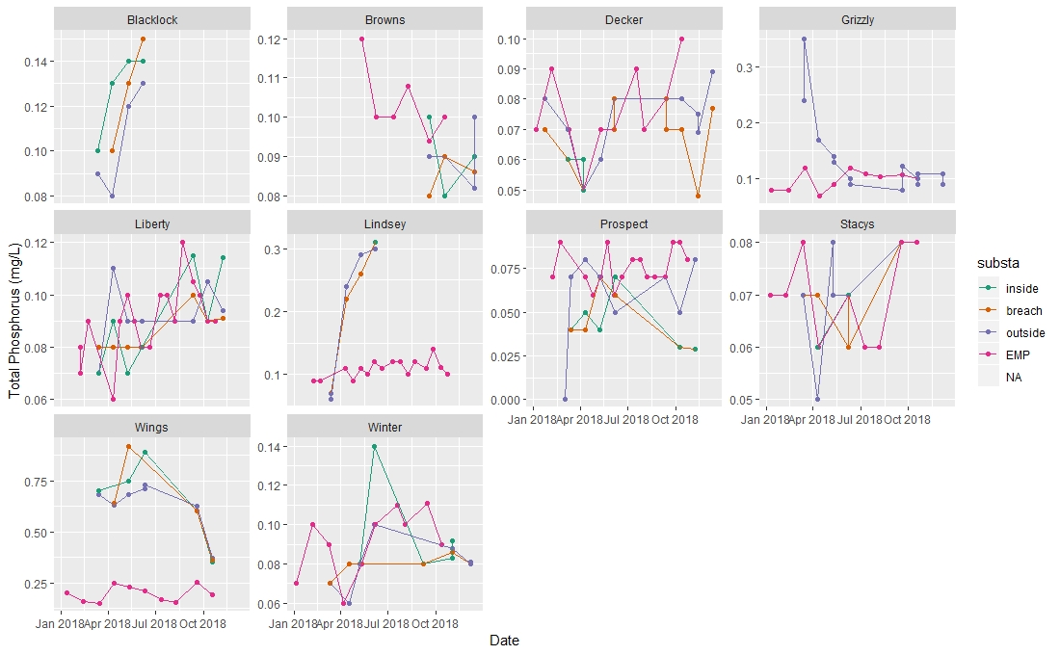

|  |  |  |  |  |  |  |  |  |  |
| --- | --- | --- | --- | --- | --- | --- | --- | --- | --- |
|  | CHL-a | CHL- sonde | Dissolved Ammonia | Dissolved Nitrate + Nitrite | Dissolved organic Nitrogen | Dissolved ortho-phosphate | Pheophytin a | Total Kjeldahl Nitrogen | Total Phosphorus |
| site | **2.27E-03** | **3.58E-10** | **<2.00E-16** | **<2.00E-16** | **< 2e-16** | **<2.00E-16** | **0.000568** | **<2.00E-16** | **<2.00E-16** |
| substa | 0.11299 | 0.8655 | **<2.00E-16** | **2.81E-10** | 0.934 | 0.844 | 0.050702 | **0.0478** | **0.0262** |
| month | 0.20274 | **0.0463** | **7.41E-14** | **7.58E-16** | **1.88E-09** | **4.87E-09** | **0.036506** | **<2.00E-16** | **0.2406** |
| site:substa | **0.00109** | 1 | **1.44E-10** | **0.00477** | 0.893 | **<2.00E-16** | **0.005246** | **4.37E-11** | **6.62E-11** |

Chlorophyll-a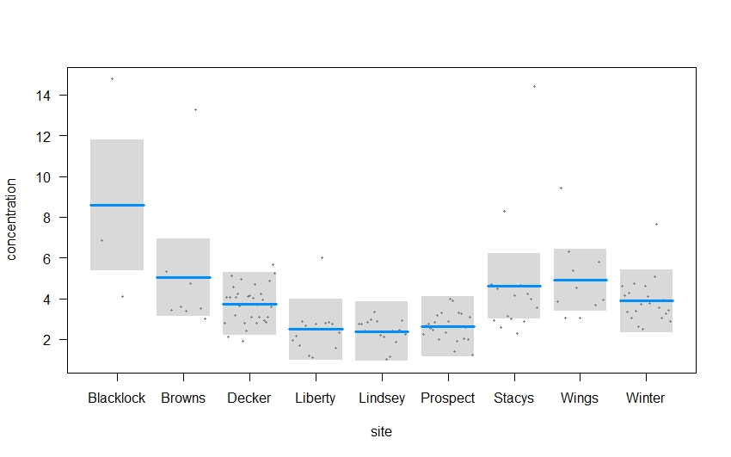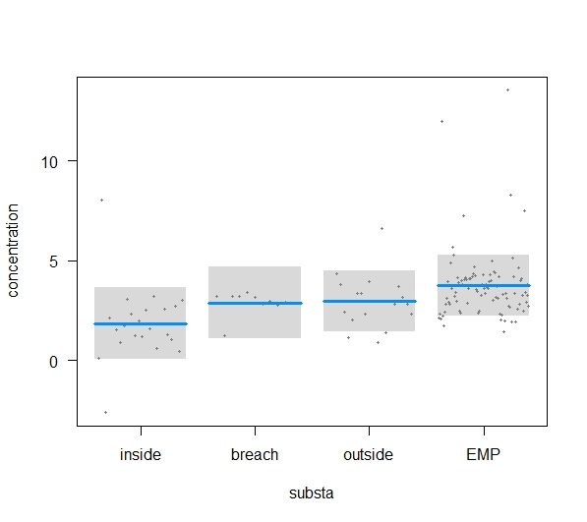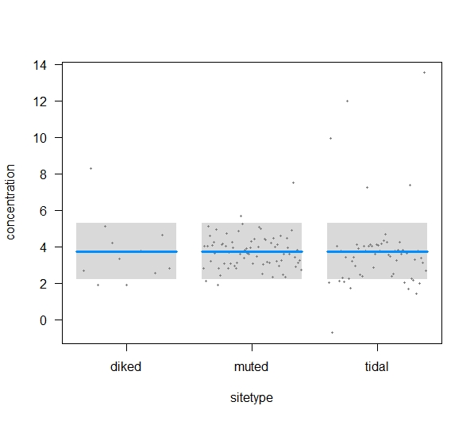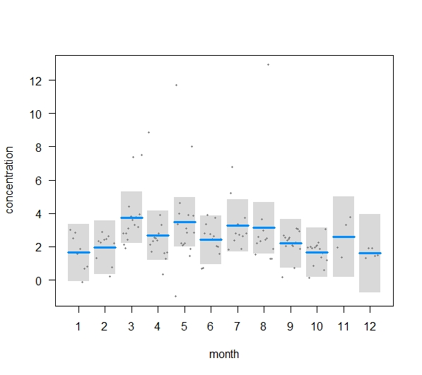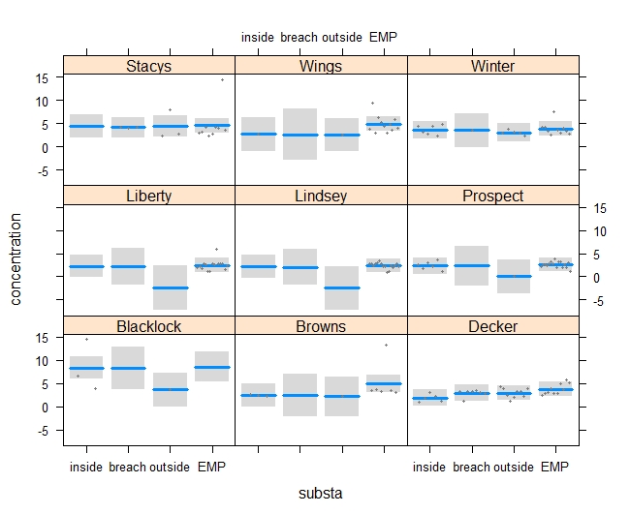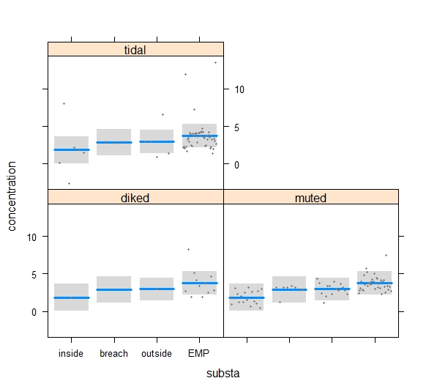

CHL- sonde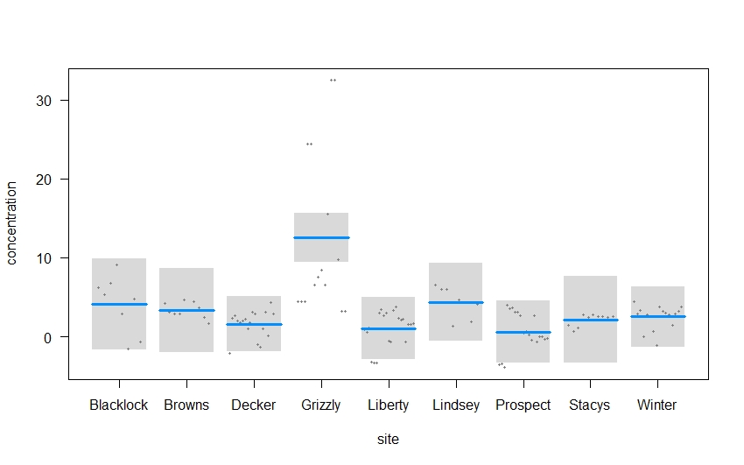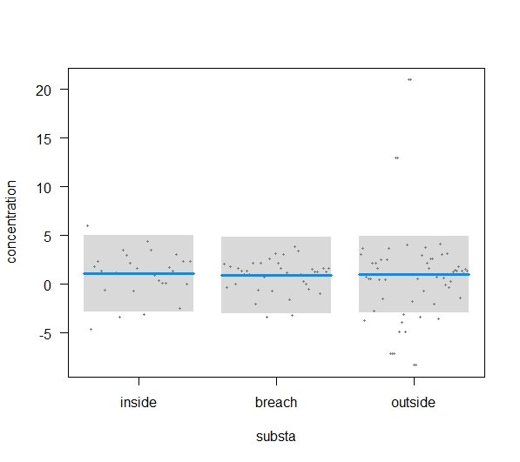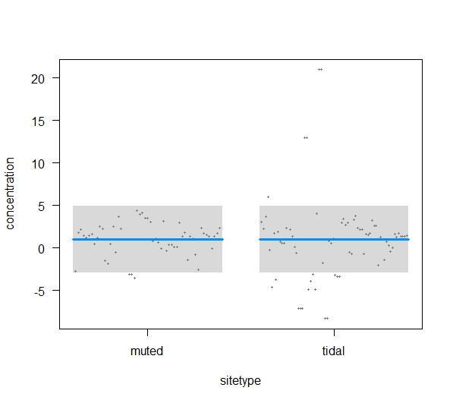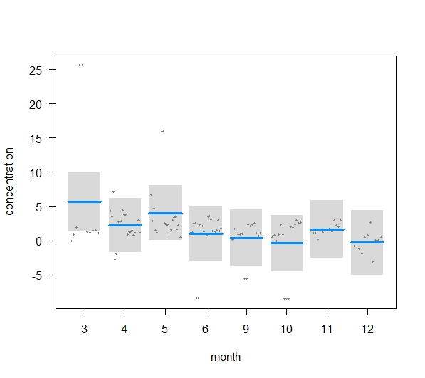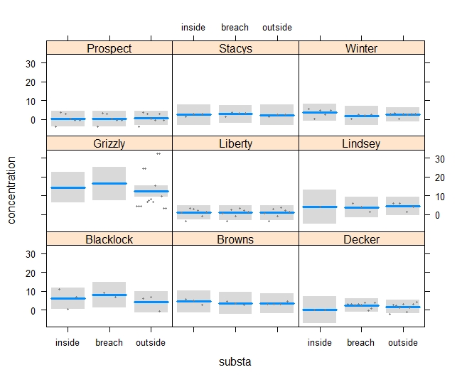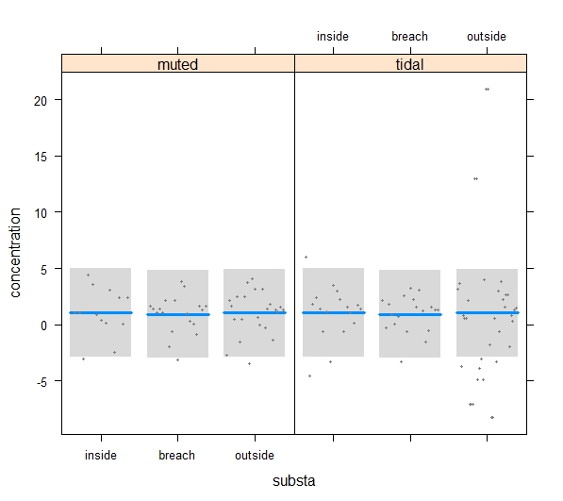

Dissolved Ammonia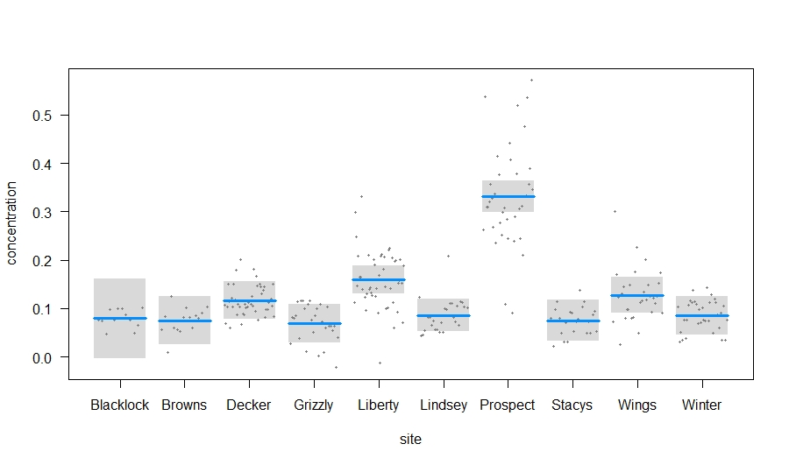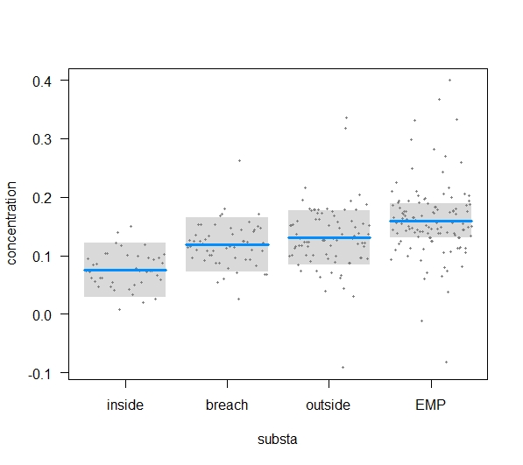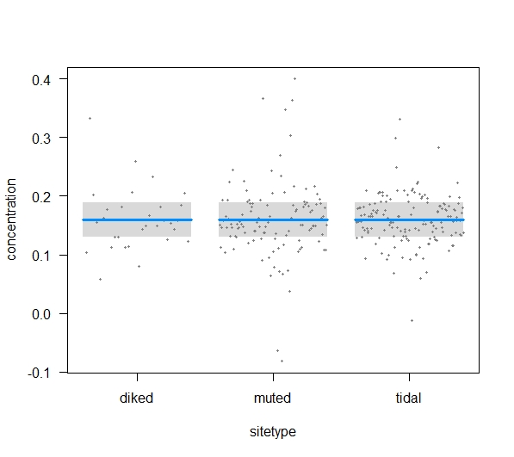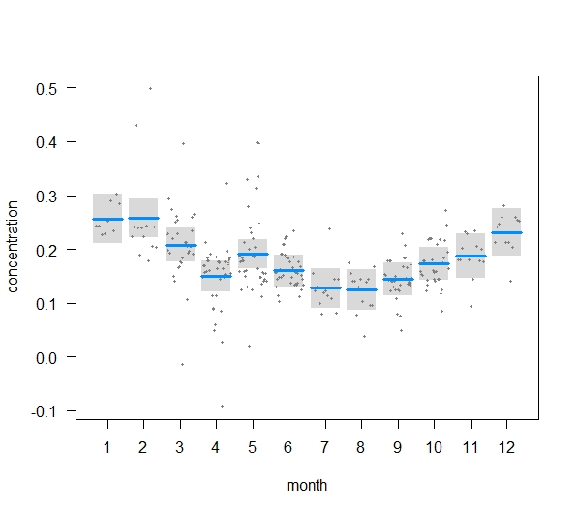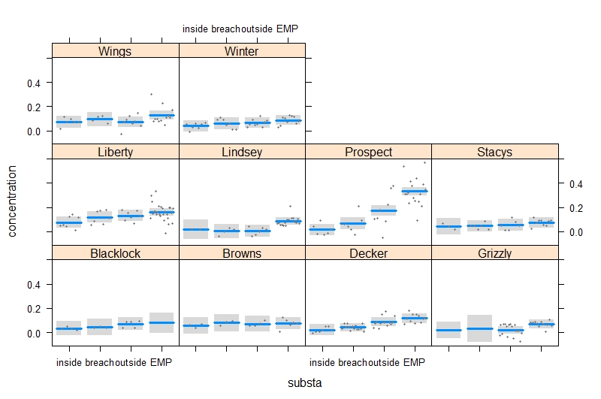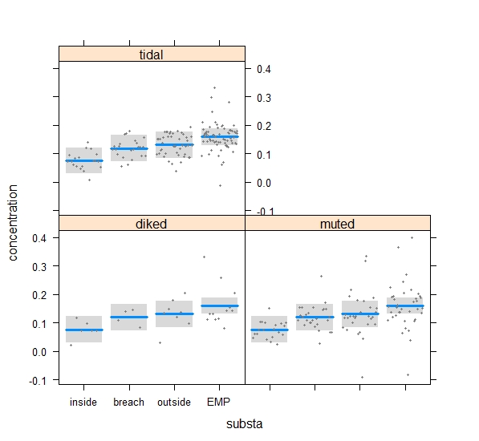

Dissolved organic Nitrogen

Dissolved Nitrate + Nitrite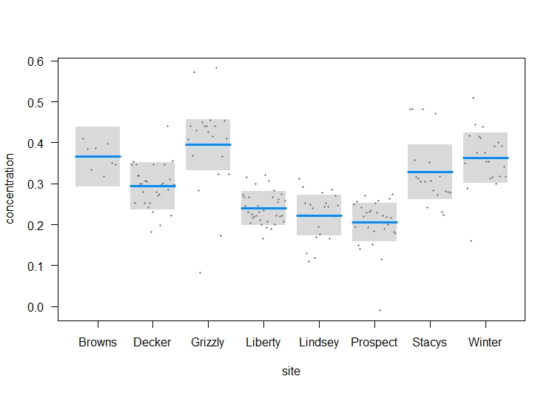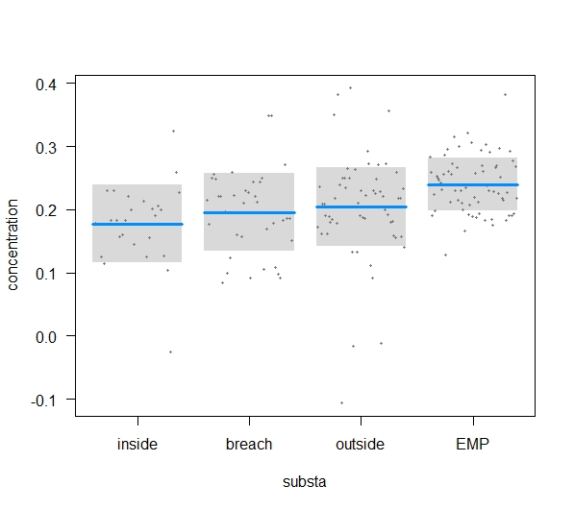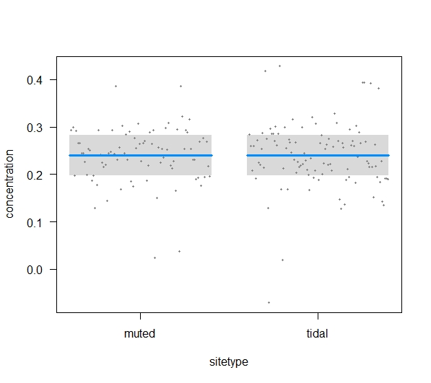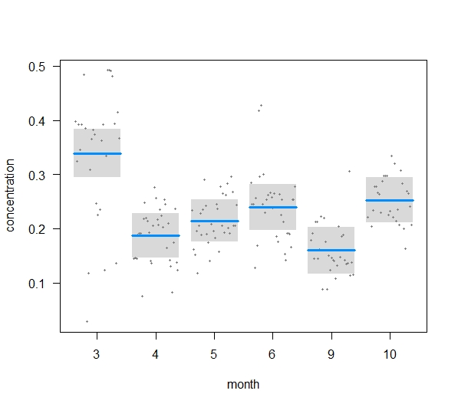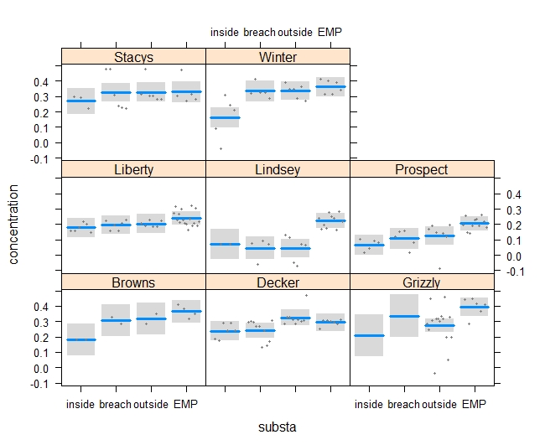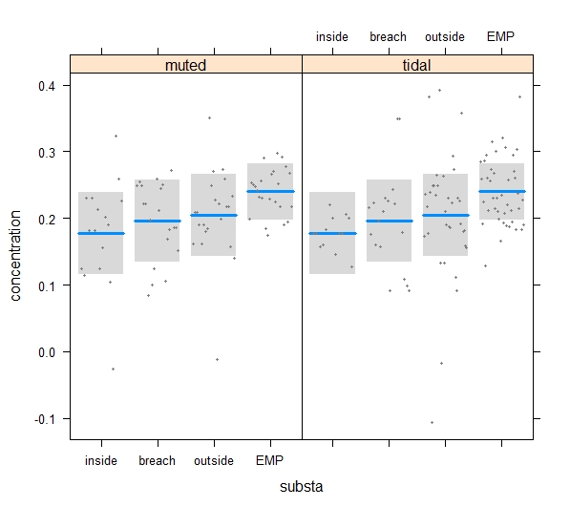

Dissolved organic Nitrogen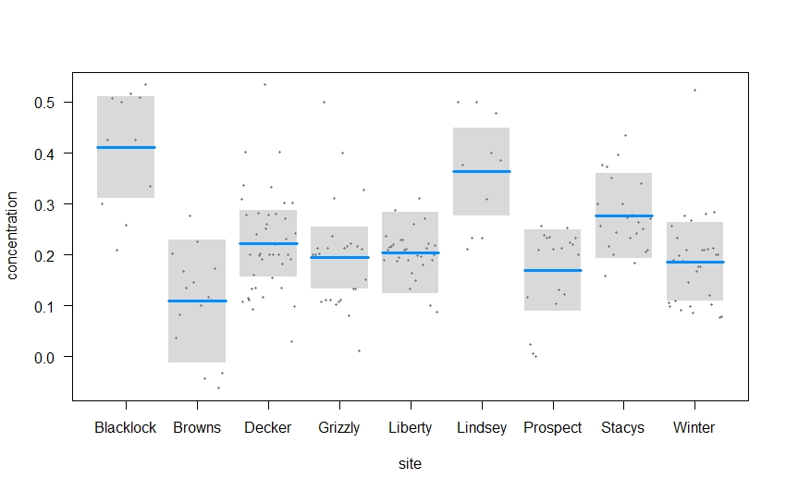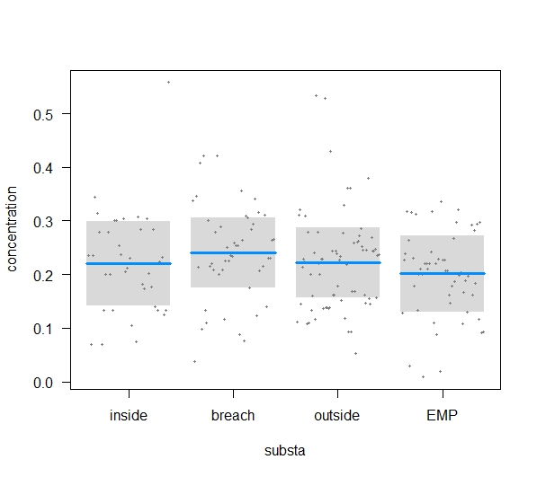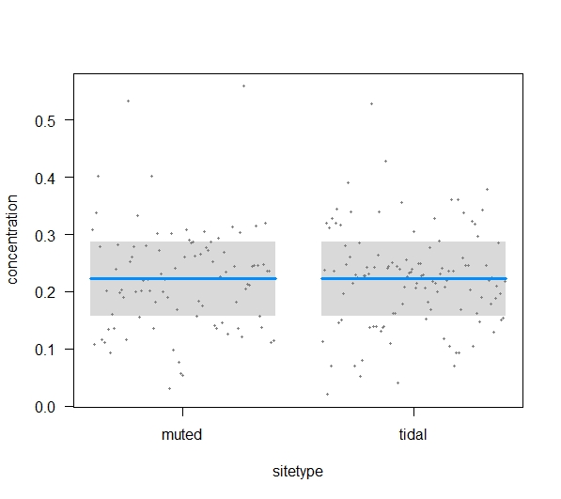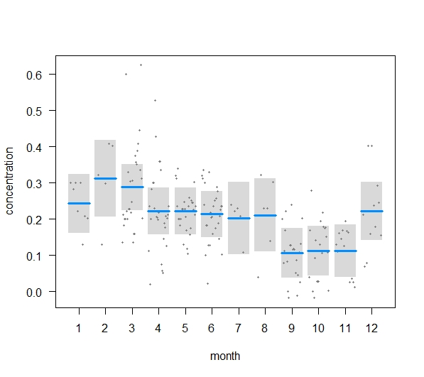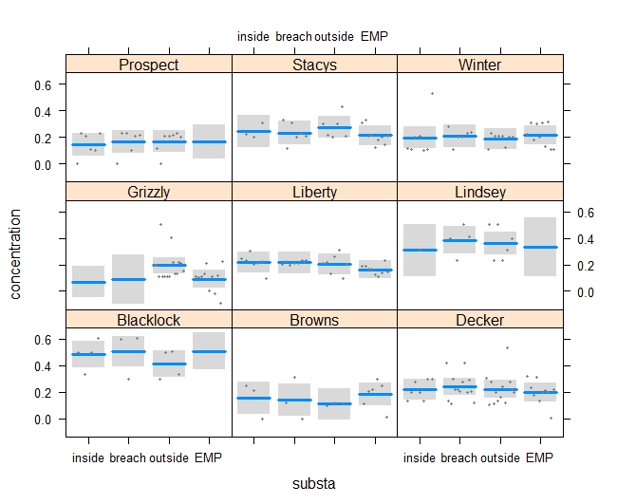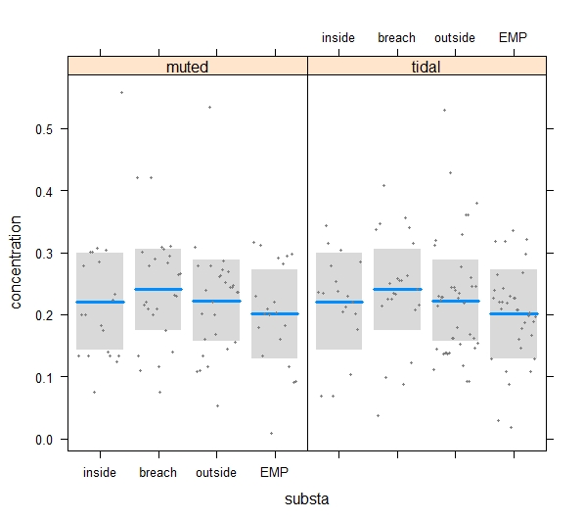

Dissolved ortho-phosphate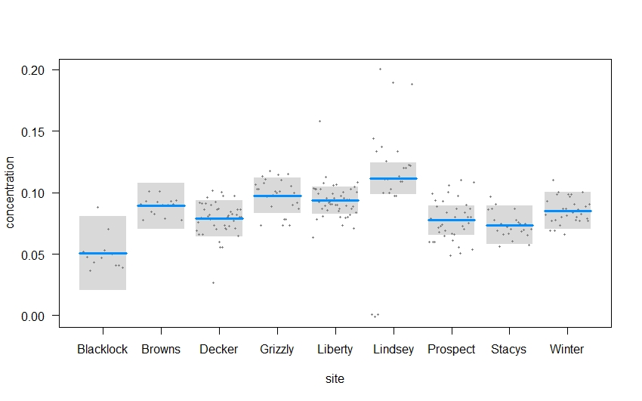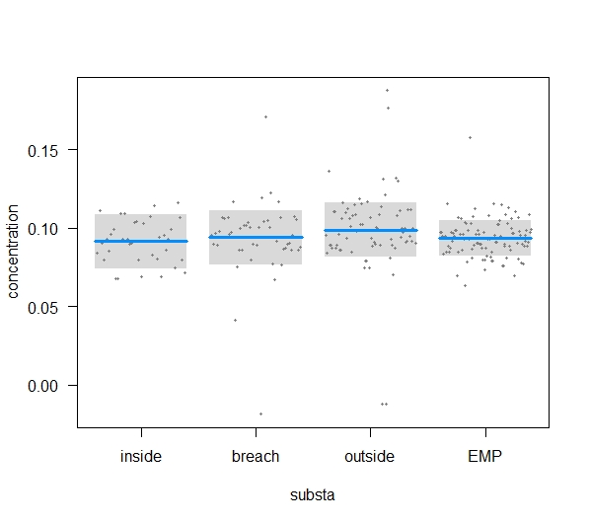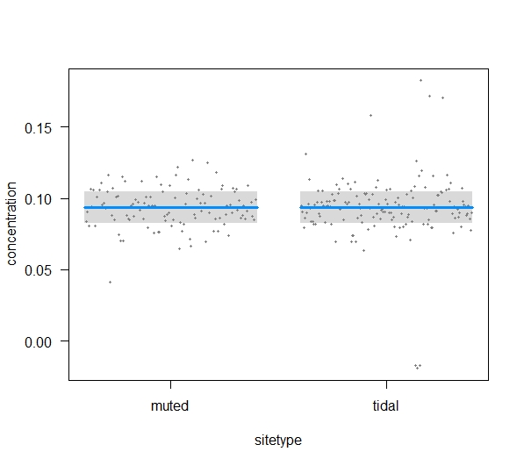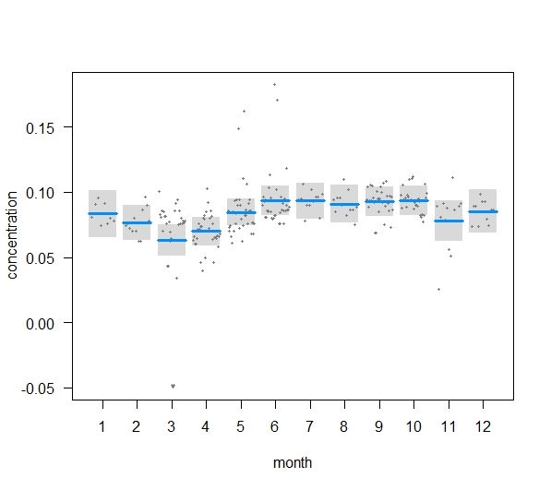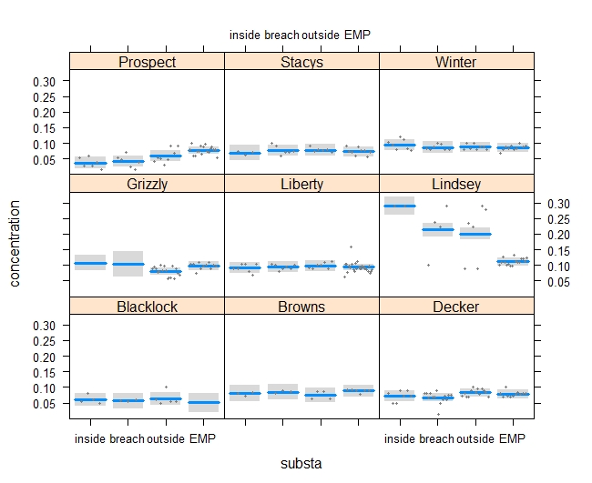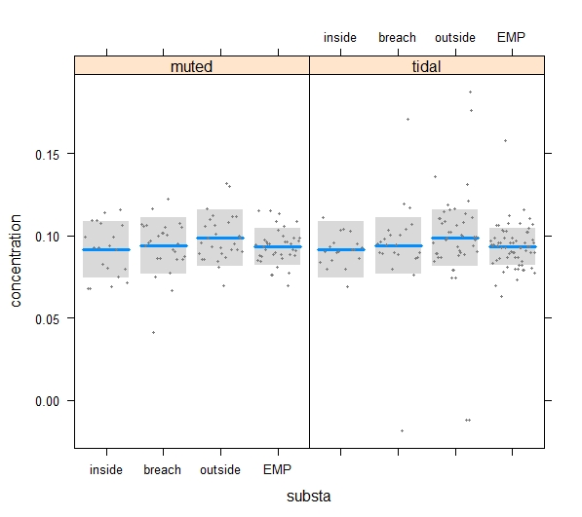

Pheophytin a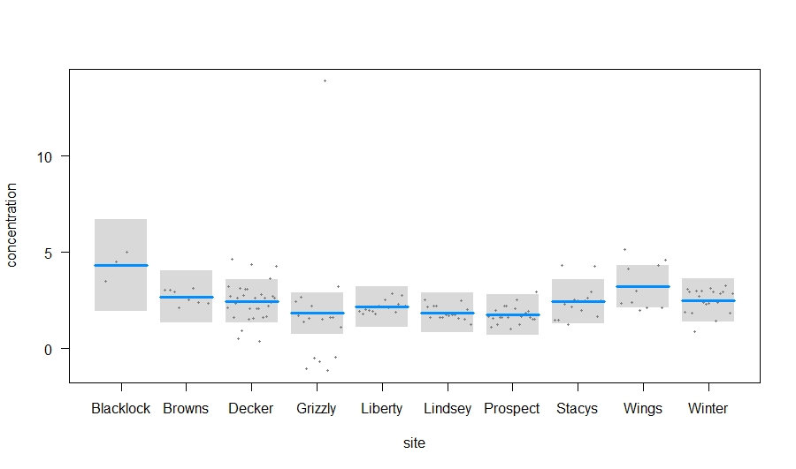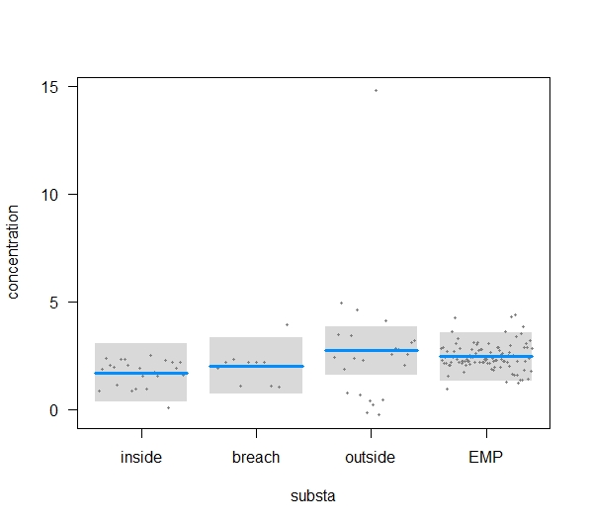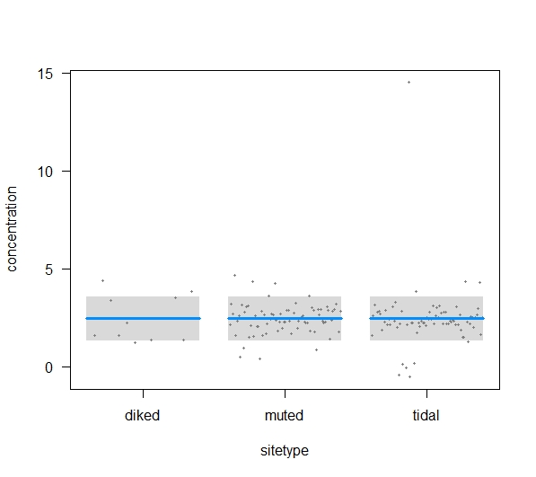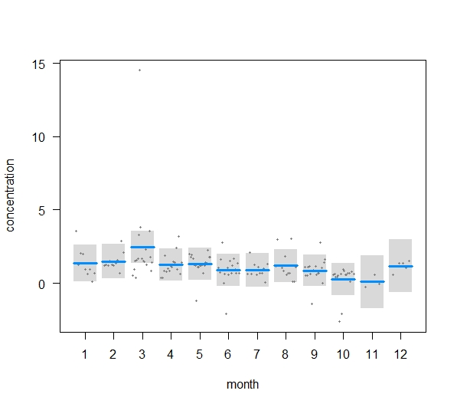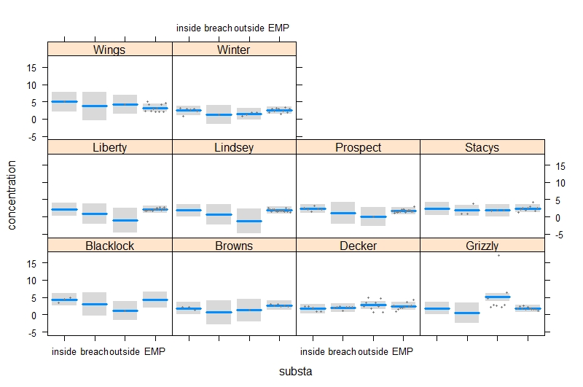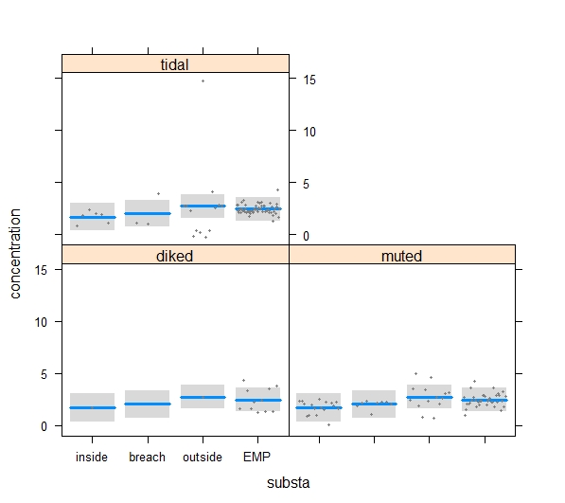

Total Kjeldahl Nitrogen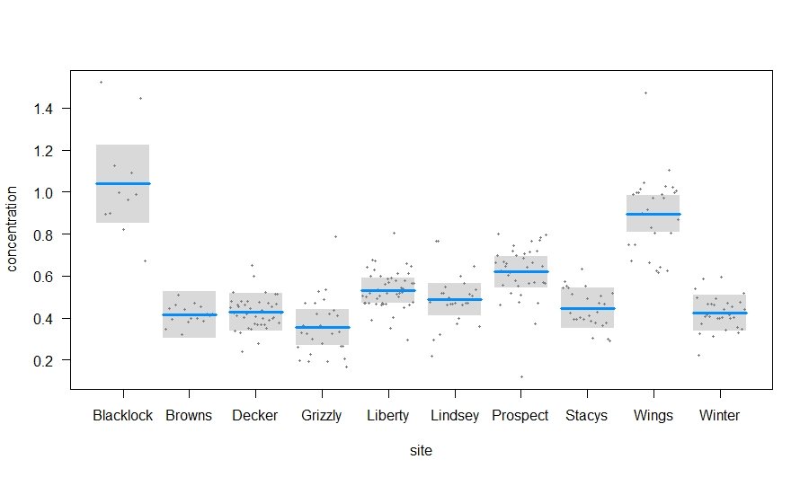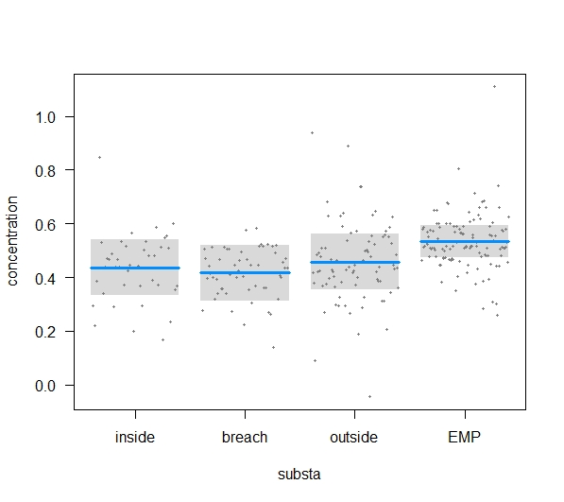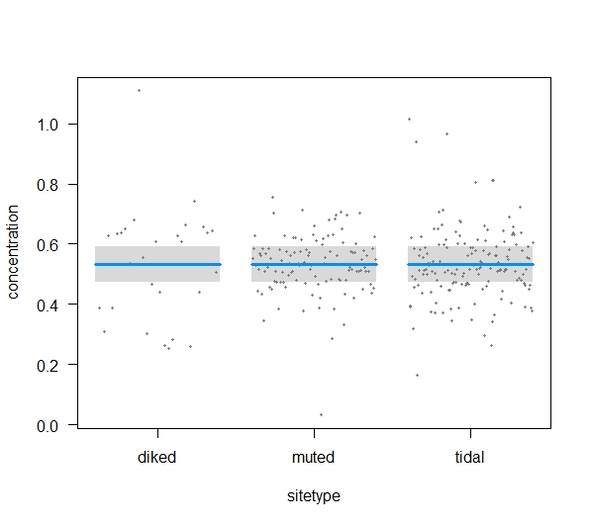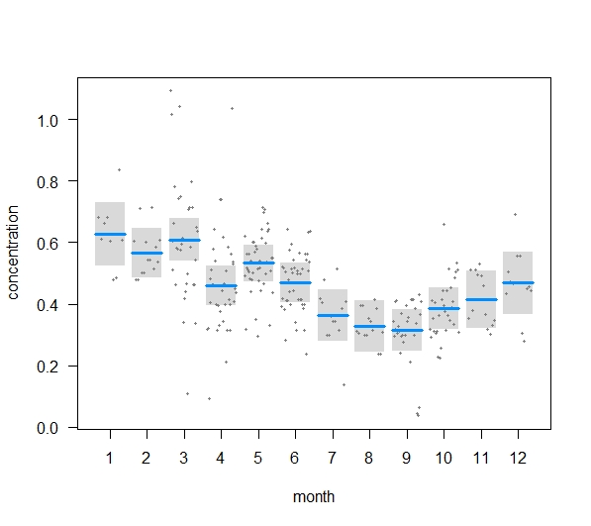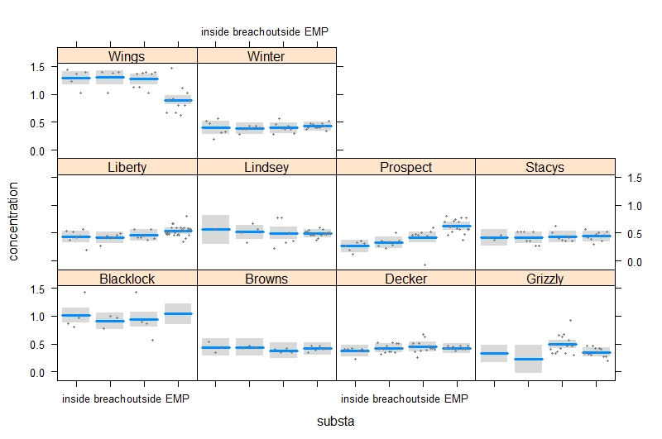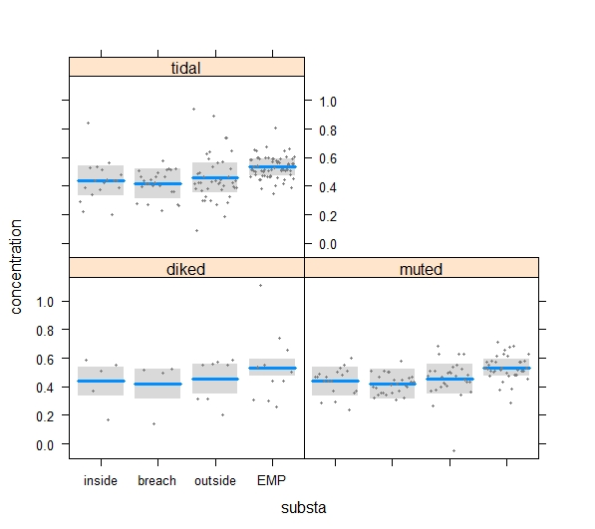

Total Phosphorus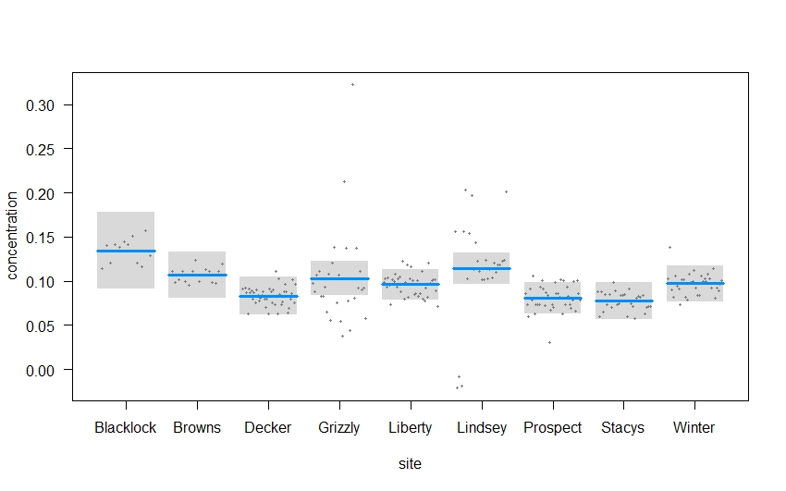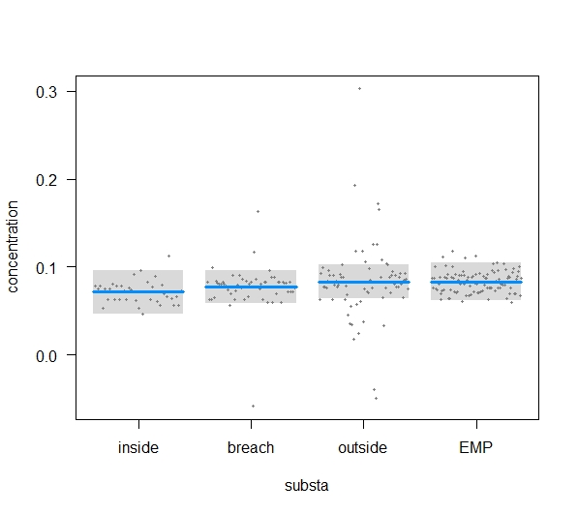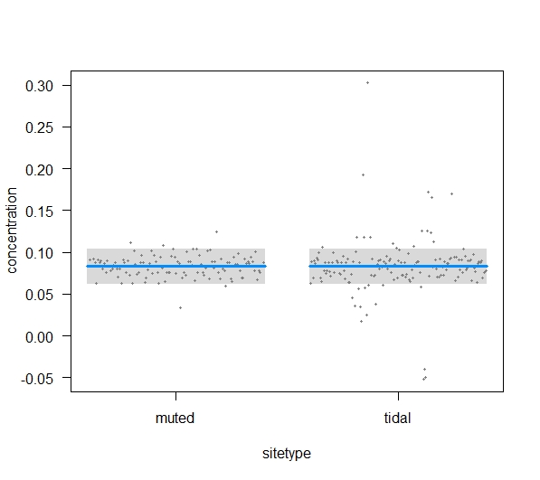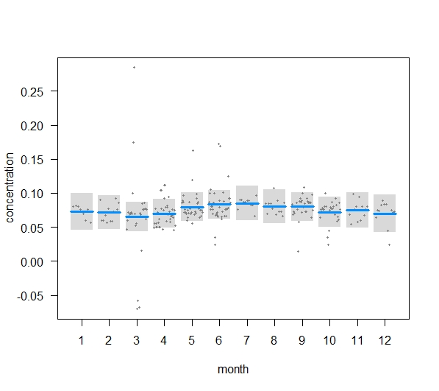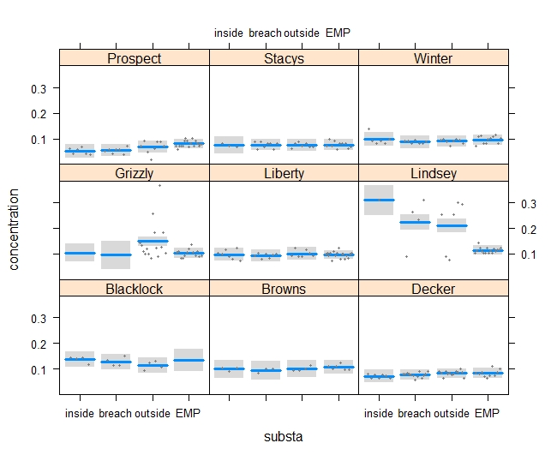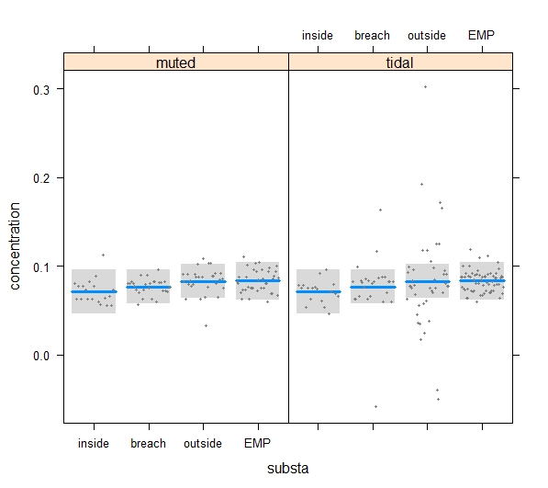

## Discussion

# CHAPTER 3: Methods Development

Project Component Lead: Dave Contreras

## Introduction

### Submerged Aquatic Vegetation

### ARIS Sonar

Due to procurement issues obtaining an ARIS sonar device this year, we would like to reinitiate a component from the 2017 work plan. Last year, we briefly worked with the USGS observing how fish behave within wetland breach sites using Dual frequency IDentification SONar (DIDSON) and Adaptive Resolution Imaging Sonar (ARIS) devices. We used gill nets and boat electrofishing to confirm species identity, but because we fished within the sonar field-of-view, we were able to observe fish response to the gears (e.g., a few fish appeared swim towards the gill net and then do a u-turn away from the net). We would like to see if an ARIS sonar device can be used to determine how effective electrofishing and gill net sampling techniques are, and whether particular biases of the methods could be identified. Full gear efficiency studies are labor intensive, requiring planning and the recognition of the limitations of the evaluation technique. We propose to explore gear evaluation techniques in 2018 and plan a comprehensive gear efficiency study for gill netting and boat electrofishing for 2019. We will also explore the extent to which an ARIS would be useful in monitoring fish communities in wetland habitats that are difficult to sample with other gears (e.g., adjacent to emergent vegetation).

### Algae/Phytoplankton

In the past, most evidence pointed to pelagic phytoplankton as the key driver of the Bay-Delta food web (Canuel et al. 1995; Sobczak et al. 2005; Sobczak et al. 2002), however, more recent work suggests benthic, epiphytic, and wetland-derived carbon may play a more important role than previously recognized (Schroeter et al. 2015). Due to the lack of information on benthic and epiphytic algae in the SFE, it is unclear whether algae found in the water column of wetlands were produced in the water column, or were produced in other microhabitats and washed into the water column. Learning how algae are distributed within a wetland will be important to supporting Framework Hypothesis F3: Form and magnitude of primary production, along with site and landscape attributes, will drive the form and magnitude of secondary production.

Study Questions

1. Can the ARIS sonar be used as a tool to determine gill net and electrofishing efficiency?
2. Can ARIS sonar be used to monitor fish use of wetlands with decreased take of listed species?
3. What is the relative contribution of different types of algae to the phytoplankton in wetland channels versus major channels?

## Methods

### SAV survey techniques

Rake collections

SAV sampling occurred in March, August, and October of 2018 and January of 2019 to capture temporal shifts in community structure. SAV undergoes rapid growth in the summer and biomass peaks near the end of August in the Delta (Hestir et al. 2008). In wet years, heavy flows may uproot significant portions of SAV across the Delta, whereas, in dryer years, SAV can grow year round (Durand et al. 2016). At each site, maps of SAV were created for SAV composition.

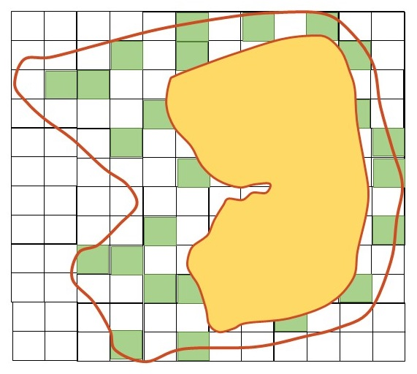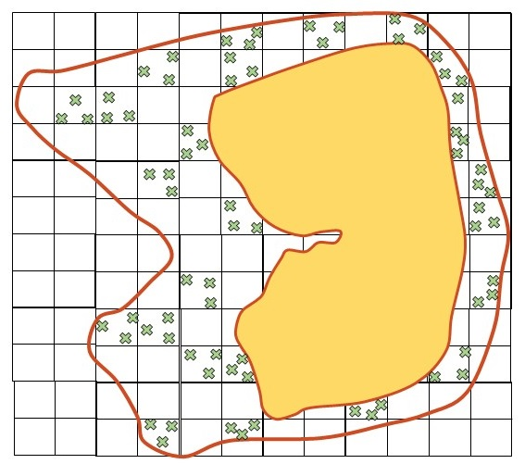

Figure 17. Sampling layout at a model wetland site. Green squares represent randomly-selected sampling quadrats and Xs represent sample replicates within the quadrat.

To address patterns in SAV growth, SAV rakes were collected at multiple scales across each site. At each site, 30–50 randomly-selected sampling quadrats were selected from navigable waterways within and at the exterior of wetland sites (Figure 17). The number of points varied with the size of the site, with larger sites being sampled more, to obtain similar sampling point densities. At each sample quadrat, 2 replicate SAV rakes were collected according to standard operating procedures developed through the Aquatic Vegetation Project Work Team (PWT). In brief, at each location a 10 m x 10 m quadrat was located. Haphazard rake samples were collected from within it. For each sample, a 19-tine thatch rake attached to an extensible pole was lowered to the bottom of the water column, twisted three times to break off any SAV, and lifted out of the water. Scientists estimated percent coverage of the rake head and recorded species of SAV included in the sample. Health and condition of each species were noted using a standard set of conditions and symptoms of disease (Table 12). Wet biomass was measured to the nearest 1-2 g with tabletop scales after 20 seconds of spinning in a commercial salad spinner (19 L capacity). If necessary, vegetation was bagged in the field and transported back to the laboratory. A replicate sample was then collected from within the quadrat, but no closer than five meters from the other sample replicate. Sampling continued until 30–50 quadrats, 60–100 SAV rakes, were collected. Logisticla constraints reduced the number of samples obtainable at two sites in the Cache slough Region, but sampling effort in the confluence met project goals. All sites were sampled in March, 2018, three in August, 2018, and two each for October, 2018 and January, 2019 (Table 13).

Table 12. Submerged aquatic vegetation health and condition factors.

|  |  |
| --- | --- |
| **Condition factor** | **Description** |
| **1** | **Healthy** (Portion / entire sample contains no signs of damage) |
| **2** | **New growth** (Portion / entire sample contains recent growth of tips) |
| **3** | **Yellowing / browning** (Portion / entire sample turning yellow or brown hue) |
| **4** | **Bleached tips** (Portion / entire sample has tips which have turned white) |
| **5** | **Foliage loss / Stemmy** (Portion / entire sample has lost leaves- may look stemmy) |
| **6** | **Blackened / dead material** (Portion / entire sample has died, begun decomposing) |

Table 13. Number of SAV rake samples collected at each site.

|  |  |  |  |  |  |  |  |
| --- | --- | --- | --- | --- | --- | --- | --- |
| **Samples near** | **Region** | **Site type** | **Mar, 2018** | **Aug, 2018** | **Oct, 2018** | **Jan, 2019** | **Total** |
| Liberty Island | Cache Slough | Tidal Wetland | 62 | 0 | 0 | 0 | 62 |
| Prospect Island | Cache Slough | Muted tidal Wetland | 119 | 60 | 0 | 0 | 179 |
| Winter Island | Confluence | Muted Tidal wetland | 86 | 84 | 73 | 74 | 317 |
| Browns Island | Confluence | Tidal wetland | 82 | 74 | 65 | 62 | 283 |
|  |  | **Total** | 349 | 218 | 138 | 136 | 841 |

SAV mapping using boat-mounted sonar was tested with a Lowrance Sonar (model hds 7, hds 9, or Carbon 12). Data were processed using BioBase’s EcoSound software to convert the sonar tracks to biovolume of SAV (CMAP Inc., https://www.cibiobase.com/). This software converts sonar data to estimates of water column filled with submerged aquatic vegetation. Comparisons between the mapped SAV data and SAV rakes were made to determine the suitability of sonar mapping for shallow tidal wetland monitoring.

Sonar w/Biobase

### ARIS Evaluation of Boat Electrofisher and Gill Net

An Adaptive Resolution Imaging Sonar (ARIS) will be used to evaluate the efficiency of boat electrofishing and gill net sampling in the vicinity of Decker and Prospect Islands. Four sites will be sampled in both Horseshoe Bend and Miner Slough using the following methods. An ARIS unit will be mounted on the hull of a kayak to record the presence and behavior of fish in a defined sampling area. The kayak will make a slow pass of the sampling site approximately 15m away and record fish presence within the sampling area. Once the site has been recorded with the ARIS, the site will be electrofished. A Smith-Root electrofishing vessel with a 5.0 GPP electrofisher will be used to sample the site following the ARIS recording. Crew members will stand on the bow of the vessel operating a foot pedal, using eight to ten second bursts of electricity along one shoreline. All fish will be collected with a 5mm mesh dip net and placed in a live well, measured, and counted.

To estimate efficiency of gill net sampling, an ARIS unit will be mounted on the gill net vessel. The gill net will measure 30.5 m long x 1.8 m high and is composed of various mesh panels, where the largest mesh panel is 15.2 cm. Gill nets will be set at four sites in both Horseshoe Bend and Miner Slough. Each net will be deployed by a vessel parallel to the shore, anchored by two 8lb weights. As the net is sampling, a slow pass will be made with the ARIS unit along the net face to record fish behavior near the gear. After 60 minutes of sampling, the ARIS unit will be shut off and the gill net retrieved. All fish will be placed in a large bin with water. All ESA-listed fish will be measured. Only 30 fish of other species will be measured; all remaining fish will be counted. In the office, fish counts and length estimates will be made from images captured by the ARIS unit.

### Algae/Phytoplankton

To supplement routine monitoring of phytoplankton communities at all FRP sites, and to better differentiate between the sources of phytoplankton in the water column, we intensively sampled a wide variety of habitats at one site (Liberty Island). Collection methods were be based on standard benthic algae methods developed by the California State Water Resources Control Board Surface Water Ambient Monitoring Program (Ode et al. 2016). At Liberty Island, we collected algae from four microhabitats within the wetland (also see Table 2):

* 3 SAV samples – algae were scraped from a 10-cm section of the *Stuckenia pectinata* or dominant form of submerged vegetation.
* 4 EAV samples – algae were scraped from a 10-cm section of *Schoenoplectus acutus*, or dominant form of emergent vegetation.
* 3 Benthic samples (Epipelic or Episammic) – algae will be rinsed from the mud/sand collected by a 10-cm PVC core, or petite ponar grab.
* 6 Pelagic – phytoplankton were collected as per “Water Quality Grab Samples SOP” (PWT 2017).
* 1 Filamentous algae sample.

All samples were preserved in Lugol’s Iodine solution and shipped to EcoAnalysts, Inc. for analysis. EcoAnalysts measured and counted all taxa of algae within the sample using the Utermöhl microscopic method (Utermöhl 1958) and APHA Standard Methods (APHA 2017), as described in section 2.2.3. Laboratory methods, above.

## Analysis

**Algae:** We compared the community composition of algae samples from different habitat types with PERMANOVA and visualized these differences using NMDS with functions from the R package vegan (Oksanen et al. 2016). We then performed multiple pattern analysis to see whether some taxa were associated with particular habitat types using the R package indicspecies (Cáceres and Jansen 2016).

## Results

More than eleven varieties of floating and submersed aquatic vegetation found at the four sites. Additional, rarer, species were present as well, but not dominant enough to be sampled. Non-native species made up the majority of aerial coverage at all sites excluding Browns Island in August and October of 2018. Percent coverage of vegetation within a given site changed drastically over the course of the year: at Browns Island, % vegetative cover went from 2% in March, 2018 to 24% in August, 2018 and at Prospect Island, vegetative cover went from 66% in March, 2018 to 87% in August, 2018. Relative composition of vegetative communities differed somewhat over the year, but the majority of the change occurring at the sites appears to be due to an increase in biomas during the grouwing season, followed by a reduction thereafter. Vegetative communities over the one year study interval did not appear to change substantially, vegetation was reduced, but returned in the following growing period. SAV communities differed between the Cache Slough and Confluence regions in the time concurrent sampling occurred. In general, SAV was associated with depths shallower than ____. Shallow ponds and expanses at the sites filled in with SAV and/or Ludwigia in the summer. Along deeper channels, SAV and Ludwigia was present along the edges where depths were shallower. This likely results in reduced access to depths less than ____ at tidal sites. At Prospect and Winter Islands, both future restoration sites, the non native Ludwigia and SAV species clearly reduce water flow across the sites. At Liberty and Browns Islands, non native species result in reduced flows, but only in restricted portions of the sites.

Table 13. Number of SAV rake samples collected at each site.

|  |  |  |  |  |  |  |  |
| --- | --- | --- | --- | --- | --- | --- | --- |
| **Samples near** | **Region** | **Site type** | **Mar, 2018** | **Aug, 2018** | **Oct, 2018** | **Jan, 2019** | **Total** |
| Liberty Island | Cache Slough | Tidal Wetland | 62 | 0 | 0 | 0 | 62 |
| Prospect Island | Cache Slough | Muted tidal Wetland | 119 | 60 | 0 | 0 | 179 |
| Winter Island | Confluence | Muted Tidal wetland | 86 | 84 | 73 | 74 | 317 |
| Browns Island | Confluence | Tidal wetland | 82 | 74 | 65 | 62 | 283 |
|  |  | **Total** | 349 | 218 | 138 | 136 | 841 |

|  |  |  |  |
| --- | --- | --- | --- |
| Call: |  |  |  |
| glm(formula = wetweight ~ Location + month + Depth.of.water + | | | |
| NADA + LUDWIG, data = biom) | | |  |
|  |  |  |  |
| Deviance Residuals: | |  |  |
| Min 1Q Median 3Q Max | | | |
| -557.78 -25.92 5.71 31.02 2618.43 | | | |
|  |  |  |  |
| Coefficients: |  |  |  |
|  | Estimate | Std. | Error |
| (Intercept) | 775.4288 | 40.7921 | 19.009 |
| LocationProspect | -21.4936 | 30.4469 | -0.706 |
| LocationWinter | 9.8243 | 19.1843 | 0.512 |
| month | -1.1152 | 2.3413 | -0.476 |
| Depth.of.water | 12.5104 | 4.0701 | 3.074 |
| NADA | -8.5482 | 0.2991 | -28.577 |
| LUDWIG | -7.9686 | 0.3439 | -23.17 |
| --- |  |  |  |
| Signif. codes: 0 ‘***’ 0.001 ‘**’ 0.01 ‘*’ 0.05 ‘.’ 0.1 ‘ ’ 1 | | | |
|  |  |  |  |
| (Dispersion parameter for gaussian family taken to be 46004.4) | | | |
|  |  |  |  |
| Null deviance: 79770315 on 696 degrees of freedom | | | |
| Residual deviance: 31743038 on 690 degrees of freedom | | | |
| (74 observations deleted due to missingness) | | | |
| AIC: 9470.3 |  |  |  |
|  |  |  |  |
| Number of Fisher Scoring iterations: 2 |  |  |  |

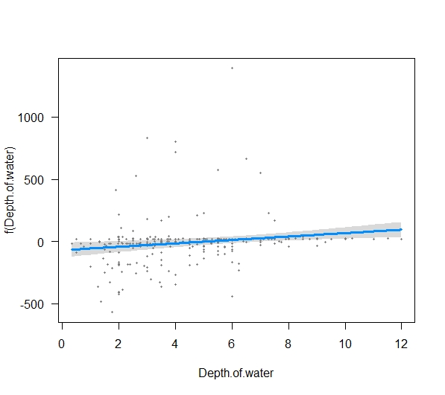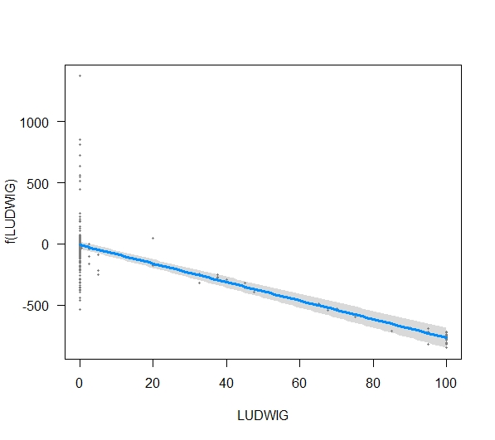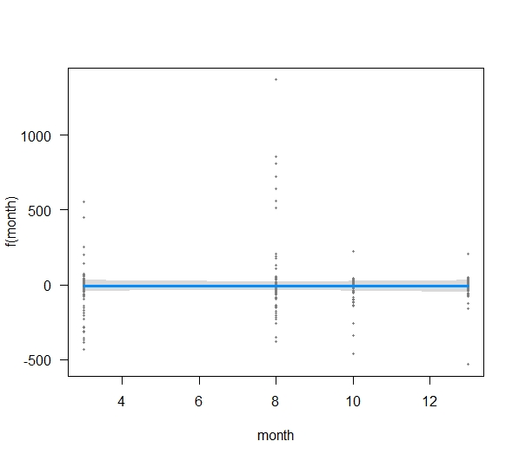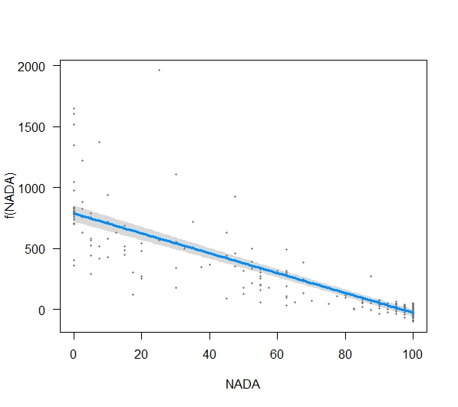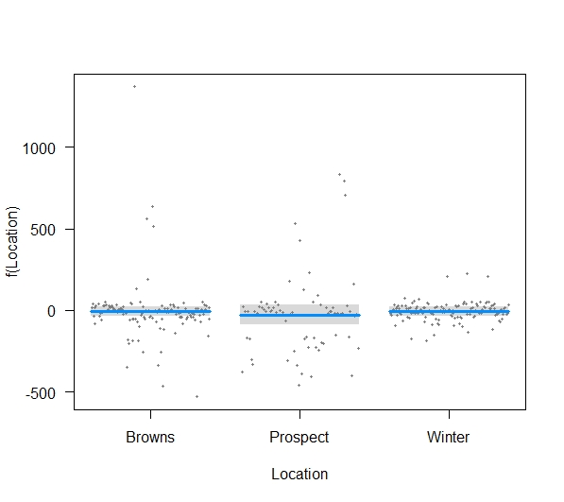

|  |  |  |  |  |  |  |  |  |  |  |  |  |  |  |  |  |  |  |  |  |
| --- | --- | --- | --- | --- | --- | --- | --- | --- | --- | --- | --- | --- | --- | --- | --- | --- | --- | --- | --- | --- |
| **Site** | **Year** | **Month** | **Azolla spp.** | **Ceratophyllum demersum** | **Elodia spp.** | **Filamentous algae** | **Stuckenia pectinata** | **Sum natives** |  | | **Cabomba caroliniana** | | **Egeria densa** | **Ludwigia spp.** | **Myriophyllum spicatum** | **Potamogeton crispis** | **Sum invasives** | **Unidentified species** | **Nothing** | **Average rake biomass (g)** |
| Browns Island | 2018 | March | 0.00 | 0.30 | 0.06 | 0.12 | 0.06 | **0.55** |  | | 0.00 | | 0.12 | 0.00 | 0.30 | 0.67 | **1.10** | 0.00 | **98.35** | 1.98 |
| Browns Island | 2018 | August | 0.00 | 2.91 | 1.19 | 2.59 | 10.61 | **17.30** |  | | 0.00 | | 1.08 | 0.00 | 3.05 | 2.24 | **6.38** | 0.15 | **76.28** | 241.82 |
| Browns Island | 2018 | October | 0.00 | 3.41 | 3.61 | 0.71 | 3.64 | **11.36** |  | | 0.00 | | 1.53 | 0.00 | 2.30 | 1.41 | **5.24** | 0.00 | **83.64** | 55.87 |
| Browns Island | 2019 | January | 0.00 | 0.42 | 2.61 | 0.06 | 0.08 | **3.18** |  | | 0.00 | | 0.02 | 0.00 | 1.55 | 0.68 | **2.24** | 0.00 | **94.76** | 8.05 |
| Winter Island | 2018 | March | 0.00 | 1.63 | 0.06 | 0.58 | 0.93 | **3.20** |  | | 0.00 | | 1.51 | 0.00 | 0.76 | 0.35 | **2.62** | 0.07 | **94.13** | 19.49 |
| Winter Island | 2018 | August | 0.00 | 1.62 | 0.01 | 2.85 | 3.33 | **7.81** |  | | 0.00 | | 2.35 | 35.77 | 3.10 | 2.32 | **43.54** | 0.00 | **48.69** | 94.42 |
| Winter Island | 2018 | October | 0.00 | 0.43 | 0.41 | 0.64 | 1.35 | **2.82** |  | | 0.00 | | 3.78 | 27.78 | 0.32 | 2.30 | **34.19** | 0.00 | **61.08** | 44.79 |
| Winter Island | 2019 | January | 0.00 | 1.08 | 0.08 | 0.07 | 0.00 | **1.23** |  | | 0.00 | | 1.43 | 21.62 | 0.34 | 0.69 | **24.08** | 0.00 | **74.73** | 23.01 |
| Liberty Island | 2018 | March | 0.00 | 0.75 | 1.38 | 0.34 | 0.00 | **2.47** |  | | 0.00 | | 8.16 | 0.00 | 0.90 | 1.51 | **10.57** | 0.00 | **87.21** | 76.67 |
| Prospect Island | 2018 | March | 0.34 | 23.65 | 1.03 | 4.09 | 0.00 | **29.11** |  | | 0.00 | | 0.16 | 25.26 | 11.47 | 0.08 | **36.98** | 0.00 | **33.93** | 181.66 |
| Prospect Island | 2018 | August | 0.08 | 24.92 | 5.27 | 0.15 | 11.22 | **41.63** |  | | 0.00 | | 0.00 | 33.17 | 12.45 | 0.03 | **45.65** | 0.00 | **13.08** | 443.88 |
|  |  |  |  |  |  |  |  |  |  |  | |  |  |  |  |  |  |  |  |  |  |

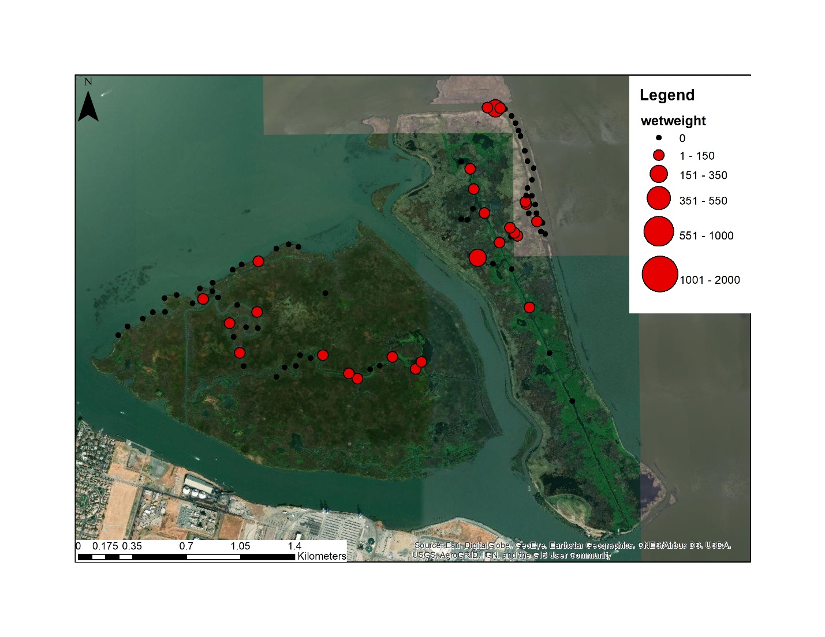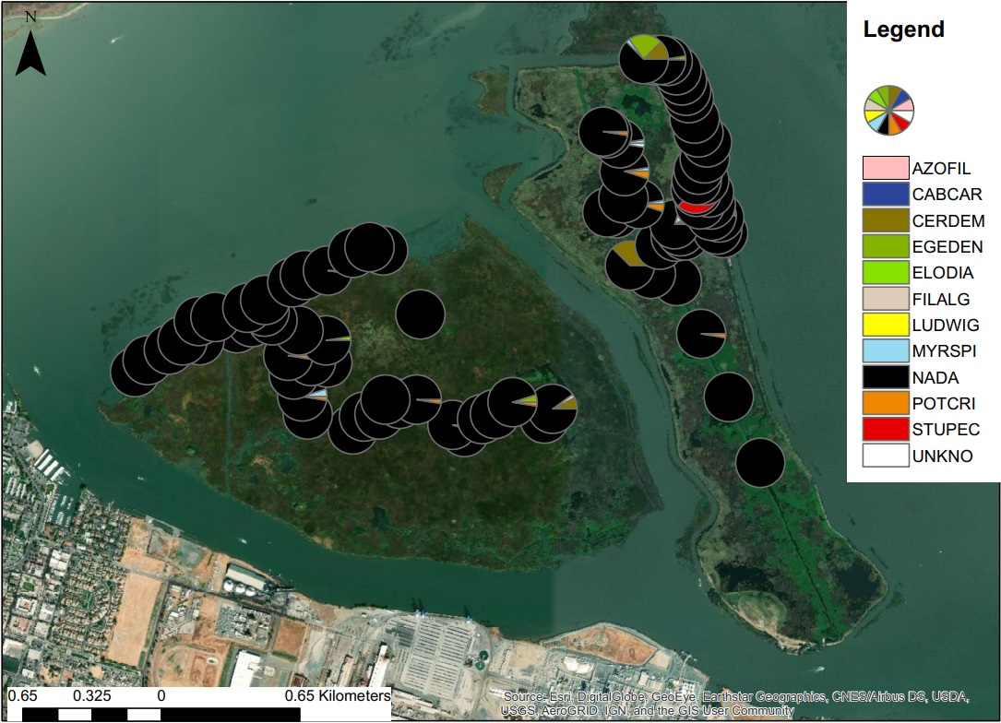

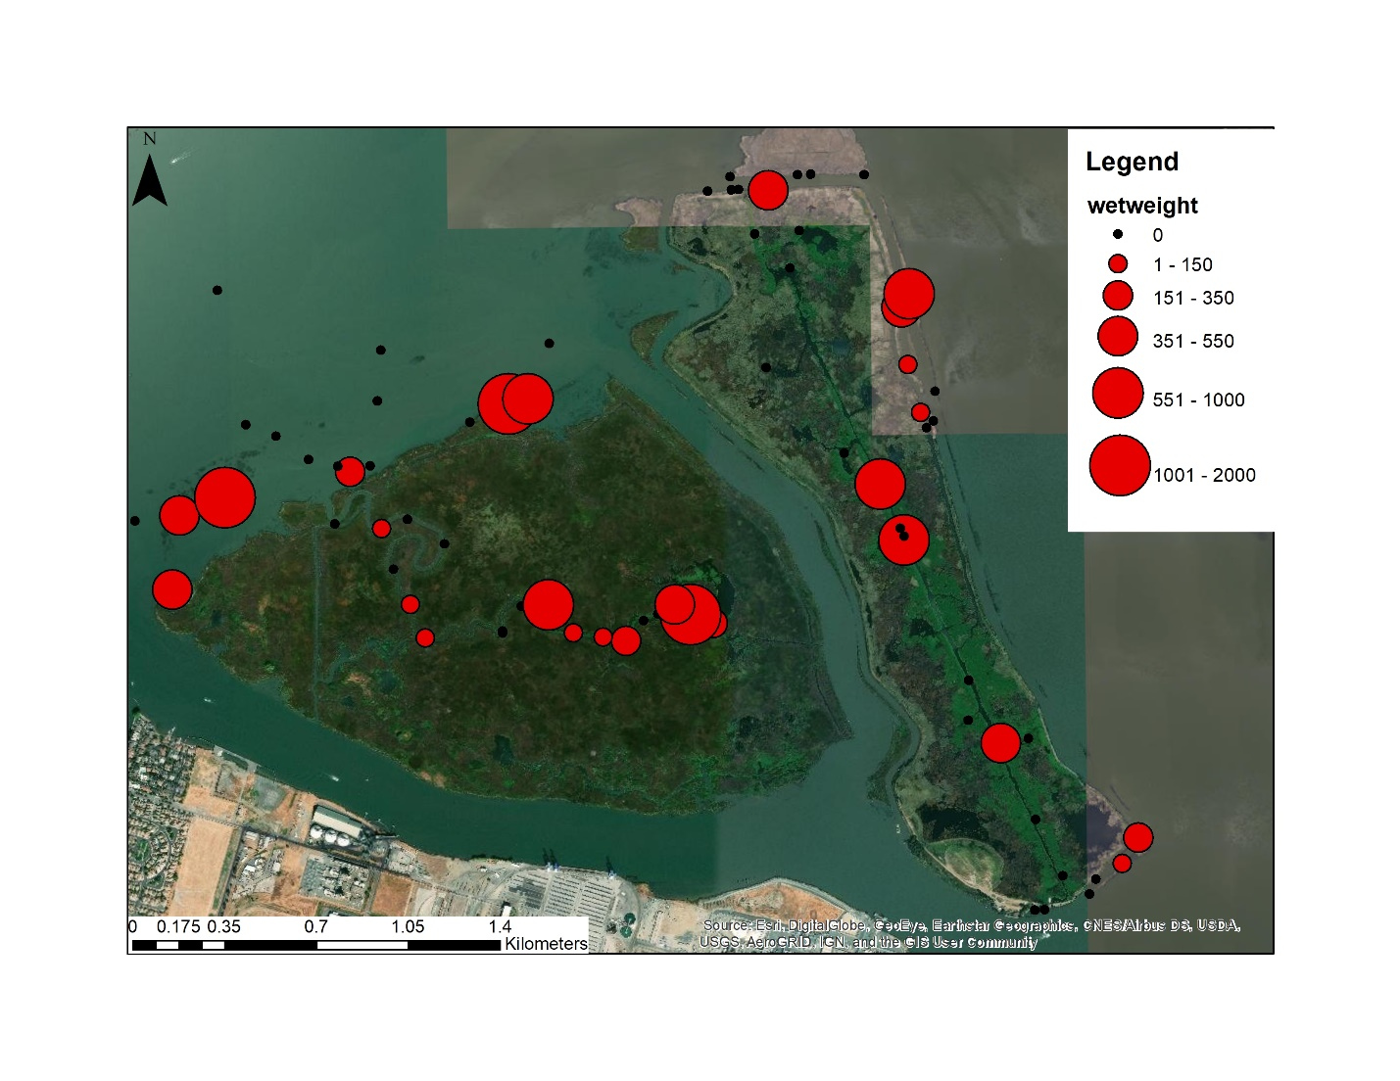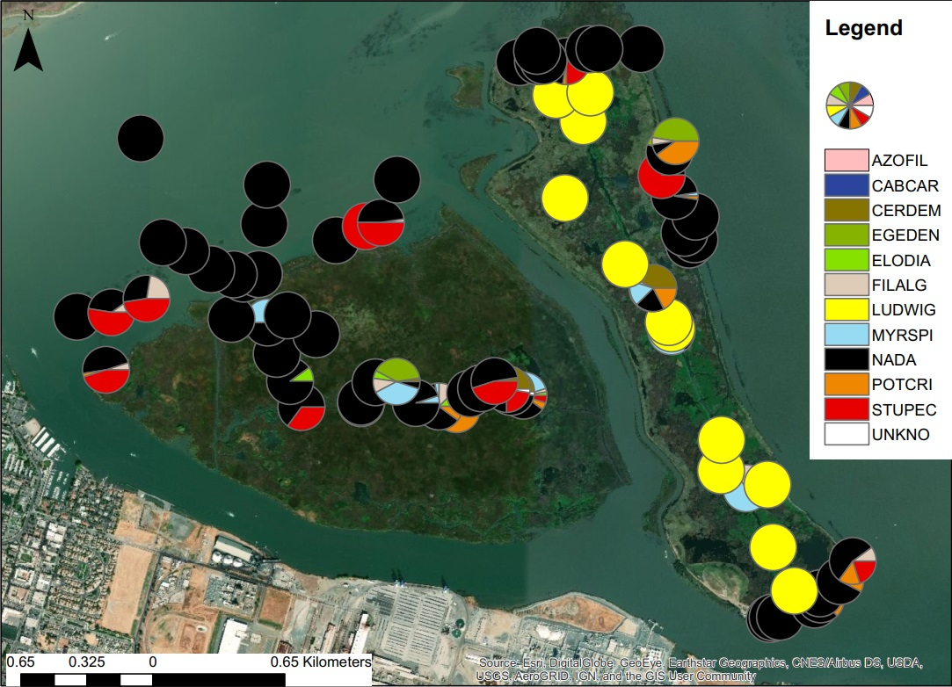

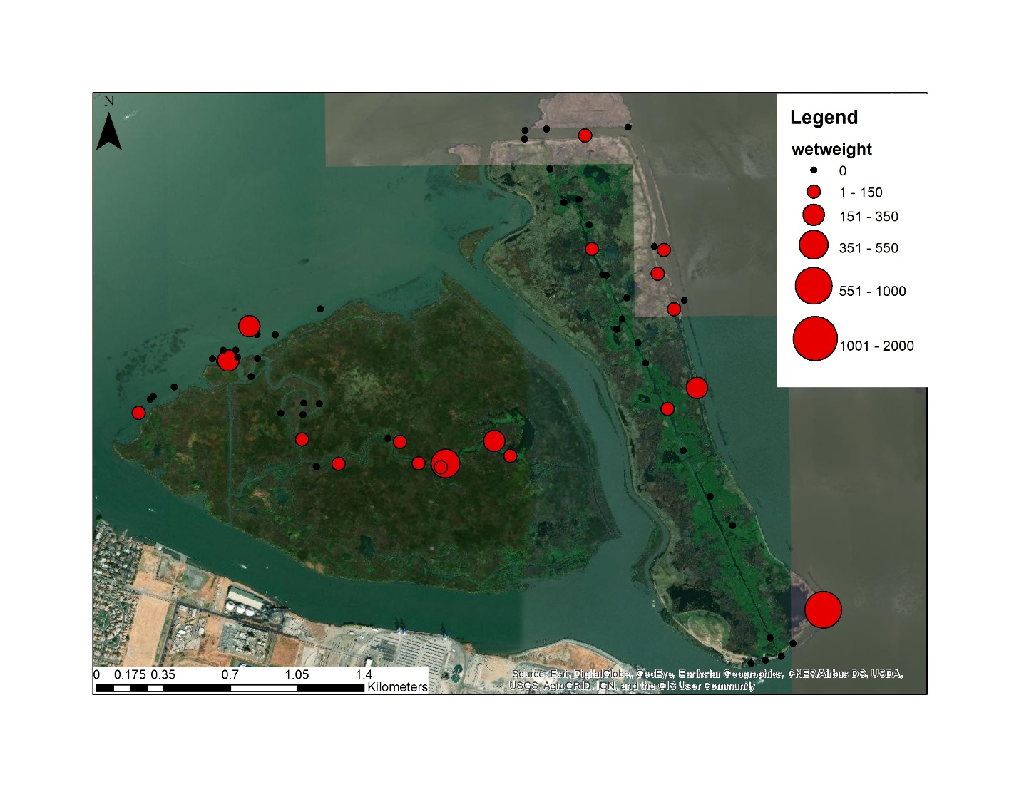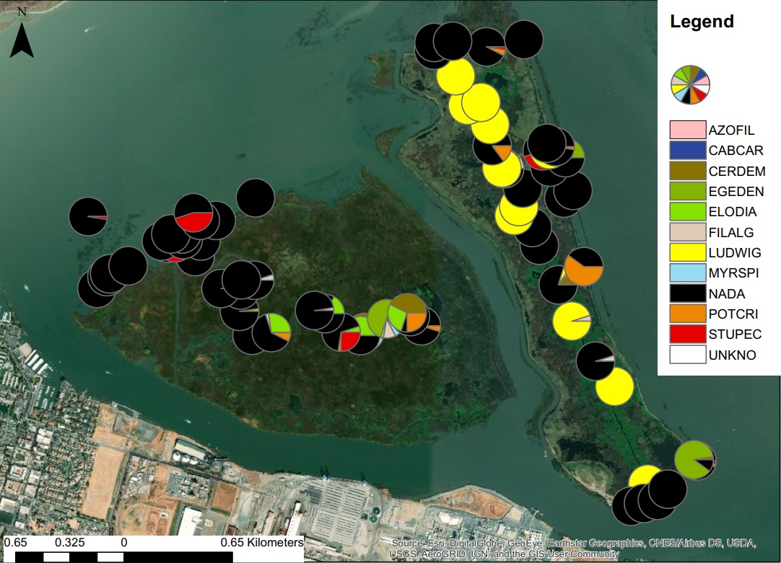

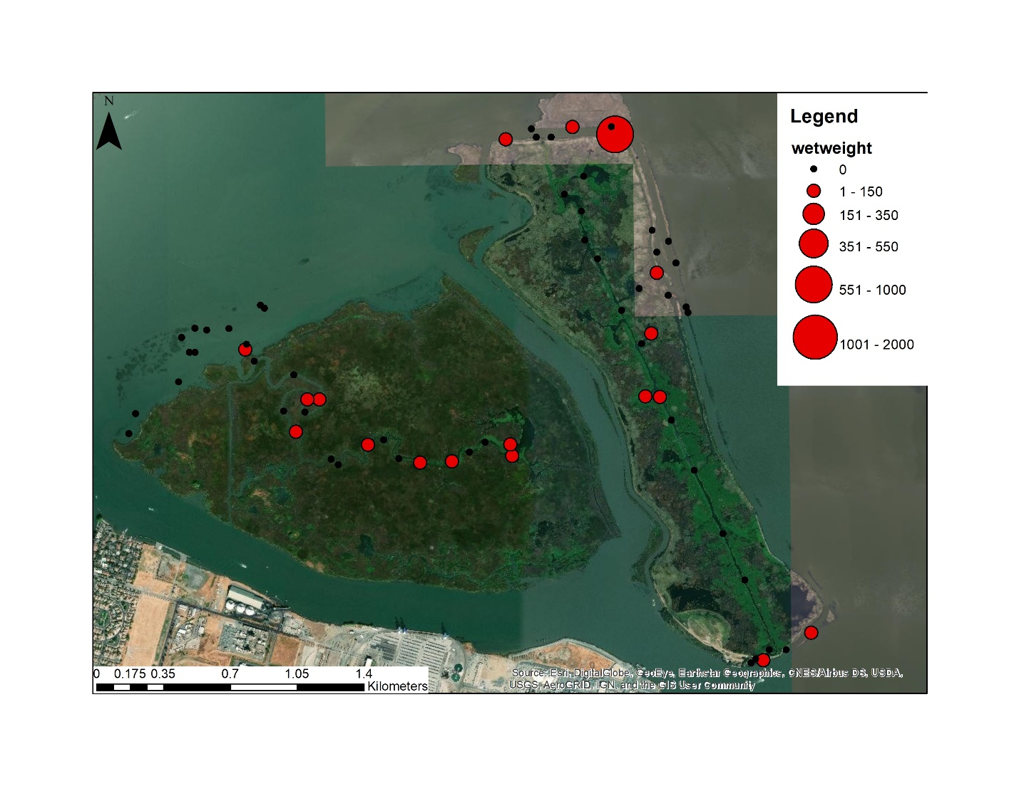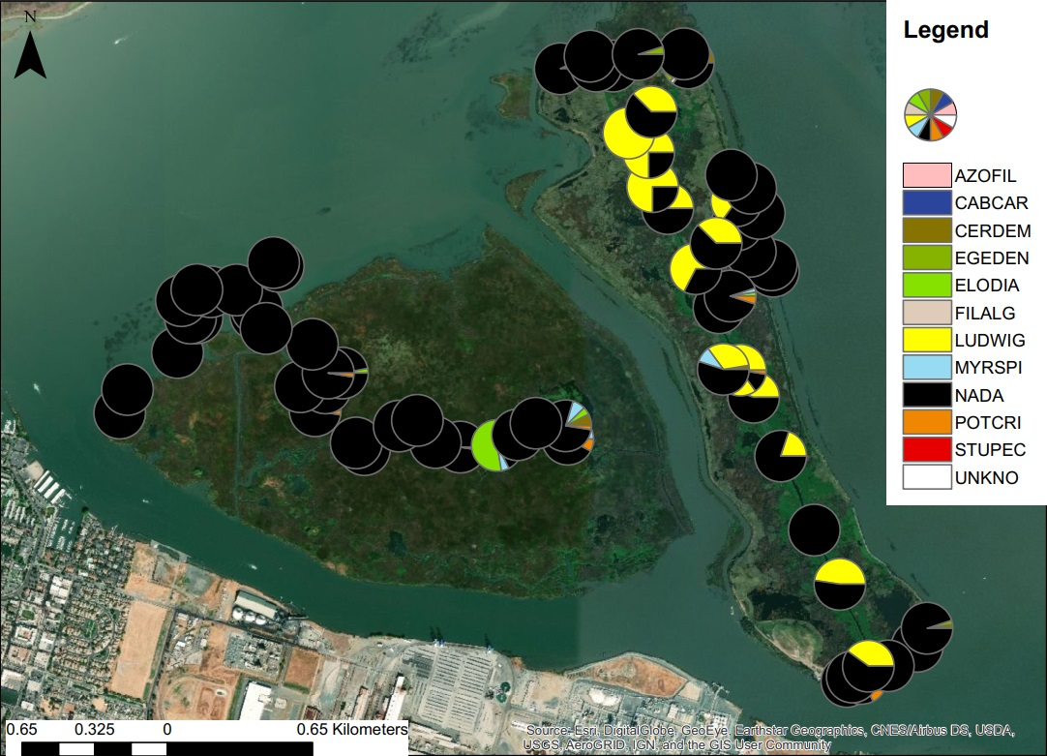

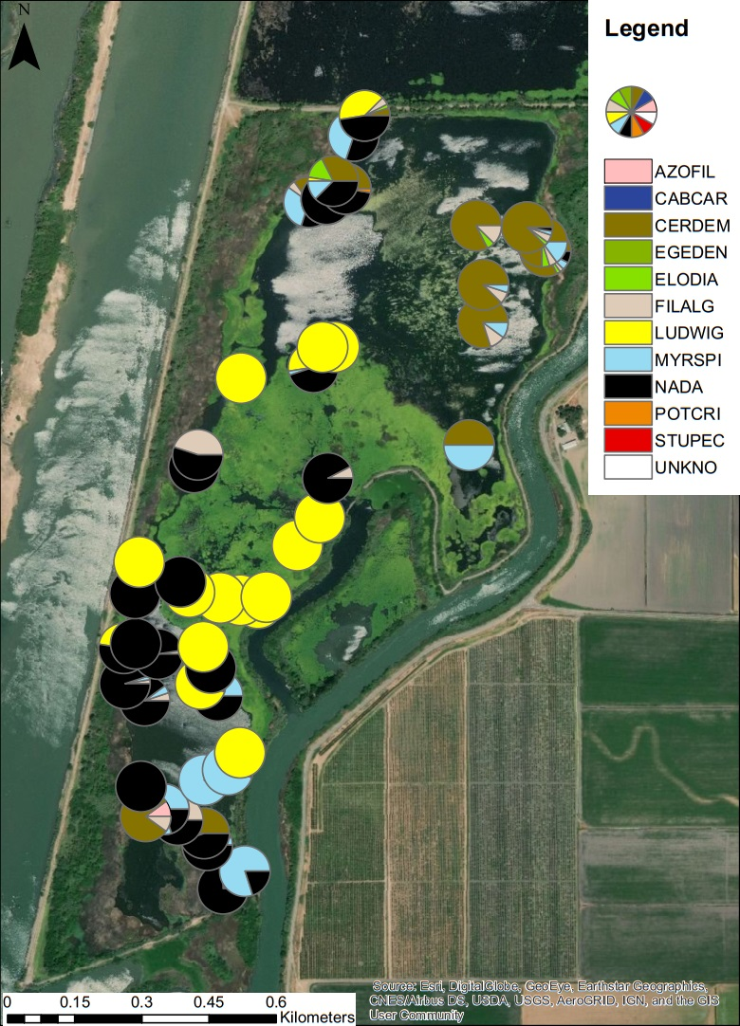

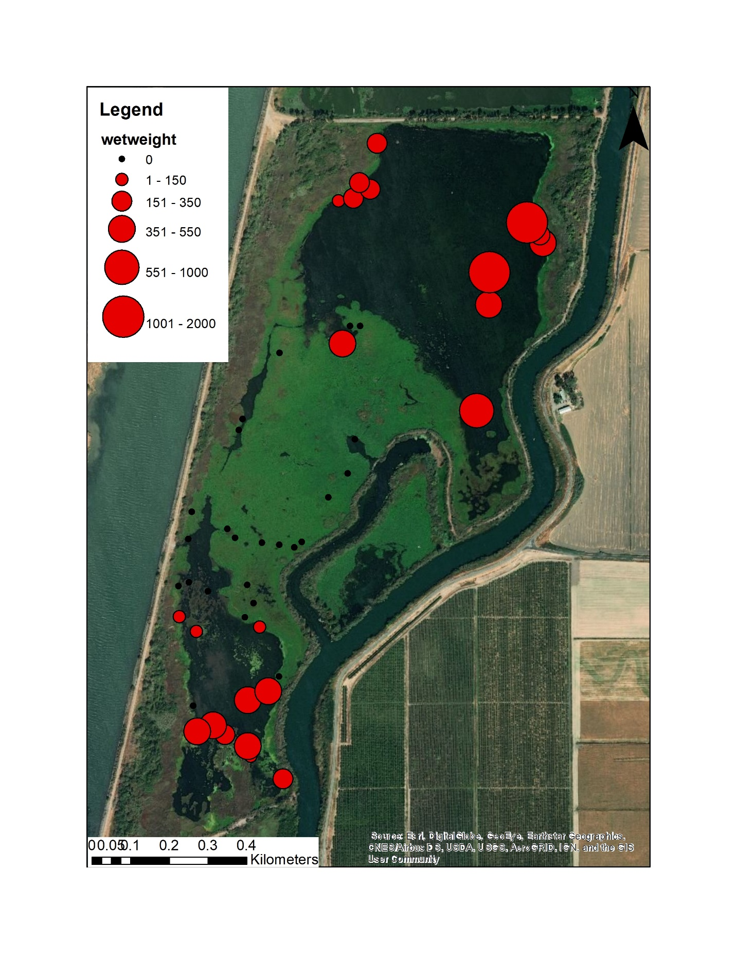

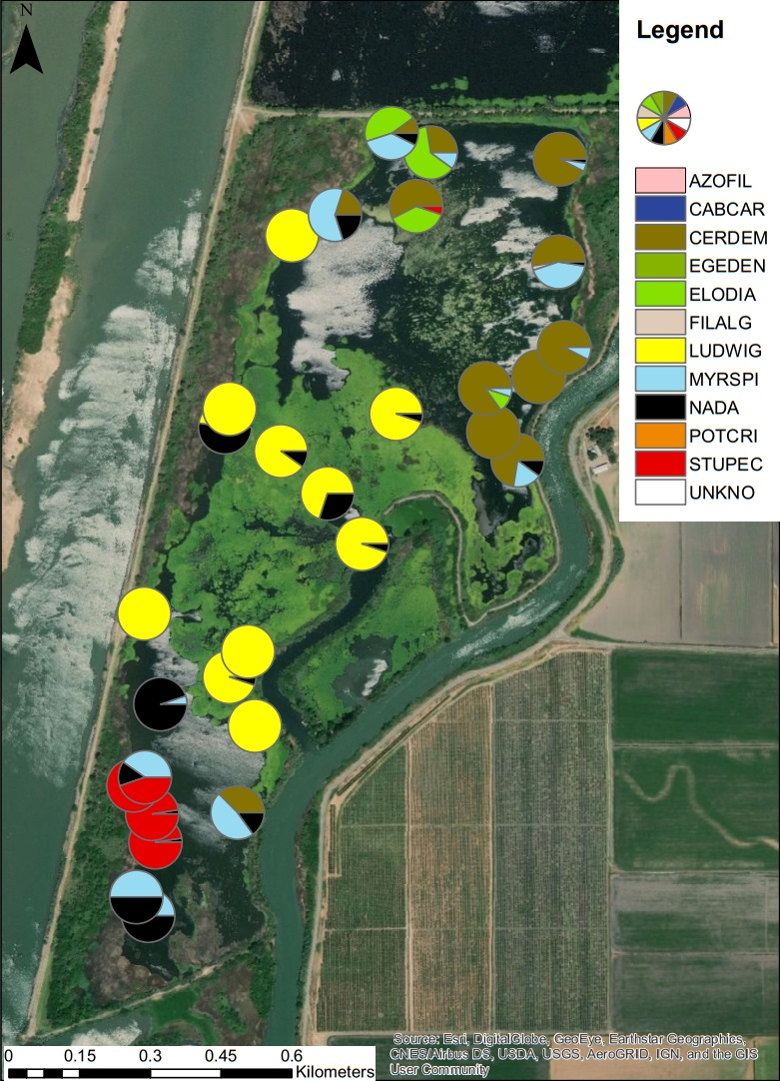

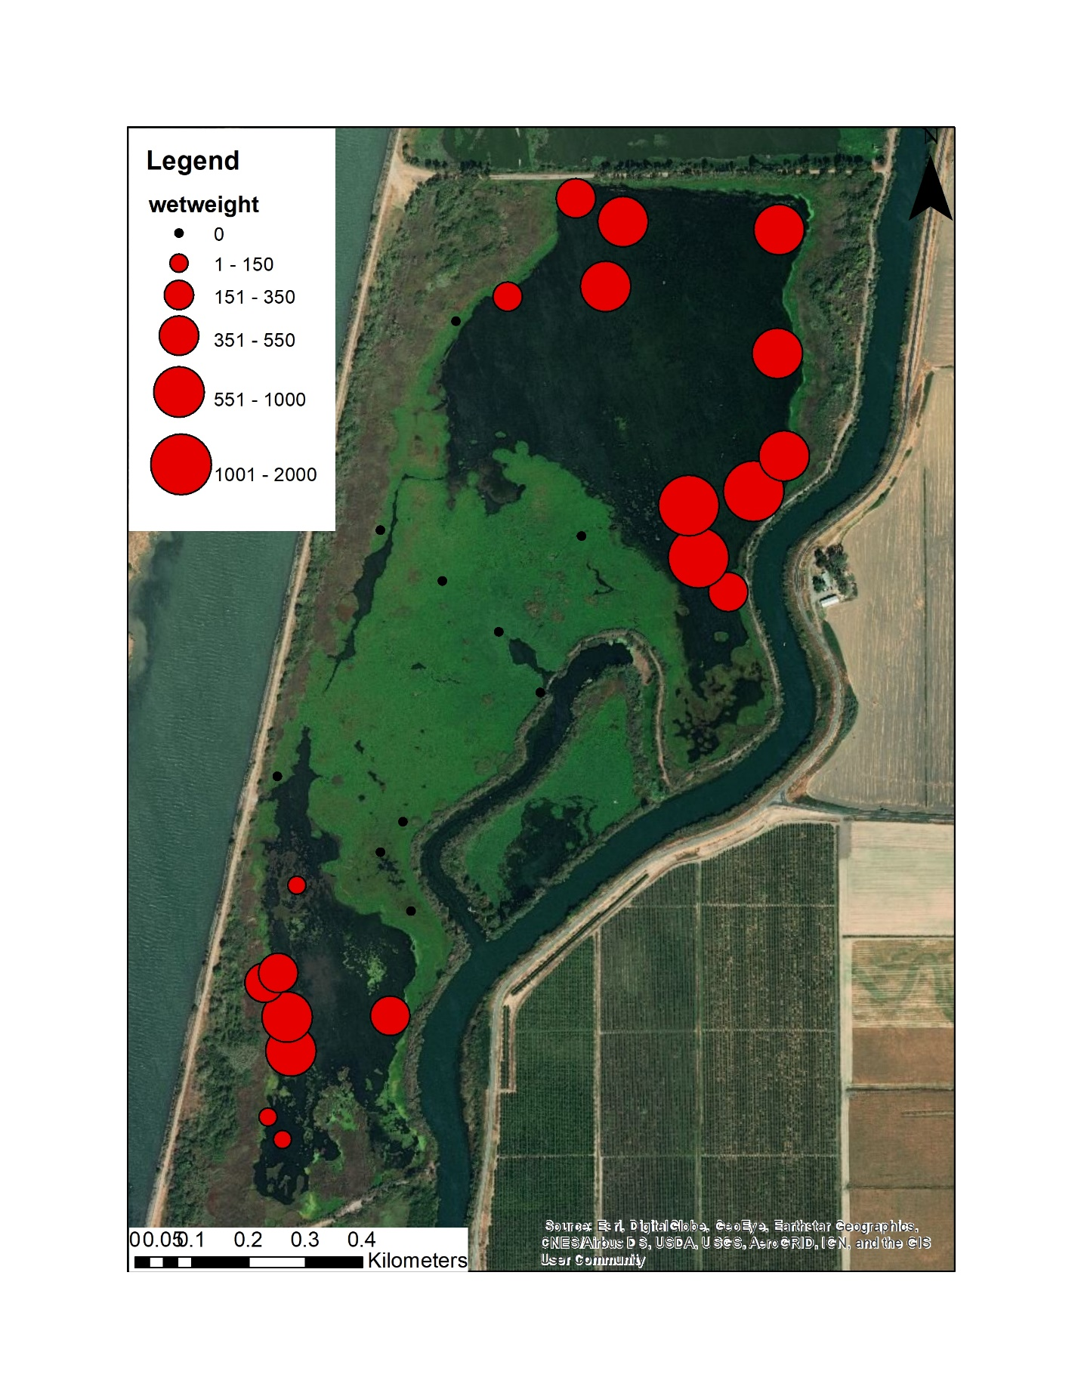

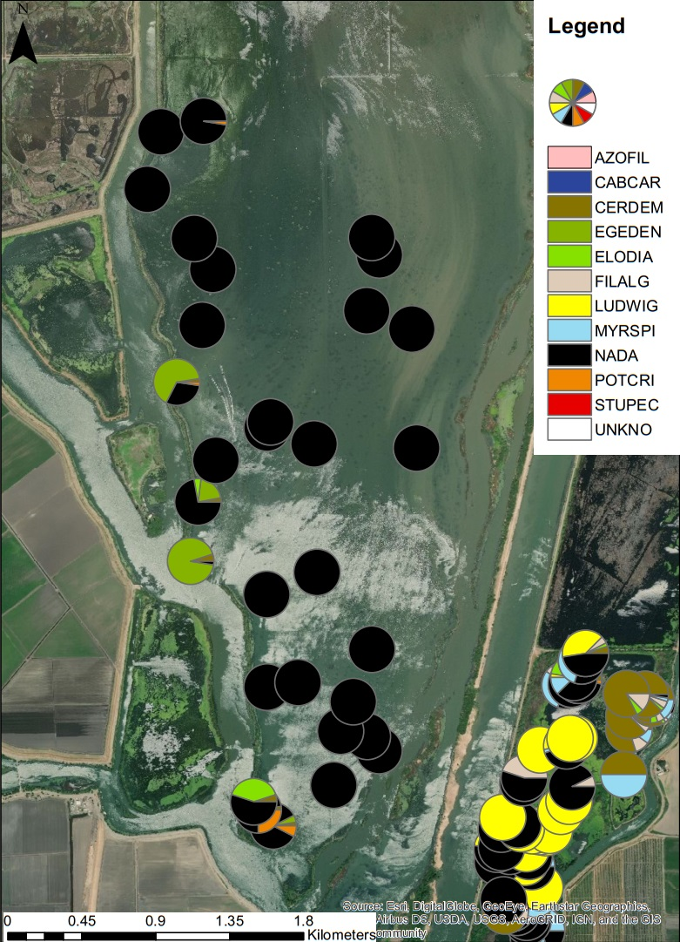

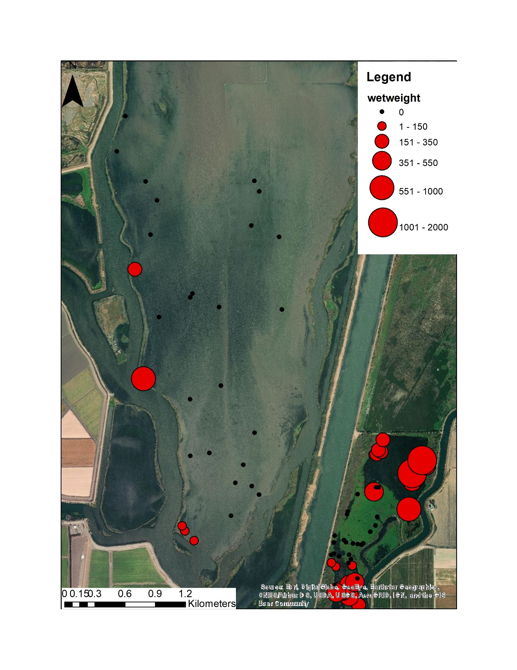

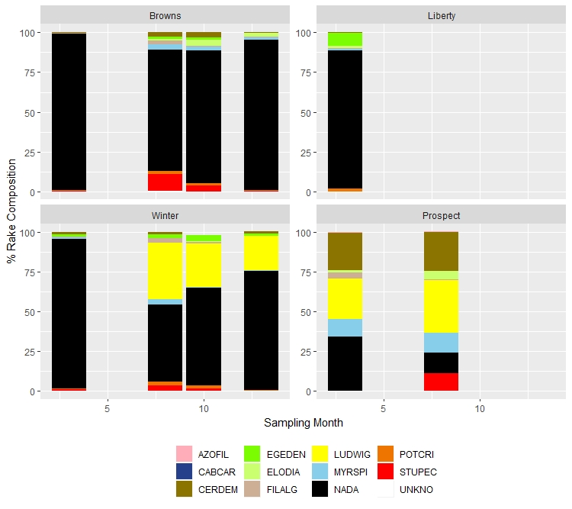

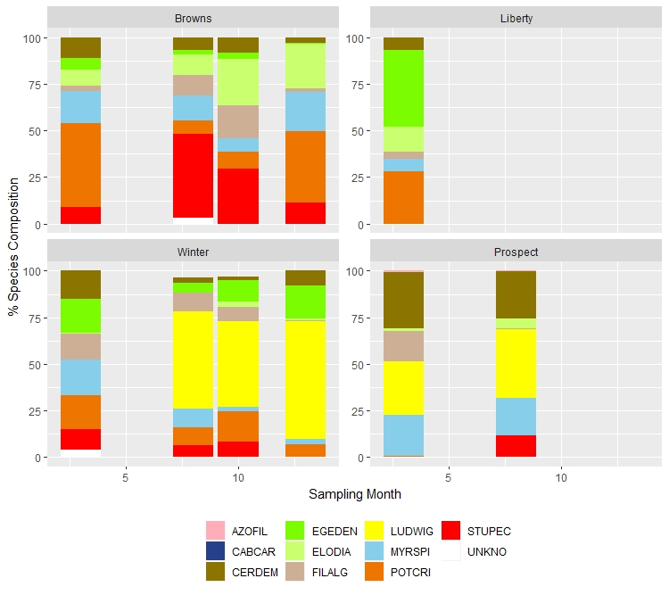

|  |  |  |  |  |  |  |  |
| --- | --- | --- | --- | --- | --- | --- | --- |
| **PERMANOVA with reps + quads distinct** | | |  |  |  |  |  |
| **Single replicate from each quadrat (Browns and winter only, all months):** | | | | | |  |  |
| Call: |  |  |  |  |  |  |  |
| adonis(formula = data1 ~ Location + month + rep.num, data = data2) |  |  |  |  |  |  |  |
|  |  |  |  |  |  |  |  |
| Permutation: free |  |  |  |  |  |  |  |
| Number of permutations: 999 |  |  |  |  |  |  |  |
|  |  |  |  |  |  |  |  |
| Terms added sequentially (first to last) |  |  |  |  |  |  |  |
|  |  |  |  |  |  |  |  |
|  | Df | SumsOfSqs | MeanSqs | F.Model | R2 | Pr(>F) |  |
| Location | 1 | 6.093 | 6.0931 | 48.202 | 0.0742 | 0.001 | *** |
| month | 1 | 1.373 | 1.373 | 10.862 | 0.01672 | 0.001 | *** |
| rep.num | 1 | 0.07 | 0.0697 | 0.551 | 0.00085 | 0.614 |  |
| Residuals | 590 | 74.581 | 0.1264 | 0.90823 |  |  |  |
| Total | 593 | 82.117 | 1 |  |  |  |  |
| --- |  |  |  |  |  |  |  |
| Signif. codes: 0 ‘***’ 0.001 ‘**’ 0.01 ‘*’ 0.05 ‘.’ 0.1 ‘ ’ 1 |  |  |  |  |  |  |  |
| > summary(perm) |  |  |  |  |  |  |  |
| Length Class Mode |  |  |  |  |  |  |  |
| aov.tab 6 anova list |  |  |  |  |  |  |  |
| call 3 -none- call |  |  |  |  |  |  |  |
| coefficients 60 -none- numeric |  |  |  |  |  |  |  |
| coef.sites 2376 -none- numeric |  |  |  |  |  |  |  |
| f.perms 2997 -none- numeric |  |  |  |  |  |  |  |
| model.matrix 2376 -none- numeric |  |  |  |  |  |  |  |
| terms 3 terms call |  |  |  |  |  |  |  |
|  |  |  |  |  |  |  |  |

|  |  |  |  |  |  |  |  |  |  |
| --- | --- | --- | --- | --- | --- | --- | --- | --- | --- |
| **Single replicate from each quadrat Browns, Winter, Prospect (all months):** | | | | | | | |  |  |
| Call: |  |  |  |  |  |  |  |  |  |
| adonis(formula = allsites1 ~ Location + month + rep.num, data = allsites2) | | | | | | | | | |
|  |  |  |  |  |  |  |  |  |  |
| Permutation: free | | |  |  |  |  |  |  |  |
| Number of permutations: 999 | | | |  |  |  |  |  |  |
|  |  |  |  |  |  |  |  |  |  |
| Terms added sequentially (first to last) | | | | | |  |  |  |  |
|  |  |  |  |  |  |  |  |  |  |
|  | Df | SumsOfSqs | MeanSqs | F.Model | R2 | Pr(>F) |  |  |  |
| Location | 2 | 33.275 | 16.6377 | 96.744 | 0.19797 | 0.001 | *** |  |  |
| month | 1 | 2.286 | 2.2863 | 13.295 | 0.0136 | 0.001 | *** |  |  |
| rep.num | 1 | 0.104 | 0.1037 | 0.603 | 0.00062 | 0.603 |  |  |  |
| Residuals | 770 | 132.421 | 0.172 | 0.78782 |  |  |  |  |  |
| Total | 774 | 168.086 | 1 |  |  |  |  |  |  |
| --- |  |  |  |  |  |  |  |  |  |
| Signif. codes: 0 ‘***’ 0.001 ‘**’ 0.01 ‘*’ 0.05 ‘.’ 0.1 ‘ ’ 1 | | | | | | | |  |  |
| > summary(perm) | |  |  |  |  |  |  |  |  |
| Length Class Mode | | | | |  |  |  |  |  |
| aov.tab 6 anova list | | | | |  |  |  |  |  |
| call 3 -none- call | | | | |  |  |  |  |  |
| coefficients 75 -none- numeric | | | | |  |  |  |  |  |
| coef.sites 3875 -none- numeric | | | | |  |  |  |  |  |
| f.perms 2997 -none- numeric | | | | |  |  |  |  |  |
| model.matrix 3875 -none- numeric | | | | |  |  |  |  |  |
| terms 3 terms call |  |  |  |  |  |  |  |  |  |
|  |  |  |  |  |  |  |  |  |  |
|  |  |  |  |  |  |  |  |  |  |

**Algae:** There were significant differences in algal communities collected in different microhabitats at Liberty Island (Table 16). In particular, pelagic samples had more *Microcystis*, benthic samples had more *Oscillatoria*, and filamentous algae had more *Oedogonium* (Figure 24). This was apparent from the separation in the NMDS plot (Figure 24), however the sample sizes were relatively small. There were surprisingly few taxa pulled out as indicator species. Only five taxa were indicated as being associated with open water, and two species with benthic/epiphytic samples (Table 17). We attempted to identify indicator species for SAV, EAV, and benthic samples separately, but none were selected until we combined the groups into to groupings: “Pelagic” and “Benthic/epiphytic”.



Figure 24 - community composition of algal samples from different microhabitats in Liberty Island.

Table 17 – Results of a PERMANOVA comparing algae collected in different habitat types at Liberty Island in March of 2018.

|  |  |  |  |  |  |  |  |
| --- | --- | --- | --- | --- | --- | --- | --- |
| Factor | DF | SumsOfSqs | MeanSqs | F value | R2 | P value |  |
| Habitat | 4 | 1.3518 | 0.33795 | 2.4844 | 0.45299 | 0.003 | ** |
| Residuals | 12 | 1.6324 | 0.13603 |  | 0.54701 |  |  |
| Total | 16 | 2.9842 |  |  | 1 |  |  |



Figure 25. NMDS plot of algal samples taken from different habitat types at Liberty Island. The sample labled “other” is a sample of filamentous algae.

Table 18. Multilevel pattern analysis of invertebrate associations with wetlands of differing types. A significant p value indicates the particular taxa was positively associated with a particular habitat type. Habitat types were combined so that there were only two groups, “Pelagic” and “Benthic/epiphytic”.

|  |  |  |  |
| --- | --- | --- | --- |
| **Pelagic** |  |  |  |
|  | **stat** | **P value** |  |
| *Cyclotella* | 0.988 | 0.005 | ** |
| *Teleaulax* | 0.983 | 0.005 | ** |
| *Monoraphidium* | 0.924 | 0.005 | ** |
| *Cryptomonas* | 0.896 | 0.010 | * |
| *Achnanthidium* | 0.754 | 0.020 | * |
|  |  |  |  |
|  |  |  |  |
| **Benthic/epiphytic** |  |  |  |
|  | **stat** | **P value** |  |
| *Melosira* | 0.895 | 0.025 | * |
| *Oscillatoria* | 0.858 | 0.030 | * |
|  |  |  |  |

## Discussion

## Algae

We expected to observe significantly different communities exiting the wetland than are observed in the exterior channel, and that differences will be driven by higher abundances of epibenthic and epiphytic taxa in the wetland channels. Samples from the surface of vegetation and benthic substrates within the wetland will have greater overlap in community composition when compared to tidal channels than with exterior channels. However, our sample size during 2018 was too small to make any firm conclusions about taxa that can be labeled as definitively “benthic” or “pelagic”.

There were some significant differences in communities between microhabitats, but the degree of overlap between hulls on the NMDS is difficult to interpret with only a few samples per group. It does seem that the benthic, epiphytic, and filamentous samples cluster together, while the pelagic samples form a separate grouping (Figure 25). There were also few species identified as “indicators” for of pelagic versus benthic/epiphytic habitats. Of the indicator species that were identified, *Cyclotella* is a centric diatom considered to be good zooplankton food and historically common in the LSZ (Lehman 2000). *Teleaulax* is a generalist mixotorophic cryptophyte that can withstand varying salinities, light availability, and temperatures (Cloern and Dufford 2005). *Monoraphidium* is a green algae found to be abundant in the central Delta and considered to be good zooplankton food (Lehman et al. 2010). *Cryptomonas* is a small cryptophyte considered to be highly nutritious (Burns et al. 2011), but rarely consumed by zooplankton (Kimmerer et al. 2018a) and found to be associated with the toxic cyanobacteria *Microcystis* (Lehman et al. 2010), though no *Microcystis* was found in these samples. *Achanathidium* is a genus of pennate diatoms that are more often benthic than pelagic (Potapova and Hamilton 2007), so it was somewhat surprising to see it associated with the “pelagic” samples. This may have been an artifact of our low sample size, or may be due to the high wind-wave resuspention of benthic sediments common on Liberty Island. The indicators for benthic/epiphytic habitats were *Melosira*, a chain-forming centric diatom, and *Oscillatoria,* a chain-forming cyanobacteria that can produce toxins (Paerl and Otten 2013).

We repeated our sampling of microhabitats in 2019 at a difference site (Little Honker Bay), and will re-sample some of these sites in 2020. With an increased sample size at a wider variety of sites, we may be able to make inferences as to differences in epibenthic versus pelagic contributions to phytoplankton at various wetland sites.

# Endangered Species Act Take

Table 19. Take of listed fish species in all FRP sampling during 2018. Gears not listed had zero take.

|  |  |  |  |  |  |  |  |  |  |
| --- | --- | --- | --- | --- | --- | --- | --- | --- | --- |
|  | **Listed fish species take** | | | | | | | | |
| **Gear Type** | **Chinook Salmon** | **Steelhead** | **Delta Smelt (larval)** | **Delta Smelt (juv)** | **Delta Smelt (adult)** | **Longfin Smelt (larval)** | **Longfin Smelt (juv)** | **Longfin Smelt (adult)** | **Green Sturgeon** |
| Mysid Trawls | 0 | 0 | 2 | 0 | 0 | 25 | 0 | 0 | 0 |
| Beach Seine | 2 (fall-run) | 0 | 0 | 0 | 0 | 0 | 0 | 0 | 0 |
| **Total** | **2** | **0** | **2** | **0** | **0** | **25** | **0** | **0** | **0** |

# References

Ahearn, D. S., J. H. Viers, J. F. Mount, and R. A. Dahlgren. 2006. Priming the productivity pump: flood pulse driven trends in suspended algal biomass distribution across a restored floodplain. Freshwater Biology 51:1417-1433.

American Public Health Association (APHA). 2017. Standard methods for the examination of water and wastewater, 23 edition. American Public Health Association, American Water Works Association, and Water Environment Federation.

Bates, D., M. Maechler, B. Bolker, and S. Walker. 2016. lme4: Linear Mixed-Effects Models using 'Eigen' and S4. The Comprehensive R Archive Network (CRAN). <https://github.com/lme4/lme4/> <http://lme4.r-forge.r-project.org>

Baxter, R., L. R. Brown, G. Castillo, L. Conrad, S. Culberson, M. Dekar, F. Feyrer, L. Grimaldo, T. Hunt, J. Kirsch, A. Mueller-Solger, S. Slater, T. Sommer, and K. Souza. 2015. An updated conceptual model for Delta Smelt: our evolving understanding of an estuarine fish. Interagency Ecological Program, Sacramento, CA.

Bennett, W. A., and J. R. Burau. 2015. Riders on the Storm: Selective Tidal Movements Facilitate the Spawning Migration of Threatened Delta Smelt in the San Francisco Estuary. Estuaries and Coasts 38(3):826-835. 10.1007/s12237-014-9877-3

Bollens, S. M., J. Breckenridge, J. R. Cordell, C. Simenstad, and O. Kalata. 2014. Zooplankton of tidal marsh channels in relation to environmental variables in the upper San Francisco Estuary. Aquatic Biology 21:205-219.

Bottom, D. L., A. Baptista, J. Burke, L. Campbell, E. Casillas, S. Hinton, D. A. Jay, M. A. Lott, G. McCabe, R. McNatt, M. Ramirez, G. C. Roegner, S. C.A., S. Spilseth, L. Stamatiou, D. Teel, and J. E. Zamon. 2011. Estuarine habitat and juvenile salmon: current and historical linkages in the Lower Columbia River and Estuary. Northwest Fisheries Science Center, U.S. National Marine Fisheries Service, National Oceanic and Atmospheric Administration, Seattle, WA.

Bouley, P., and W. J. Kimmerer. 2006. Ecology of a highly abundant, introduced cyclopoid copepod in a temperate estuary. Marine Ecology Progress Series 324:219-228.

Boyer, K., E. Borgnis, J. Miller, J. Moderan, and M. Patten. 2013. Habitat Values of Native SAV (*Stukenia spp*.) in the Low Salinity Zone of San Francisco Estuary, Final Project Report. Delta Stewardship Council, Sacramento, CA.

Brandes, P. L., and J. S. McLain. 2000. Juvenile Chinook salmon abundance, distribution, and survival in the Sacramento-San Joaquin Estuary. Citeseer.

Brown, L. R. 2003. Will tidal wetland restoration enhance populations of native fishes? San Francisco Estuary and Watershed Science 1(1):43 pages.

Brown, L. R., R. Baxter, G. Castillo, L. Conrad, S. Culberson, G. Erickson, F. Feyrer, S. Fong, K. Gehrts, L. Grimaldo, B. Herbold, J. Kirsch, A. Mueller-Solger, S. Slater, T. Sommer, K. Souza, and E. Van Nieuwenhuyse. 2014. Synthesis of studies in the fall low salinity zone of the San Francisco Estuary, September-December 2011. U.S. Department of the Interior, U.S. Geological Survey, Sacramento, CA.

Brown, L. R., W. Kimmerer, J. L. Conrad, S. Lesmeister, and A. Mueller–Solger. 2016. Food webs of the Delta, Suisun Bay, and Suisun Marsh: an update on current understanding and possibilities for management. San Francisco Estuary and Watershed Science 14(3).

Burns, C. W., M. T. Brett, and M. Schallenberg. 2011. A comparison of the trophic transfer of fatty acids in freshwater plankton by cladocerans and calanoid copepods. Freshwater Biology 56(5):889-903. doi:10.1111/j.1365-2427.2010.02534.x

Busby, M. S., and R. A. Barnhart. 1995. Potential food sources and feeding ecology of juvenile fall chinook salmon in California's Mattole River lagoon. California Fish and Game 81(4):133-146.

Cáceres, M. D., and F. Jansen. 2016. Package: indicspecies. Studying the statistical relationship between species and groups of sites. The Comprehensive R Archive Network (CRAN). <https://cran.r-project.org/package=indicspecies>

Canuel, E. A., J. E. Cloern, D. B. Ringelberg, J. B. Guckert, and G. H. Rau. 1995. Molecular and Isotopic Tracers Used to Examine Sources of Organic Matter and its Incorporation Into the Food Webs of San Francisco Bay. Limnology and Oceanography 40(1):67-81.

Cloern, J. E., and R. Dufford. 2005. Phytoplankton community ecology: principles applied in San Francisco Bay. Marine Ecology Progress Series 285:11-28.

Cloern, J. E., K. A. Hieb, T. Jacobson, B. Sanso, E. Di Lorenzo, M. T. Stacey, J. L. Largier, W. Meiring, W. T. Peterson, T. M. Powell, M. Winder, and A. D. Jassby. 2010. Biological communities in San Francisco Bay track large-sale climate forcing over the North Pacific. Geophysical Research Letters 37(L21602):6 pages.

Contreras, D., R. Hartman, and S. Sherman. 2017. Pilot Study Phase II: Results from 2016 gear evaluation in the North Delta. California Department of Fish and Wildlife, Fish Restoration Program, Stockton, CA.

Contreras, D., R. Hartman, and S. Sherman. 2018. Sampling fish and invertebrate resources in tidal wetlands of the Sacramento-San Joaquin Delta: Report on Phase III Pilot Monitoring, 2017. California Department of Fish and Wildlife, Stockton, CA.

Contreras, D., R. Hartman, S. Sherman, A. Furler, and A. Low. 2016. Pilot study phase I: Results from 2015 gear methodology trials in the North Delta. California Department of FIsh and Wildlife, Fish Restoration Program, Stockton, CA.

David, A. T., C. S. Ellings, I. Woo, C. A. Simenstad, J. Y. Takekawa, K. L. Turner, A. L. Smith, and J. E. Takekawa. 2014. Foraging and Growth Potential of Juvenile Chinook Salmon after Tidal Restoration of a Large River Delta. Transactions of the American Fisheries Society 143(6):1515-1529.

David, A. T., P. A. L. Goertler, S. H. Munsch, B. R. Jones, C. A. Simenstad, J. D. Toft, J. R. Cordell, E. R. Howe, A. Gray, M. P. Hannam, W. Matsubu, and E. E. Morgan. 2016a. Influences of Natural and Anthropogenic Factors and Tidal Restoration on Terrestrial Arthropod Assemblages in West Coast North American Estuarine Wetlands. Estuaries and Coasts 39(5):1491-1504. 10.1007/s12237-016-0091-3

David, A. T., C. A. Simenstad, J. R. Cordell, J. D. TOft, C. S. Ellings, A. Gray, and H. B. Berge. 2016b. Wetland loss, juvenile salmon foraging performance, and density dependence in Pacific Northwest estuaries. Estuaries and Coasts 39:767-780.

Downing, B. D., B. A. Bergamaschi, C. Kendall, T. E. C. Kraus, K. J. Dennis, J. A. Carter, and T. S. Von Dessonneck. 2016. Using Continuous Underway Isotope Measurements To Map Water Residence Time in Hydrodynamically Complex Tidal Environments. Environmental Science & Technology 50(24):13387-13396. 10.1021/acs.est.6b05745

Duffy, E. J., D. A. Beauchamp, R. M. Sweeting, R. J. Beamish, and J. S. Brennan. 2010. Ontogenetic diet shifts of juvenile Chinook salmon in nearshore and offshore habitats of Puget Sound. Transactions of the American Fisheries Society 139(3):803-823.

Glibert, P. M., R. Dugdale, F. P. Wilkerson, A. E. Parker, J. Alexander, E. Antell, S. Blaser, A. Johnson, J. Lee, T. Lee, S. Murasko, and S. Strong. 2014. Major–but rare–spring blooms in 2014 in San Francisco Bay Delta, California, a result of the long-term drought, increased residence time, and altered nutrient loads and forms. Journal of Experimental Marine Biology and Ecology 460:8-18.

Goertler, P., K. Jones, J. Cordell, B. Schreier, and T. Sommer. 2018. Effects of Extreme Hydrologic Regimes on Juvenile Chinook Salmon Prey Resources and Diet Composition in a Large River Floodplain. Transactions of the American Fisheries Society 147(2):287-299. doi:10.1002/tafs.10028

Goertler, P., K. Jones, J. Kirsch, J. L. Conrad, and T. Sommer. 2017. Chinook Salmon. S. Sherman, R. Hartman, and D. Contreras, editors. Effects of Tidal Wetland Restoration on Fish: A Suite of Conceptual Models, Interagency Ecological Program Technical Report 91. Department of Water Resources, Sacramento, CA.

Gray, A., C. A. Simenstad, D. L. Bottom, and T. J. Cornwell. 2002. Contrasting functional performance of juvenile salmon habitat in recovering wetlands of the Salmon River estuary, Oregon, U.S.A. Restoration Ecology 10(3):514-526.

Grimaldo, L., F. Feyrer, J. Burns, and D. Maniscalco. 2017. Sampling Uncharted Waters: Examining Rearing Habitat of Larval Longfin Smelt (*Spirinchus thaleichthys*) in the Upper San Francisco Estuary. Estuaries and Coasts:1-14.

Hammock, B. G., R. Hartman, S. B. Slater, A. Hennessy, and S. J. Teh. 2019. Tidal Wetlands Associated with Foraging Success of Delta Smelt. Estuaries and Coasts. 10.1007/s12237-019-00521-5

Hartman, R., L. Brown, and J. Hobbs. 2017a. Food Web Conceptual Model. S. Sherman, R. Hartman, and D. Contreras, editors. Effects of Tidal Wetland Restoration on Fish: A Suite of Conceptual Models, Interagency Ecological Program Technical Report 91. Department of Water Resources, Sacramento, CA.

Hartman, R., B. Herbold, K. Kayfetz, and S. Culberson. 2017b. Regional Transport Conceptual Model for Tidal Wetland Restoration. S. Sherman, R. Hartman, and D. Contreras, editors. Effects of Tidal Wetland Restoration on Fish: A Suite of Conceptual Models, Interagency Ecological Program Technical Report 91. Department of Water Resources, Sacramento, CA.

Hennessy, A. 2009. Zooplankton Meta Data. IEP Bay-Delta Monitoring and Analysis Section, Department of Water Resources, Sacramento, CA.

Hennessy, A., and T. Enderlein. 2013. Zooplankton monitoring 2011. IEP Newsletter 26(1):23-30.

Herbold, B., D. M. Baltz, L. Brown, R. Grossinger, W. Kimmerer, P. Lehman, C. S. Simenstad, C. Wilcox, and M. Nobriga. 2014. The role of tidal marsh restoration in fish management in the San Francisco Estuary. San Francisco Estuary and Watershed Science 12(1).

Howe, E. R., C. A. Simenstad, J. D. Toft, J. R. Cordell, and S. M. Bollens. 2014. Macroinvertebrate prey availability and fish diet selectivity in relation to environmental variables in natural and restoring North San Francisco Bay tidal marsh channels. San Francisco Estuary and Watershed Science 12(1).

IEP Tidal Wetland Monitoring Project Work Team (PWT). 2017. Tidal wetland monitoring framework for the upper San Francisco Estuary: Standard Operating Procedures.

Jassby, A. 2008. Phytoplankton in the upper San Francisco Estuary: recent biomass trends, their causes and their trophic significance. San Francisco Estuary and Watershed Science 6(1):24 pages.

Katz, J. V. E., C. Jeffres, J. L. Conrad, T. R. Sommer, J. Martinez, S. Brumbaugh, N. Corline, and P. B. Moyle. 2017. Floodplain farm fields provide novel rearing habitat for Chinook salmon. Plos ONE 12(6):e0177409. 10.1371/journal.pone.0177409

Kimmerer, W., T. R. Ignoffo, B. Bemowski, J. Modéran, A. Holmes, and B. Bergamaschi. 2018a. Zooplankton Dynamics in the Cache Slough Complex of the Upper San Francisco Estuary. San Francisco Estuary and Watershed Science 16(3). 10.15447/sfews.2018v16iss3art4

Kimmerer, W. J. 2002. Effects of freshwater flow on abundance of estuarine organisms: physical effects or trophic linkages? Marine Ecology Progress Series 243:39-55.

Kimmerer, W. J., J. R. Burau, and W. A. Bennett. 1998. Tidally oriented vertical migration and position maintenance of zooplankton in a temperate estuary. Limnology & Oceanography 43(7):1697-1709.

Kimmerer, W. J., T. R. Ignoffo, K. R. Kayfetz, and A. M. Slaughter. 2018b. Effects of freshwater flow and phytoplankton biomass on growth, reproduction, and spatial subsidies of the estuarine copepod *Pseudodiaptomus forbesi*. Hydrobiologia 807(1):113-130. 10.1007/s10750-017-3385-y

Kimmerer, W. J., and L. Lougee. 2015. Bivalve grazing causes substantial mortality to an estuarine copepod population. Journal of Experimental Marine Biology and Ecology 473:53-63. <http://dx.doi.org/10.1016/j.jembe.2015.08.005>

Kimmerer, W. J., and J. K. Thompson. 2014. Phytoplankton growth balanced by clam and zooplankton grazing and net transport into the low-salinity zone of the San Francisco Estuary. Estuaries and Coasts:1-17.

Lehman, P., S. Teh, G. Boyer, M. Nobriga, E. Bass, and C. Hogle. 2010. Initial impacts of *Microcystis aeruginosa* blooms on the aquatic food web in the San Francisco Estuary. Hydrobiologia 637(1):229-248.

Lehman, P. W. 2000. Phytoplankton biomass, cell diameter, and species composition in the low salinity zone of northern San Francisco Bay Estuary. Estuaries 23(2):216-230.

Lehman, P. W., S. Mayr, L. Liu, and A. Tang. 2015. Tidal day organic and inorganic material flux of ponds in the Liberty Island freshwater tidal wetland. Springer Plus 4:273. DOI 10.1186/s40064-015-1068-6

Lucas, L. V., and J. K. Thompson. 2012. Changing restoration rules: Exotic bivalves interact with residence time and depth to control phytoplankton productivity. Ecosphere 3(12):art117. 10.1890/es12-00251.1

Maier, G. O., and C. A. Simenstad. 2009. The role of marsh-derived macrodetritus to the food webs of juvenile Chinook salmon in a large altered estuary. Estuaries and Coasts 32(5):984-998.

Marineau, E. D., M. J. Perryman, S. Lawler, R. Hartman, and P. D. Pratt. 2019. Management of invasive Water Hyacinth as Both a Nuisance Weed and Invertebrate Habitat. San Francisco Estuary and Watershed Science 17(2):1-19. <https://doi.org/10.15447/sfews.2019v17iss5>

McLain, J., and G. Castillo. 2009. Nearshore areas used by fry Chinook Salmon, *Oncorhynchus tshawytscha*, in the northwestern Sacramento–San Joaquin Delta, California. San Francisco Estuary and Watershed Science 7(2).

Michel, C. J., A. J. Ammann, S. T. Lindley, P. T. Sandstrom, E. D. Chapman, M. J. Thomas, G. P. Singer, A. P. Klimley, and R. B. MacFarlane. 2015. Chinook salmon outmigration survival in wet and dry years in California’s Sacramento River. Canadian Journal of Fisheries and Aquatic Sciences 72(11):1749-1759. 10.1139/cjfas-2014-0528

Moyle, P. B., A. D. Manfree, and P. L. Fiedler. 2013. The Future of Suisun Marsh as Mitigation Habitat. San Francisco Estuary and Watershed Science 11(3).

Moyle, P. B., A. D. Manfree, and P. L. Fiedler. 2014. Suisun Marsh: Ecological History and Possible Futures. Univ of California Press, Berkeley, CA.

Muller-Solger, A. B., A. D. Jassby, and D. C. Muller-Navarra. 2002. Nutritional quality of food resources for zooplankton (*Daphnia*) in a tidal freshwater system (Sacramento-San Joaquin River Delta). Limnology and Oceanography 47(5):1468-1476.

Ode, P., A. E. Fetscher, and L. B. Busse. 2016. Standard operating procedures (SOP) for the collection of field data for bioassessments of California wadable streams: benthic macroinvertebrates, algae, and physical habitat. California State Water Resources Control Board Surface Water Ambient Monitoring Program (SWAMP) Bioassessment SOP 004.

Oksanen, J., F. G. Blanchet, R. Kindt, P. Legendre, P. R. Minchin, R. B. O'Hara, G. L. Simpson, and P. Solymos. 2016. Community Ecology Package "vegan". Comprehensive R Archive Network (CRAN).

Orsi, J. J. 1995. Food habits of several abundant zooplankton species in the Sacramento-San Joaquin estuary. Interagency Ecological Program for the Sacramento-San Joaquin Estuary (IEP), Stockton, CA.

Paerl, H. W., and T. G. Otten. 2013. Harmful Cyanobacterial Blooms: Causes, Consequences, and Controls. Microbial ecology 65(4):995-1010. 10.1007/s00248-012-0159-y

Potapova, M., and P. B. Hamilton. 2007. Morphological and ecological variation within the Achnanthidium minutissimum (Bacillariophyceae) species complex 1. Journal of phycology 43(3):561-575.

Schroeter, R. E., T. A. O'Rear, M. J. Young, and P. B. Moyle. 2015. The aquatic trophic ecology of Suisun Marsh, San Francisco Estuary, California, during autumn in a wet year. San Francisco Estuary and Watershed Science 13(3).

Sherman, S., R. Hartman, and D. Contreras, editors. 2017. Effects of Tidal Wetland Restoration on Fish: A Suite of Conceptual Models. Department of Water Resources, Sacramento, CA.

Shreffler, D. K., C. A. Simenstad, and R. M. Thom. 1992. Foraging by juvenile salmon in a restored estuarine wetland. Estuaries 15(2):204. 10.2307/1352693

Simenstad, C. A., and J. R. Cordell. 2000. Ecological assessment criteria for restoring anadromous salmonid habitat in Pacific Northwest estuaries. Ecological Engineering 15(3–4):283-302. <http://dx.doi.org/10.1016/S0925-8574(00)00082-3>

Slater, S. B., and R. D. Baxter. 2014. Diet, prey selection and body condition of age-0 Delta Smelt, *Hypomesus transpacificus*, in the upper San Francisco Estuary. San Francisco Estuary and Watershed Science 14(4).

Sobczak, W. V., J. E. Cloern, A. D. Jassby, B. E. Cole, T. S. Schraga, and A. Arnsberg. 2005. Detritus fuels ecosystem metabolism but not metazoan food webs in San Francisco Estuary's freshwater Delta. Estuaries 28(1):122-135.

Sobczak, W. V., J. E. Cloern, A. D. Jassby, and A. B. Muller-Solger. 2002. Bioavailability of organic matter in a highly disturbed estuary: The role of detrital and algal resources. Proceedings of the National Academy of Sciences 99(12):8101-8105.

Sommer, T., and F. Mejia. 2013. A place to call home: a synthesis of Delta Smelt habitat in the upper San Francisco Estuary. San Francisco Estuary and Watershed Science 11(2):25 pages.

Sommer, T., K. Reece, F. Mejia, and M. Nobriga. 2009. Delta smelt life-history contingents: a possible upstream rearing strategy. IEP Newsletter 22(1):11-13.

Sommer, T. R., W. C. Harrell, A. M. Solger, B. Tom, and W. Kimmerer. 2004. Effects of flow variation on channel and floodplain biota and habitats of the Sacramento River, California, USA. Aquatic Conservation 14(3):247-261.

Sommer, T. R., M. L. Nobriga, W. C. Harrell, W. Batham, and W. J. Kimmerer. 2001. Floodplain rearing of juvenile chinook salmon: Evidence of enhanced growth and survival. Canadian Journal of Fisheries and Aquatic Sciences 58(2):325-333.

Strong, S. E. 2015. Dissolved inorganic nitrogen and chlorophyll-a at a restored site in Suisun Marsh. San Francisco State University.

Thompson, B., J. A. Ranasinghe, S. Lowe, A. Melwani, and S. B. Weisberg. 2013. Benthic macrofaunal assemblages of the San Francisco Estuary and Delta, USA. Environmental Monitoring and Assessment 185(3):2281-2295. 10.1007/s10661-012-2708-8

Tiffan, K. F., J. M. Erhardt, and S. J. St. John. 2014. Prey Availability, Consumption, and Quality Contribute to Variation in Growth of Subyearling Chinook Salmon Rearing in Riverine and Reservoir Habitats. Transactions of the American Fisheries Society 143(1):219-229.

Turner, A. M., and J. C. Trexler. 1997. Sampling aquatic invertebrates from marshes: evaluating the options. Journal of the North American Benthological Society 16(3):694-709.

Utermöhl, H. 1958. Methods of collecting plankton for various purposes are discussed. SIL Communications, 1953-1996 9(1):1-38. 10.1080/05384680.1958.11904091

Wells, E. 2015. IEP Environmental Monitoring Program Benthos Metadata. C. D. o. W. Resources, editor. Division of Environmental Services, Bay-Delta Monitoring and Analysis Section, West Sacramento, CA.

Whitley, S. N., and S. M. Bollens. 2014. Fish assemblages across a vegetation gradient in a restoring tidal freshwater wetland: diets and potential for resource competition. Environmental Biology of Fishes 97(6):659-674. <http://dx.doi.org/10.1007/s10641-013-0168-9>

Williams, J. G. 2012. Juvenile Chinook Salmon (Oncorhynchus tshawytscha) in and Around the San Francisco Estuary. San Francisco Estuary and Watershed Science 10(3).

Winder, M., and A. D. Jassby. 2011. Shifts in zooplankton community structure: implications for food web processes in the upper San Francisco Estuary. Estuaries and Coasts 34(4):675-690.

Wong, A. 2012. Bryte Chemical Laboratory Quality Assurance Manual. C. D. o. W. Resources, editor. State of California, The Resources Agency, West Sacramento, CA.

Yoshiyama, R. M., F. W. Fisher, and P. B. Moyle. 1998. Historical abundance and decline of Chinook salmon in the Central Valley region of California. North American Journal of Fisheries Management 18(3):487-521.

Young, M. J., J. L. Conrad, A. J. Bibian, and A. Sih. 2018. The Effect of Submersed Aquatic Vegetation on Invertebrates Important in Diets of Juvenile Largemouth Bass, *Micropterus salmoides*. San Francisco Estuary and Watershed Science 16(2).